|  |  |  |  |  |  |
| --- | --- | --- | --- | --- | --- |
| |  |  |  | | --- | --- | --- | | **Logo_FPT_University_doc** | **MINISTRY OF EDUCATION AND TRAINING** | | | **FPT UNIVERSITY** | | |
| Capstone Project |
| Information System In Logistic Company  Final Report |
| |  |  |  |  |  |  |  |  |  |  |  |  |  |  |  |  |  |  |  |  |  |  |  |  |  |  | | --- | --- | --- | --- | --- | --- | --- | --- | --- | --- | --- | --- | --- | --- | --- | --- | --- | --- | --- | --- | --- | --- | --- | --- | --- | --- | | |  |  |  |  | | --- | --- | --- | --- | | **Group 6** | | | | | **Group Members** | Lê Anh Đảo |  | 60142 | | Nguyễn Bá Linh |  | 60153 | | Hồ Hữu Tài |  | 60267 | | Thân Văn Thành  Lê Quang Tú |  | 60277  60037 | | **Supervisor** | Lâm Hữu Khánh Phương | | | | **Capstone Project code** | HDMS | | | | |
| * Ho Chi Minh City, Dec / 2012 - |

Table of Contents

[1. Introduction 4](#_Toc342822698)

[1.1 Project organization 4](#_Toc342822699)

[1.2 Overview 4](#_Toc342822700)

[1.3 Existing Methods 4](#_Toc342822701)

[1.4 Limitation of the existing system 4](#_Toc342822702)

[1.5 Benefits of expected system 4](#_Toc342822703)

[1.6 Stake Holders 5](#_Toc342822704)

[2. Software Project Management Plan 6](#_Toc342822705)

[2.1 Problem Definition 6](#_Toc342822706)

[*2.1.1.* Name of this Capstone Project 6](#_Toc342822709)

[*2.1.2.* Problem Abstract 6](#_Toc342822710)

[*2.1.3.* Project Overview 6](#_Toc342822711)

[2.1.3.1. The Current System 6](#_Toc342822712)

[2.1.3.2. The Proposed System 6](#_Toc342822713)

[2.1.3.3. Boundaries of the System 6](#_Toc342822714)

[2.1.3.4. Development Environment 7](#_Toc342822715)

[2.2 Project organization 7](#_Toc342822716)

[2.2.1 Software Development Process Model 7](#_Toc342822717)

[2.2.2 Roles and Responsibilities 8](#_Toc342822718)

[2.2.3 Tools and Technologies 9](#_Toc342822719)

[2.3 Project Management Plan 9](#_Toc342822720)

[2.3.1 Tasks 9](#_Toc342822721)

[2.3.2 Task sheet 11](#_Toc342822722)

[2.4 Coding Convention 12](#_Toc342822723)

[2.4.1 Naming Convention 12](#_Toc342822724)

[2.4.2 Lengths 12](#_Toc342822725)

[3. Software Requirement Specification 13](#_Toc342822726)

[3.1 User Requirement Specification 13](#_Toc342822727)

[3.1.1 Common Features 13](#_Toc342822728)

[3.1.2 Account Management 13](#_Toc342822729)

[3.1.3 Customer’s Uses 13](#_Toc342822730)

[3.1.4 Customers Management 13](#_Toc342822731)

[3.1.5 Request Management 14](#_Toc342822732)

[3.1.6 Order Management 14](#_Toc342822733)

[3.1.7 Area Management 14](#_Toc342822734)

[3.1.8 Collection Planning 14](#_Toc342822735)

[3.1.9 Delivery Planning 15](#_Toc342822736)

[3.2 System Requirement Specification 15](#_Toc342822737)

[3.2.1 External Interface Requirements 15](#_Toc342822738)

[3.2.2 System Features 16](#_Toc342822739)

[3.2.3 Software System Attributes 78](#_Toc342822740)

[4. Software Design Description 81](#_Toc342822741)

[4.1 System Overview 81](#_Toc342822743)

[4.2 System Architectural Design 81](#_Toc342822744)

[4.2.1 Choice of System Architecture 81](#_Toc342822745)

[4.3 Package Diagram 82](#_Toc342822746)

[4.4 Classes Detail Description 83](#_Toc342822747)

[4.4.1 HDMS.Models Package 83](#_Toc342822748)

[4.4.2 HDMS.Controllers Package 97](#_Toc342822749)

[4.5 State Diagrams 122](#_Toc342822750)

[4.5.1 Request State Diagram 122](#_Toc342822751)

[4.5.2 Order State Diagram 123](#_Toc342822752)

[4.6 Algorithms 124](#_Toc342822753)

[5. Software Test Documentation 125](#_Toc342822754)

[5.1 Introduction 125](#_Toc342822755)

[5.1.1 System Overview 125](#_Toc342822756)

[5.1.2 Test Approach 125](#_Toc342822757)

[5.2 Test Plan 126](#_Toc342822758)

[5.2.1 Functions 126](#_Toc342822759)

[5.2.2 Features not to be tested 128](#_Toc342822760)

[5.2.3 Testing Tools and Environment 128](#_Toc342822761)

[5.3 Test Cases 128](#_Toc342822762)

[5.3.1 Functions 128](#_Toc342822763)

[6. Software User’s Manual 167](#_Toc342822764)

[6.1 User’s Guide 167](#_Toc342822766)

[6.1.1 General Guide 167](#_Toc342822767)

[6.1.2 Customers Guide 168](#_Toc342822768)

[6.1.3 Admin guide 172](#_Toc342822769)

[6.1.4 Staff guide 175](#_Toc342822770)

# Introduction

* 1. Project organization

Project Title:Home Delivery Management System

Project Code: HDMS

Date of Authorization: Aug 6th, 2012

Project Start Date: Sep 10th, 2012

Project Finish Date: Dec 20th, 2012

* 1. Overview

TicTac is a company providing Home Delivery service for online and offline shops. As the business consists of many complex processes, a management system is needed for its operation. Therefore, HDMS is built to fulfill this need.

* 1. Existing Methods

Currently, TicTac doesn’t have any management information system so all the management tasks are done manually by the staff.

* 1. Limitation of the existing system

Manual work is not efficient in term of speed and cost, especially when it is information management work. Moreover, the precision of manual work is not guaranteed. It also takes a lot of time to gather all the information from other documents to create a regular report.

* 1. Benefits of expected system

The benefits of the Management Information System:

* Reduce time and cost of paper work.
* Be able to retrieve information quickly and precisely.
* Can be accessed from anywhere with an internet connection.
* Customers can place orders anytime.
  1. Stake Holders

|  |  |  |
| --- | --- | --- |
| Full Name | Roles | Contact |
| Lâm Hữu Khánh Phương | Supervisor | phuonglhk@fpt.edu.vn |
| Lê Anh Đảo | Team Leader | daola60142@fpt.edu.vn |
| Nguyễn Bá Linh | Team Member | linhnb60153@fpt.edu.vn |
| Hồ Hữu Tài | Team Member | taihh60267@fpt.edu.vn |
| Thân Văn Thành | Team Member | thanhtv60277@fpt.edu.vn |
| Lê Quang Tú | Team Member | tulq60037@fpt.edu.vn |

Table 1 - Stake Holders

# Software Project Management Plan

* 1. Problem Definition



## Name of this Capstone Project

Project Full name: **Information System In Logistic Company**

Project Code: **HDMS (Home Delivery Management System)**

## Problem Abstract

TicTac is a company providing Home Delivery service for online and offline shops. The business consists of many complex processes such as delivery booking, items tracking, task assigning, etc. To increase efficiency in work and compete with other service providers in the industry, the company needs a powerful information system that helps complete management tasks quickly and easily.

## Project Overview

### The Current System

Currently, TicTac is not using any information system. All the tasks are done manually using paper and common software like Microsoft Word and Microsoft Excel. Customers are placing orders using phone calls or email.

### The Proposed System

HDMS is developed as a web-based system. Below features are provided to support the management process:

* *Management*: Customers, Staff, Orders, and others are managed easily through the system.
* *Online Delivery Booking*: Customers can book deliveries online using TicTac’s website. They can also manage and track all the deliveries they have booked.
* *Collection and Delivery Planning*: The system will help managers at the company to create good plans for collecting and delivering items which are able to help increase efficiency and reduce cost.
* *Reporting (future feature)*: Daily, weekly, or any required type of report are created precisely and quickly by the system.

### Boundaries of the System

* The system is intended to use for TicTac Co. only.
* All the functions of the system are built based on the requirements from TicTac.
* The system will be used only for managing the tasks related to the delivery process in TicTac. It does not include general management functions like accounting, customer relationship, salary managing, etc.

### Development Environment

***Hardware Requirements:***

* Personal computers for developing with the minimum configuration: 2 GB of RAM, 40GB of hard disk, Core 2 Duo 2.0 GHz

***Software Requirements:***

* Operating system: Windows 7
* IDE: Visual Studio 2010 SP1
* Microsoft Office (Word, Excel)
* DBMS: SQL Server 2008 R2 Express
* Source Control: SVN
* Browser: Chrome/Firefox
  1. Project organization
     1. Software Development Process Model

Due to specific characteristics of a Capstone project, the model we use for developing this project is Waterfall model.

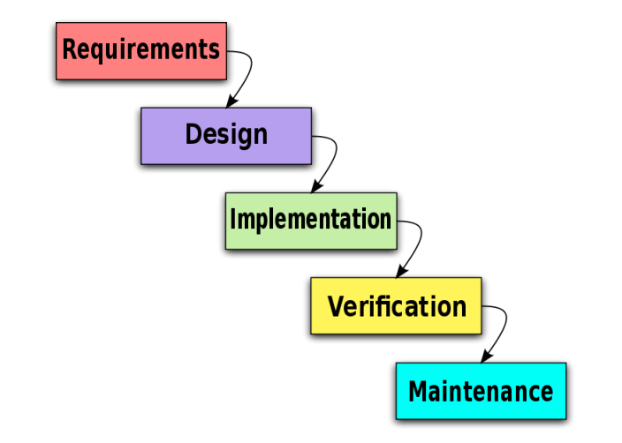

Figure 1 - Waterfall Model

* + 1. Roles and Responsibilities

|  |  |  |
| --- | --- | --- |
| Full name | Role in Group | Responsibilities |
| Lâm Hữu Khánh Phương | Supervisor | * Tracking & managing progress * Advising Idea & solutions * Suggesting & supporting in technologies |
| Lê Anh Đảo | Team Leader, Developer, Business Analyst, Tester, QA | * Tracking & managing progress * Designing database * Creating coding framework * Analyzing requirements * Planning & scheduling * Coding * Testing * Writing documents & reports |
| Nguyễn Bá Linh | Developer, Business Analyst, Tester | * Analyzing requirements * Coding * Writing documents * Testing |
| Hồ Hữu Tài | Developer, Business Analyst, Tester | * Analyzing requirements * Coding * Writing documents * Testing |
| Thân Văn Thành | Developer, Business Analyst, Tester | * Analyzing requirements * Coding * Writing documents * Testing |
| Lê Quang Tú | Developer, Business Analyst, Tester | * Analyzing requirements * Coding * Writing documents * Testing |

Table 2 - Roles and Responsibilities

* + 1. Tools and Technologies

***Tools:***

* *Microsoft Visual Studio 2010*: Used to implement software modules.
* *Microsoft SQL server 2008 R2 Express*: Used as the database of the system.
* *Microsoft Excel*: For the team leader to manage tasks of the members and the progress of the project.
* *TortoiseSVN*: Control Source code of the whole project.
* *VisualSVN*: extension for using subversion (SVN) inside Visual Studio.
* *Google Cloud Connect*: Connect and synchronize the documents.
* *Assembla*: Used as SVN repository
* *Visual Paradigm*: Design database and draw use cases
* *Google Chrome, Firefox*: Used to test the system

**Technologies:**

* ASP.NET MVC 3
* LINQ
* HTML 5, CSS 3, AJAX, jQuery, Bootstrap
* Google Maps API
  1. Project Management Plan
     1. Tasks

|  |  |
| --- | --- |
| **Feasibility study** | |
| Description | General requirements analysis, technology & business process study |
| Deliverables | The feasibility report and decisions for the project |
| Resources Needed | 25 man-days |
| Dependencies and Constraints | N/A |
| Risks | The project or the chosen technology is not feasible. |
| **Documentation and review** | |
| Description | Create all the necessary documents for research and delivery |
| Deliverables | 1. Project Management Plan (PMP) 2. Software Requirements Specification (SRS) 3. Software Design Description (SDD) 4. Software Test Documentation (STD) 5. Software User’s Manual (SUM) |
| Resources Needed | FPT templates,  75 man-day |
| Dependencies and Constraints | Follow FPT templates |
| Risks | Not follow FPT templates, poor review leads to faults in later phases |
| **GUI design and implementation** | |
| Description | Design user interface |
| Deliverables | Prototype |
| Resources Needed | 25 man-days |
| Dependencies and Constraints | Web Application |
| Risks | The interface is not user-friendly and not effective |
| **Implementation** | |
| Description | Create the executable files |
| Deliverables | Usable software product |
| Resources Needed | Visual Studio 2010, .NET framework 4, Web browsers  200 man-days |
| Dependencies and Constraints | N/A |
| Risks | Not meet the deadline, or not all the functions can be implemented |
| **Release and deployment** | |
| Description | Release the complete application and deploy it on the server |
| Deliverables | HDMS installation file and all the related documents (SUM) |
| Resources Needed | Installation package  10 man-days |
| Dependencies and Constraints | Meet the user requirements |
| Risks | The program is not running properly in real environment  Cannot release before the deadline |
| **Quality control** | |
| Description | Testing application’s performance and usability |
| Deliverables | STD |
| Resources Needed | QA, testers (team member),members), FPT template test case  75 man-days |
| Dependencies and Constraints | Follow FPT template test case |
| Risks | The program performance bellow standard  Not user friendly  Bugs and leakages |
| **Human resource management** | |
| Description | Manage human resource, task assignments and member’s performances |
| Deliverables | Project Task List – Assignment Table sheet |
| Resources Needed | Project Task List |
| Dependencies and Constraints | N/A |
| Risks | Lack of planning and management skill  Communication problem  Decrease in team members during project implementation |

* + 1. Task sheet

|  |  |  |  |
| --- | --- | --- | --- |
| Task Name | Duration | Start | Finish |
| **Home Delivery Management System** | **75 days** | Mon 9/10/12 | **Fri 12/21/12** |
| **Initiating** | **1 day** | Mon 9/10/12 | Mon 9/10/12 |
| Project Kick-off meeting | 1 day | Mon 9/10/12 | Mon 9/10/12 |
| **Planning** | **4 days** | **Tue 9/11/12** | **Fri 9/14/12** |
| Prepare Project Introduction | 1 day | **Tue 9/11/12** | Tue 9/11/12 |
| Develop Software Project Management Plan | 2 days | **Wed 9/12/12** | Thu 9/13/12 |
| Review Project plan | 1 day | **Fri 9/14/12** | Fri 9/14/12 |
| **Executing** | **65 days** | **Mon 9/17/12** | **Fri 12/14/12** |
| **Analysis** | **4 days** | **Mon 9/17/12** | **Thu 9/20/12** |
| Create SRS | 4 days | Mon 9/17/12 | Thu 9/20/12 |
| Review SRS | 1 day | Fri 9/21/12 | Fri 9/21/12 |
| **Design** | **10 days** | Mon 9/24/12 | **Fri 10/5/12** |
| Architecture Design | 2 days | Mon 9/24/12 | Tue 9/25/12 |
| Database Design | 2 days | Wed 9/26/12 | Thu 9/27/12 |
| UI Design | 3 days | Fri 9/28/12 | Tue 10/2/12 |
| Create Software Detail Description | 2 days | Wed 10/3/12 | Thu 10/4/12 |
| Review DD | 1 day | Fri 10/5/12 | Fri 10/5/12 |
| **Implementation** | **35 days** | Mon 10/8/12 | **Fri 11/23/12** |
| Implement database | 2 days | Mon 10/8/12 | Tue 10/9/12 |
| coding (code and fix bug) | 33 days | Wed 10/10/12 | Fri 11/23/12 |
| **Testing** | **10 days** | **Mon 11/26/12** | **Fri 12/7/12** |
| Create software Test plan | 1 day | Mon 11/26/12 | Mon 11/26/12 |
| Review Test plan | 1 day | Tue 11/27/12 | Tue 11/27/12 |
| Create Software Test Document | 1 day | Wed 11/28/12 | Wed 11/28/12 |
| Execute IT | 3 days | Thu 11/29/12 | Mon 12/3/12 |
| Execute ST | 3 days | Tue 12/4/12 | Thu 12/6/12 |
| Review STD | 1 day | Fri 12/7/12 | Fri 12/7/12 |
| **Final release** | **5 days** | Thu 12/13/12 | **Wed 12/19/12** |
| Create Software Installation package | 2 days | Thu 12/13/12 | Fri 12/14/12 |
| Create User manual Guide | 2 days | Mon 12/17/12 | Tue 12/18/12 |
| Review User Manual Guide | 1 day | Wed 12/19/12 | Wed 12/19/12 |
| **Closing** | **1 days** | Thu 12/20/12 | **Thu 12/20/12** |
| Final Capstone project Presentation | 1 day | Thu 12/20/12 | Thu 12/20/12 |

* 1. Coding Convention
     1. Naming Convention
* Private Fields: underscore followed by lowerCamelCase.
* Non-private Fields and properties: UpperCamelCase.
* Local variables: lowerCamelCase.
* Do not use consecutive underscores in name.
* Do not use Hungarian style.
  + 1. Lengths
* Public name should not be longer than 32 characters or 7 words.
* Methods should contain no more than 70 lines of code (if it is, it must be divided into methods).
* Methods should contain no more than 5 levels of indentation (if it is, it must be divided into methods).
* A line of code should contain no more than 80 characters.

# Software Requirement Specification

* 1. User Requirement Specification
     1. Common Features
* Only authenticated users can access the system. Users can log in and log out using their own accounts.
* Users can change their password.
* Only authorized users can use specific functions of the system.
  + 1. Account Management
* System administrators have privileges to create new account, enable or disable account, and reset account’s password.
* When the password of an account is reset, an email is sent to the account owner to announce the new password.
  + 1. Customer’s Uses
* Customers can create request when they want some orders to be delivered to the receivers. A request may include many orders. Each order is associated with one receiver. If the receiver is the buyer and the sender is the seller, this order is the same as the order that the buyer made to the seller. An order may include many items.
* When creating a new request, the customer must add new order with request information and items in that order. Another way to create new order is “upload excel file”, it’s helpful when there are a lot of order and items need to be delivered. The customer will input items into excel file (with predefined template) and upload, so the system will import all the data and show on the screen for customer to confirm.
* When a request is submitted, the customer is not allowed to edit/cancel request. Any change must be done by the staff of TicTac.
  + 1. Customers Management
* Customers must have signed a contract with TicTac before they could use the delivery service. Then, office staff will create a new account. After that, they can use this account to access the system.
* Office staff can update the information of customers whenever there is a change.
* Also, each customer may have one or many personnel for contacting and address with TicTac. The contact’s information and address’s information should also be stored in the system for use when needed.
* When a customer no longer uses TicTac’s services, this customer must be deleted from the system and all the accounts associated with this customer are blocked.
  + 1. Request Management
* When receiving a request by phone or email, office staff can create new Request for the customer by using web form or importing Excel file. A new request must have Customer’s company name (or Customer id), address for orders collecting and complete details of the orders/items include name of item, delivery address, amount of payment, etc.
* Office Staff can view all requests, orders and items’ information for checking on their information, statuses, etc.
* Office Staff can filter requests by statuses and dates.
* Office Staff can approve new requests, cancel requests and add/ edit orders if necessary.
  + 1. Order Management
* Office Staff can create new order inside a Request by selecting a Request and then add a new order into it.
* Office Staff can filter all orders to manage and to do with it faster.
* Office Staff can view all orders and items’ information for checking on their information, statuses, etc.
* If an order is canceled by the customer after collected, it must be returned.
  + 1. Area Management
* When login to HDMS with the office staff role, user can create new city/district/ward that helps addressing easy. Area manager can also update information or delete a city/district/ward.
  + 1. Collection Planning
* Office staff can view request/order/item information that has been created. If collection manager feels the number of request is enough to collect, he can make a collection plan and assign it for collectors to go to the customers to collect items.
* Staff can view collection plan detail to cancel collection plan, update status “finished” for it, update status “collected” for every request.
  + 1. Delivery Planning
* Office staff can view order/item information that has been collected. If delivery manager feels the number of item is enough to deliver, delivery manager can also make a delivery plan and assign it for delivery men to go to the receivers to deliver items.
* Staff can view delivery plan detail to cancel delivery plan, update status “finished” for it, update status “delivered” for every order.
  1. System Requirement Specification
     1. External Interface Requirements
        1. User Interfaces

• The design should be simple and user-friendly. Green and dark blue will be 2 main colors of the website. The text color should be white if the background is dark, and it should be black if the background is light.

* The design should be responsive. It means that the web components should be scaled according to a range of resolutions and devices to provide a consistent experience, no matter what.
  + - 1. Hardware Interfaces
* To access to the system, users only need a computer with a fair internet connection.
  + - 1. Software Interfaces
* At the server side, the system should run on top of Windows 7, Windows Server 2008 or later versions of Windows Server. Besides, Microsoft .NET Framework 4 and MVC 3 should be installed on the server. The database management system use for HDMS is SQL Server 2008 R2.
* At the client side, users can use any modern browser that supports javascript and HTML 5 to access to the system.
  + - 1. Communications Protocol

HTTP is the protocol used for loading the web site in browsers.

* + 1. System Features

* + - 1. Manage Account

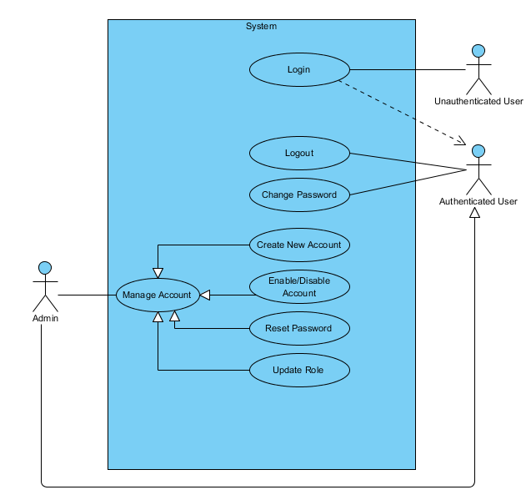

Figure 2 - Manage Account Use Case Diagram

#### Login

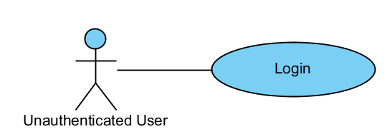

|  |  |  |  |
| --- | --- | --- | --- |
| USE CASE - LOGIN specification | | | |
| Use-case No. | UC01.1 | Use-case Version | 1.0 |
| Use-case Name | Login | | |
| Author | ThanhTV | | |
| Date | 21/11/2012 | Priority | Normal |
| **Actor:** Unauthenticated User  **Summary:** This use case is about how Unauthenticated User login  **Goal:** Have access to functions that require logging in  **Triggers:** User enters TicTac web site’s URL into browser’s address bar and press Enter  **Pre-conditions:** User is not logged  **Post-conditions:** User is logged in  **Main Success Scenario:**   1. User enters TicTac web site’s URL into browser’s address bar and press Enter 2. System redirects to “Login” page 3. User enters username and password and clicks “Login” button. 4. User is logged in successfully 5. System redirects to “Dashboard” page.   **Alternative Scenario:**  N/A  **Exceptions:** When inputs wrong username or password, the system will notify and require input again  **Relationships:**  N/A  **Business Rules:** N/A | | | |

#### Logout

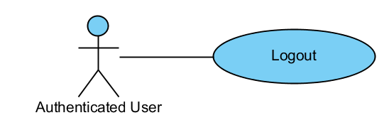

|  |  |  |  |
| --- | --- | --- | --- |
| SE CASE - LOGOUT specification | | | |
| Use-case No. | UC01.2 | Use-case Version | 1.0 |
| Use-case Name | Logout | | |
| Author | ThanhTV | | |
| Date | 21/11/2012 | Priority | Normal |
| **Actor:** Authenticated User  **Summary:** This use case is about how Authenticated User logout  **Goal:** Log out of the system  **Triggers:** User clicks “Logout” button  **Pre-conditions:** User is logged in  **Post-conditions:** User is logged out  **Main Success Scenario:**   1. User clicks to Account Navigation Button and select Logout. 2. User is logged out from the system. 3. System will redirect to Login page.   **Alternative Scenario:**  N/A  **Exceptions:** N/A  **Relationships:**  N/A  **Business Rules:** N/A | | | |

#### Create New User Account

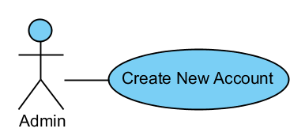

|  |  |  |  |
| --- | --- | --- | --- |
| USE CASE – CREATE NEW USER ACCOUNT specification | | | |
| Use-case No. | UC01.3 | Use-case Version | 1.0 |
| Use-case Name | Create User Account | | |
| Author | ThanhTV | | |
| Date | 21/11/2012 | Priority | Normal |
| **Actor:** Admin  **Summary:** This use case is about how to create new account.  **Goal:** Create a new user account in the system  **Triggers:** User clicks “Create new account” button  **Pre-conditions:** User is logged in with role “Admin”  **Post-conditions:** New account is successfully created  **Main Success Scenario:**   1. In Create Account page, user inputs required information: Username, Full name, Email, and appropriate roles (customer, office staff, delivery staff, admin). 2. User click “Create” button. 3. System create a new account with inputted information and generate a random password for this account 4. System send username and password to the inputted email address 5. System will redirect to “Users” page.   **Alternative Scenario:**  N/A  **Exceptions:** If there is already an account with the same username or same email, the system will notify and require input again.  When inputs require information is invalid format or missed require information, the system will notify and require input again  **Relationships:**  N/A  **Business Rules:** N/A | | | |

#### Disable User Account

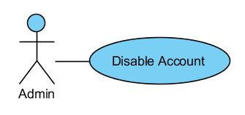

|  |  |  |  |
| --- | --- | --- | --- |
| USE CASE – DISABLE USER ACCOUNT specification | | | |
| Use-case No. | UC01.4 | Use-case Version | 1.0 |
| Use-case Name | Disable User Account | | |
| Author | ThanhTV | | |
| Date | 21/11/2012 | Priority | Normal |
| **Actor:** Admin  **Summary:** This use case is about how to disable a user account.  **Goal:** Disable a user account.  **Triggers:** In User page, admin clicks “Disable” button of a user  **Pre-conditions:** User is logged in with role “Admin”, user account is enabled  **Post-conditions:** Account is successfully disabled  **Main Success Scenario:**   1. In Users page, admin clicks “Disable” button of a user. 2. A confirmation box will appear to confirm. 3. Admin clicks on “Yes” button. 4. System turns status of chosen user from enabled to disabled. 5. System redirects to Users page   **Alternative Scenario:**  N/A  **Exceptions:** N/A  **Relationships:**  N/A  **Business Rules:** N/A | | | |

#### Enable User Account

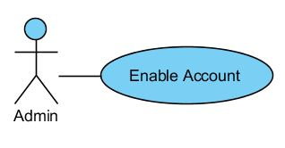

|  |  |  |  |
| --- | --- | --- | --- |
| USE CASE – ENABLE USER ACCOUNT specification | | | |
| Use-case No. | UC01.4b | Use-case Version | 1.0 |
| Use-case Name | Enable User Account | | |
| Author | ThanhTV | | |
| Date | 21/11/2012 | Priority | Normal |
| **Actor:** Admin  **Summary:** This use case is about how to enable a user account.  **Goal:** Enable a user account.  **Triggers:** In User page, admin clicks “Enable” button of a user  **Pre-conditions:** User is logged in with role “Admin”, user account is disabled  **Post-conditions:** Account is successfully enabled  **Main Success Scenario:**   1. In Users page, admin clicks “Enable” button of a user. 2. A confirmation box will appear to confirm. 3. Admin clicks on “Yes” button. 4. System will turn status of chosen user from disabled to enabled. 5. System redirects to Users page   **Alternative Scenario:**  N/A  **Exceptions:** N/A  **Relationships:**  N/A  **Business Rules:** N/A | | | |

#### Reset Password

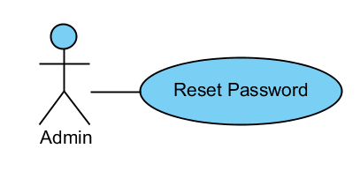

|  |  |  |  |
| --- | --- | --- | --- |
| USE CASE – RESET PASSWORD specification | | | |
| Use-case No. | UC01.5 | Use-case Version | 1.0 |
| Use-case Name | Reset Password | | |
| Author | ThanhTV | | |
| Date | 21/11/2012 | Priority | Normal |
| **Actor:** Admin  **Summary:** This use case is about how to reset password for a user account  **Goal:** Reset password for user account  **Triggers:** In main page of Users, Admin clicks “Reset password” button of a user  **Pre-conditions:** User is logged in with role “Admin”  **Post-conditions:** Password of that user will be reset.  **Main Success Scenario:**   1. In the Users page, Admin clicks “Reset password” button of a user. 2. A confirm box will be appear to confirm. 3. Admin clicks on “Yes” button to confirm reset password. 4. System will reset password of user. 5. System will send an email which includes Username and new password to user. 6. User page will reload.   **Alternative Scenario:**  N/A  **Exceptions:** N/A  **Relationships:**  N/A  **Business Rules:** N/A | | | |

#### Change Password

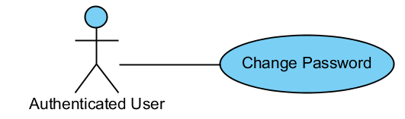

|  |  |  |  |
| --- | --- | --- | --- |
| USE CASE – CHANGE PASSWORD specification | | | |
| Use-case No. | UC01.6 | Use-case Version | 1.0 |
| Use-case Name | Change Password | | |
| Author | ThanhTV | | |
| Date | 21/11/2012 | Priority | Normal |
| **Actor:** Authenticated User  **Summary:** This use case is about how to change password.  **Goal:** Authenticated User can change password.  **Triggers:** Authenticated User clicks “Change Password” link.  **Pre-conditions:** User is logged in.  **Post-conditions:** Password is changed.  **Main Success Scenario:**   1. Authenticated User clicks “Change Password” link in Account Navigation Button. 2. System will redirect to “Change Password” page. 3. Authenticated User inputs current password, new password, confirm new password and clicks “Change Password” button. 4. Account password is changed. 5. System redirect to Dashboard   **Alternative Scenario:**  N/A  **Exceptions:** When inputs current password is wrong, new password not satisfy with required or new password and confirm new password mismatch, the system will notify and require input again.  **Relationships:**  N/A | | | |

#### Update Role

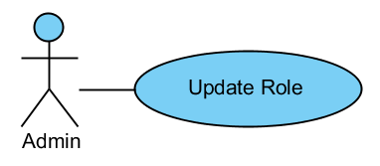

|  |  |  |  |
| --- | --- | --- | --- |
| USE CASE – UPDATE ROLE specification | | | |
| Use-case No. | UC01.7 | Use-case Version | 1.0 |
| Use-case Name | Update Role | | |
| Author | ThanhTV | | |
| Date | 21/11/2012 | Priority | Normal |
| **Actor:** Admin  **Summary:** This use case is about how to update role for a user account  **Goal:** Update role for user account  **Triggers:** In the main page of Users, Admin clicks “Update Role” button of a user  **Pre-conditions:** User is logged in with role “Admin”  **Post-conditions:** Roles of the user is updated  **Main Success Scenario:**   1. In the main page of Users, Admin clicks “Update Role” button of a user. 2. System will show a popup to select new roles. 3. Admin selects new roles 4. Admin clicks “Save” button. 5. System will update appropriate roles for the user. 6. System reloads the Users page.   **Alternative Scenario:**  N/A  **Exceptions:** If user select “Staff” radio button and don’t check any checkbox, an alert will appear require them to choose at least one role for user.  **Relationships:**  N/A  **Business Rules:** N/A | | | |

* + - 1. Manage Requests

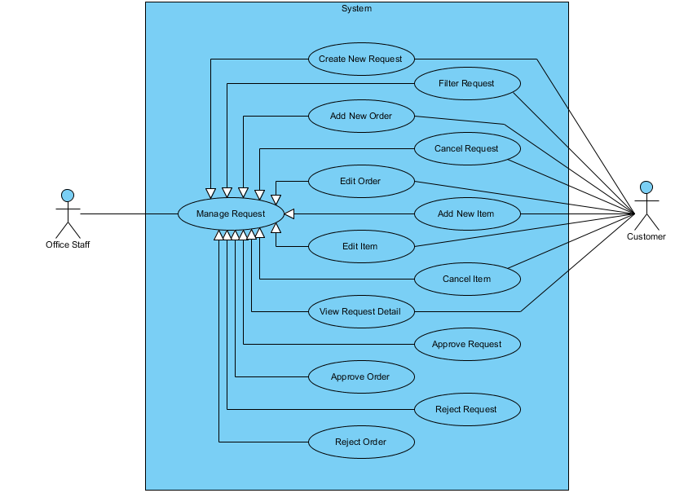

#### Create New Request

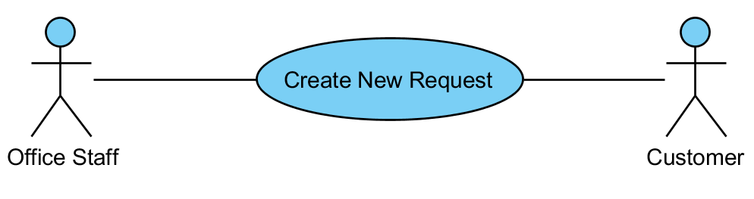

|  |  |  |  |  |
| --- | --- | --- | --- | --- |
| USE CASE - CREATE REQUEST SPECIFICATION | | | | |
| Use-case No. | UC02.1 | Use-case Version | | 1.0 |
| Use-case Name | Create Request | | | |
| Author | ThanhTV | | | |
| Date | 21/11/2012 | Priority | Normal | |
| **Actor:** Office Staff, Customer  **Summary:** This use case is about how to create new request.  **Goal:** User can create new request.  **Triggers:** In main page of requests, user click “Add” button.  **Pre-conditions:** User logged in with office staff/ customer role.  **Post-conditions:** Request is created successful.  **Main Success Scenario:**   1. In main page of requests, user clicks “Add” button. 2. System appears a popup for user input information. 3. User input customer and collection address and click “Create” button. 4. System redirect to “Add Order to Request” page. 5. User clicks “Add new Orders”, inputs information (Receiver Name, Receiver Phone Number, City/Province, District, Ward, Address, Delivery Option, Payment Type, Amount to collected and Note) and clicks “Create” button. 6. User clicks “Add new Item”, inputs information (Item, Quantity, Fragile, High Value, Size, Weight and Note) and clicks “Create” button. 7. User clicks “Submit Request”. 8. System will create new request with order, item were inputted.   **Alternative Scenario:** In step 3, user can import file excel with template of company, system will show all order, item in that and user just click “Submit Request”  **Exceptions:** When inputs require information (Receiver Name, Receiver Phone Number, City/Province, District, Address, Delivery Option, Payment Type, Amount to collected, Item, Quantity, Size and Weight) is invalid format or missed require information, the system will notify and require input again.  When user click “Submit Request” while have not at least item in order, the system will appear a notification “One or more orders contain no item”.  **Relationships:**  N/A  **Business Rules:** N/A | | | | |

#### Filter Requests

**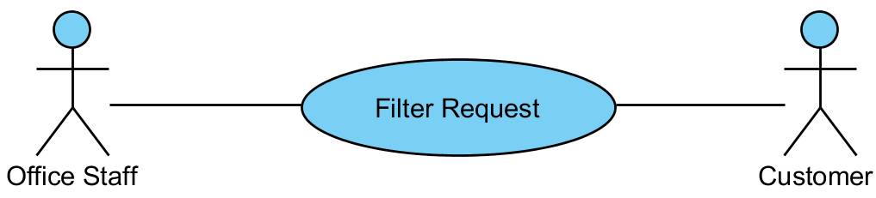**

|  |  |  |  |  |
| --- | --- | --- | --- | --- |
| USE CASE – FILTER REQUESTS SPECIFICATION | | | | |
| Use-case No. | UC02.2 | Use-case Version | | 1.0 |
| Use-case Name | Filter Request | | | |
| Author | ThanhTV | | | |
| Date | 21/11/2012 | Priority | Normal | |
| **Actor:** Office Staff, Customer  **Summary:** This use case is about how office staff filters requests.  **Goal:** User can filter requests.  **Triggers:** In main page of requests, user click “Filter” button.  **Pre-conditions:** User logged in with office staff/ customer role.  **Post-conditions:** Requests is filtered successful.  **Main Success Scenario:**   1. In main page of requests, user selects conditions (status, start date, end date) and clicks “Filter” button. 2. System will show requests tally with conditions.   **Alternative Scenario:** N/A  **Exceptions:** N/A  **Relationships:**  N/A  **Business Rules:** N/A | | | | |

#### Approve Requests

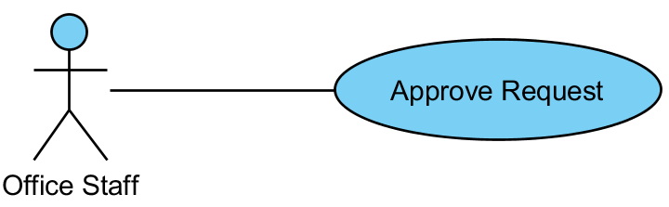

|  |  |  |  |  |
| --- | --- | --- | --- | --- |
| USE CASE – APPROVE REQUESTS SPECIFICATION | | | | |
| Use-case No. | UC02.3 | Use-case Version | | 1.0 |
| Use-case Name | Approve Requests | | | |
| Author | ThanhTV | | | |
| Date | 21/11/2012 | Priority | Normal | |
| **Actor:** Office Staff  **Summary:** This use case is about how to approve request.  **Goal:** Office staff can approve request.  **Triggers:** In main page of requests, user click “Approve Request” icon of “New” status.  **Pre-conditions:** User logged in with office staff role.  **Post-conditions:** Request was approved successful.  **Main Success Scenario:**   1. In main page of requests, user click “Approve Request” icon of “New” status. 2. System will redirect to “Approve Request” page. 3. User inputs “Due Date” and “Fee” for Order and clicks “Approve Order” icon. 4. User clicks “Approve Request” button. 5. System will change status of that request become “Approved”   **Alternative Scenario:** N/A  **Exceptions:** When status of request is not “New”, the “Approve Request” icon will be hidden.  **Relationships:**  N/A  **Business Rules:** N/A | | | | |

#### Add New Order

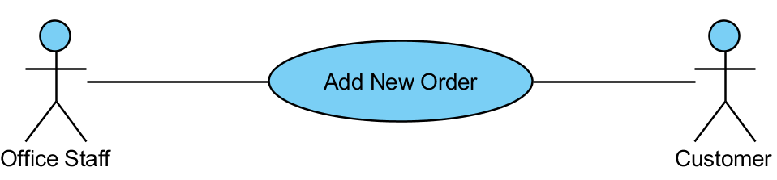

|  |  |  |  |  |
| --- | --- | --- | --- | --- |
| USE CASE – ADD NEW ORDER SPECIFICATION | | | | |
| Use-case No. | UC02.4 | Use-case Version | | 1.0 |
| Use-case Name | Add New Order | | | |
| Author | ThanhTV | | | |
| Date | 21/11/2012 | Priority | Normal | |
| **Actor:** Office Staff, Customer  **Summary:** This use case is about how to add new order.  **Goal:** User can add new order.  **Triggers:** In “Add Order to Request” page, user clicks “Add new Order” button.  **Pre-conditions:** User logged in with office staff/ customer role.  **Post-conditions:** Order is added successful.  **Main Success Scenario:**   1. In main page of requests, user click “Edit” icon of “Draft” status. 2. System will redirect to “Add Order to Request” page. 3. User clicks “Add new Order” button. 4. System appears a popup for user input information (Receiver Name, Receiver Phone Number, City/Province, District, Ward, Address, Delivery Option, Payment Type, Amount to collected and Note). 5. User inputs information and click “Create” button. 6. System will create new order with that information.   **Alternative Scenario:** N/A  **Exceptions:** When inputs require information (Receiver Name, Receiver Phone Number, City/Province, District, Address, Delivery Option, Payment Type and Amount to collected) is invalid format or missed require information, the system will notify and require input again.  When status of collection plan is not “Draft”, the “Edit” icon will be hidden.  **Relationships:**  N/A  **Business Rules:** N/A | | | | |

#### Edit Order

**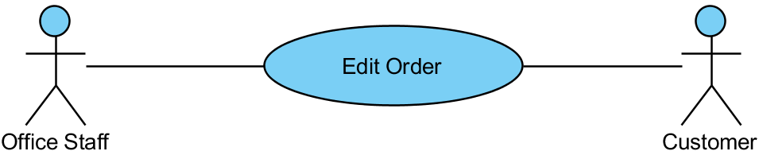**

|  |  |  |  |  |
| --- | --- | --- | --- | --- |
| USE CASE – EDIT ORDER SPECIFICATION | | | | |
| Use-case No. | UC02.5 | Use-case Version | | 1.0 |
| Use-case Name | Edit Order | | | |
| Author | ThanhTV | | | |
| Date | 21/11/2012 | Priority | Normal | |
| **Actor:** Office Staff, Customer  **Summary:** This use case is about how to edit order.  **Goal:** User can edit order.  **Triggers:** In “Add Order to Request” page, user clicks “Edit Order” icon of that order.  **Pre-conditions:** User logged in with office staff/ customer role.  **Post-conditions:** Order is edited successful.  **Main Success Scenario:**   1. In main page of requests, user click “Edit” icon of “Draft” status. 2. System will redirect to “Add Order to Request” page. 3. User clicks “Edit Order” icon of that order. 4. System appears a popup for user input information again. 5. User inputs information (Receiver Name, Receiver Phone Number, City/Province, District, Ward, Address, Delivery Option, Payment Type, Amount to collected and Note) and clicks “OK” button to edit.   **Alternative Scenario:** N/A  **Exceptions:** When status of collection plan is not “Draft”, the “Edit” icon will be hidden.  When inputs require information (Receiver Name, Receiver Phone Number, City/Province, District, Address, Delivery Option, Payment Type and Amount to collected) is invalid format or missed require information, the system will notify and require input again.  **Relationships:**  N/A  **Business Rules:** N/A | | | | |

#### Add New Item

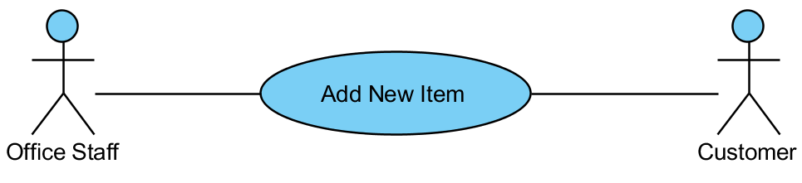

|  |  |  |  |  |
| --- | --- | --- | --- | --- |
| USE CASE – ADD NEW ITEM SPECIFICATION | | | | |
| Use-case No. | UC02.6 | Use-case Version | | 1.0 |
| Use-case Name | Add New Item | | | |
| Author | ThanhTV | | | |
| Date | 21/11/2012 | Priority | Normal | |
| **Actor:** Office Staff, Customer  **Summary:** This use case is about how to add new item.  **Goal: U**ser can add new item.  **Triggers:** In “Add Order to Request” page, user clicks “Add New Item” icon of that order.  **Pre-conditions:** User logged in with office staff/ customer role.  **Post-conditions:** Item is added successful.  **Main Success Scenario:**   1. In main page of requests, user click “Edit” icon of “Draft” status. 2. System will redirect to “Add Order to Request” page. 3. User clicks “Add New Item” icon of that order. 4. System appears a popup to input. 5. User inputs information (Item, Quantity, Fragile, High Value, Size, Weight and Note) and clicks “Create” button.   **Alternative Scenario:** N/A  **Exceptions:** When status of collection plan is not “Draft”, the “Edit” icon will be hidden.  When inputs require information (Item, Quantity, Size and Weight) is invalid format or missed require information, the system will notify and require input again.  **Relationships:**  N/A  **Business Rules:** N/A | | | | |

#### View Request Detail

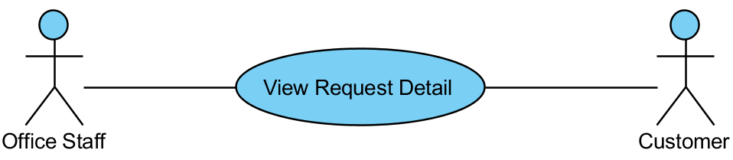

|  |  |  |  |  |
| --- | --- | --- | --- | --- |
| USE CASE – VIEW REQUEST DETAIL SPECIFICATION | | | | |
| Use-case No. | UC02.7 | Use-case Version | | 1.0 |
| Use-case Name | View Request Detail | | | |
| Author | ThanhTV | | | |
| Date | 21/11/2012 | Priority | Normal | |
| **Actor:** Office Staff, Customer  **Summary:** This use case is about how to view request detail.  **Goal:** User can view request detail.  **Triggers:** In main page of requests, user click “View request detail” icon.  **Pre-conditions:** User logged in with office staff/ customer role.  **Post-conditions:** User will view request detail.  **Main Success Scenario:**   1. In main page of request, user clicks “View request detail” icon. 2. System will redirect to “Request Details” page with request information, orders and items.   **Alternative Scenario:** N/A  **Exceptions:** N/A  **Relationships:**  N/A  **Business Rules:** N/A | | | | |

#### Cancel Request

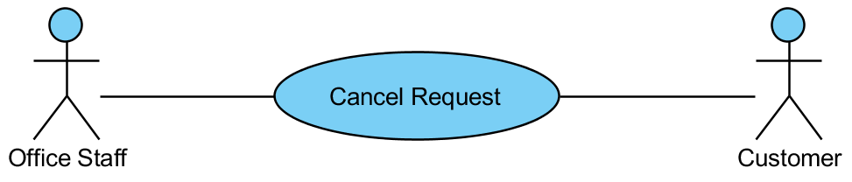

|  |  |  |  |  |
| --- | --- | --- | --- | --- |
| USE CASE – CANCEL REQUEST SPECIFICATION | | | | |
| Use-case No. | UC02.8 | Use-case Version | | 1.0 |
| Use-case Name | Cancel Request | | | |
| Author | ThanhTV | | | |
| Date | 21/11/2012 | Priority | Normal | |
| **Actor:** Office Staff, Customer  **Summary:** This use case is about how to cancel request.  **Goal:** User can cancel request.  **Triggers:** In main page of requests, user click “Cancel” icon.  **Pre-conditions:** User logged in with office staff/ customer role.  **Post-conditions:** Request will be canceled successful.  **Main Success Scenario:**   1. In main page of request, user clicks “Cancel” icon of that request. 2. System will appear a confirm box to confirm again. 3. User clicks “OK” button to cancel. 4. System will delete that request out of request list.   **Alternative Scenario:** N/A  **Exceptions:** N/A  **Relationships:**  N/A  **Business Rules:** N/A | | | | |

#### Approve Order

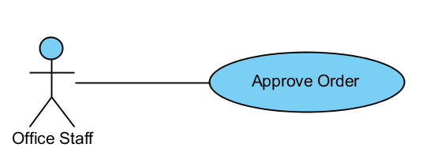

|  |  |  |  |  |
| --- | --- | --- | --- | --- |
| USE CASE – APPROVE ORDER SPECIFICATION | | | | |
| Use-case No. | UC02.9 | Use-case Version | | 1.0 |
| Use-case Name | Approve Order | | | |
| Author | ThanhTV | | | |
| Date | 21/11/2012 | Priority | Normal | |
| **Actor:** Office Staff  **Summary:** This use case is about how to approve order.  **Goal:** Office staff can approve order.  **Triggers:** In main page of requests, user click “Approve Request” icon of “New” status.  **Pre-conditions:** User logged in with office staff role.  **Post-conditions:** Order was approved successful.  **Main Success Scenario:**   1. In main page of requests, user click “Approve Request” icon of “New” status. 2. System will redirect to “Approve Request” page. 3. User inputs “Due Date” and “Fee” for Order and clicks “Approve Order” icon. 4. System will change status of that order become “Approved”.   **Alternative Scenario:** N/A  **Exceptions:** When status of request is not “New”, the “Approve Request” icon will be hidden.  **Relationships:**  N/A  **Business Rules:** N/A | | | | |

#### Edit Item

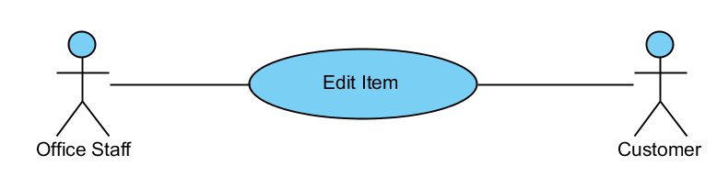

|  |  |  |  |  |
| --- | --- | --- | --- | --- |
| USE CASE – EDIT ITEM SPECIFICATION | | | | |
| Use-case No. | UC02.10 | Use-case Version | | 1.0 |
| Use-case Name | Edit Item | | | |
| Author | ThanhTV | | | |
| Date | 21/11/2012 | Priority | Normal | |
| **Actor:** Office Staff, Customer  **Summary:** This use case is about how to edit item.  **Goal:** User can edit item.  **Triggers:** In “Add Order to Request” page, user clicks “Edit Item” icon of that item.  **Pre-conditions:** User logged in with office staff/ customer role.  **Post-conditions:** Item is edited successful.  **Main Success Scenario:**   1. In main page of requests, user click “Edit” icon of “Draft” status. 2. System will redirect to “Add Order to Request” page. 3. User clicks “Edit Item” icon of that item. 4. System appears a popup for user input information (Item, Quantity, Fragile, High Value, Size, Weight and Note) again. 5. User click “OK” button to cancel. 6. System will update new item information in item list.   **Alternative Scenario:** N/A  **Exceptions:** When status of collection plan is not “Draft”, the “Edit” icon will be hidden.  When inputs require information (Item, Quantity, Size and Weight) is invalid format or missed require information, the system will notify and require input again.  **Relationships:**  N/A  **Business Rules:** N/A | | | | |

#### Cancel Item

#### 

|  |  |  |  |  |
| --- | --- | --- | --- | --- |
| USE CASE – CANCEL ITEM SPECIFICATION | | | | |
| Use-case No. | UC02.11 | Use-case Version | | 1.0 |
| Use-case Name | Cancel Item | | | |
| Author | ThanhTV | | | |
| Date | 21/11/2012 | Priority | Normal | |
| **Actor:** Office Staff, Customer  **Summary:** This use case is about how to cancel item.  **Goal:** User can cancel item.  **Triggers:** In “Add Order to Request” page, user click “Cancel” icon.  **Pre-conditions:** User logged in with office staff/ customer role.  **Post-conditions:** Item will be canceled successful.  **Main Success Scenario:**   1. In main page of requests, user click “Edit” icon of “Draft” status. 2. System will redirect to “Add Order to Request” page. 3. User clicks “Delete” icon of that item. 4. System appears a confirm box to confirm again. 5. User clicks “OK” button to delete. 6. System will delete that item out of item list.   **Alternative Scenario:** In step 3, if user wants to cancel the process, user can clicks to “Cancel” button to back the main page of request.  **Exceptions:** When status of collection plan is not “Draft”, the “Edit” icon will be hidden.  **Relationships:**  N/A  **Business Rules:** N/A | | | | |

#### Reject Request

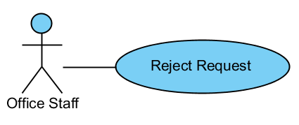

|  |  |  |  |  |
| --- | --- | --- | --- | --- |
| USE CASE – REJECT REQUEST SPECIFICATION | | | | |
| Use-case No. | UC02.12 | Use-case Version | | 1.0 |
| Use-case Name | Approve Order | | | |
| Author | ThanhTV | | | |
| Date | 21/11/2012 | Priority | Normal | |
| **Actor:** Office Staff  **Summary:** This use case is about how to reject request.  **Goal:** Office staff can reject request.  **Triggers:** In “Approve Request” page, clicks “Reject Request” button.  **Pre-conditions:** User logged in with office staff role.  **Post-conditions:** Request was rejected successful.  **Main Success Scenario:**   1. In main page of requests, user click “Approve Request” icon of “New” status. 2. System will redirect to “Approve Request” page. 3. User clicks “Reject Request” button. 4. A confirm box appear to confirm again. 5. User clicks “OK” button to reject. 6. System will delete request out of request list.   **Alternative Scenario:** N/A  **Exceptions:** When status of request is not “New”, the “Approve Request” icon will be hidden.  **Relationships:**  N/A  **Business Rules:** N/A | | | | |

#### Reject Order

#### 

|  |  |  |  |  |
| --- | --- | --- | --- | --- |
| USE CASE – REJECT ORDER SPECIFICATION | | | | |
| Use-case No. | UC02.13 | Use-case Version | | 1.0 |
| Use-case Name | Reject Order | | | |
| Author | ThanhTV | | | |
| Date | 21/11/2012 | Priority | Normal | |
| **Actor:** Office Staff  **Summary:** This use case is about how to reject order.  **Goal:** Office staff can reject order.  **Triggers:** In “Approve Request” page, clicks “Reject Order” icon.  **Pre-conditions:** User logged in with office staff role.  **Post-conditions:** Order was rejected successfully.  **Main Success Scenario:**   1. In main page of requests, user click “Approve Request” icon of “New” status. 2. System will redirect to “Approve Request” page. 3. User clicks “Reject Order” icon. 4. A confirm box appear to confirm again. 5. User clicks “OK” button to reject. 6. System will make that order become dark with announce is “Rejected”.   **Alternative Scenario:** N/A  **Exceptions:** When status of request is not “New”, the “Approve Request” icon will be hidden.  **Relationships:**  N/A  **Business Rules:** N/A | | | | |

* + - 1. Manage Orders

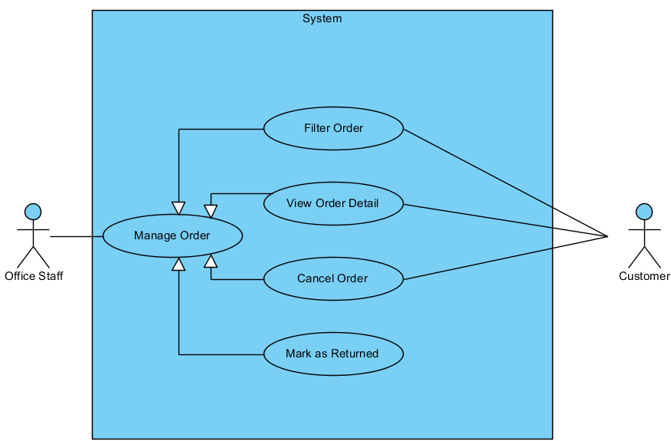

#### Filter Orders

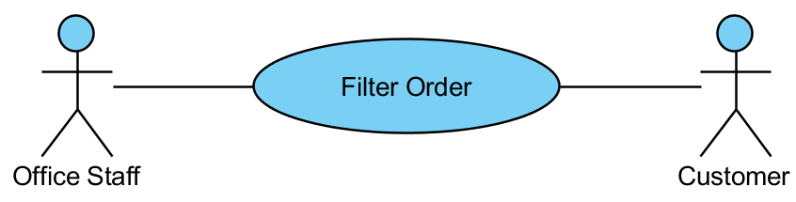

|  |  |  |  |  |
| --- | --- | --- | --- | --- |
| USE CASE – FILTER ORDERS SPECIFICATION | | | | |
| Use-case No. | UC03.1 | Use-case Version | | 1.0 |
| Use-case Name | Filter Order | | | |
| Author | ThanhTV | | | |
| Date | 21/11/2012 | Priority | Normal | |
| **Actor:** Office Staff, Customer  **Summary:** This use case is about how office staff filters orders.  **Goal:** User can filter orders.  **Triggers:** In main page of orders, user click “Filter” button.  **Pre-conditions:** User logged in with office staff/ customer role.  **Post-conditions:** Orders is filtered successfully.  **Main Success Scenario:**   1. In main page of orders, user selects conditions (status; start date; end date) and clicks “Filter” button. 2. System will show orders tally with conditions.   **Alternative Scenario:** N/A  **Exceptions:** N/A  **Relationships:**  N/A  **Business Rules:** N/A | | | | |

#### View Order Detail

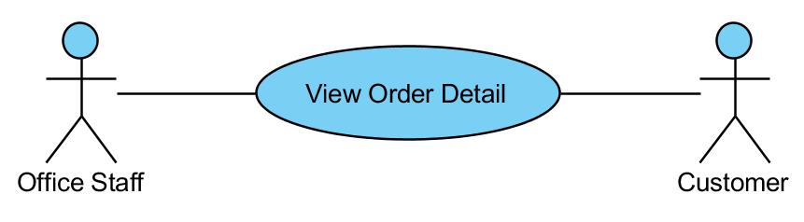

|  |  |  |  |  |
| --- | --- | --- | --- | --- |
| USE CASE – VIEW ORDERS DETAIL SPECIFICATION | | | | |
| Use-case No. | UC03.2 | Use-case Version | | 1.0 |
| Use-case Name | View Order Detail | | | |
| Author | ThanhTV | | | |
| Date | 21/11/2012 | Priority | Normal | |
| **Actor:** Office Staff, Customer  **Summary:** This use case is about how to view order detail.  **Goal:** User can view order detail.  **Triggers:** In main page of orders, user click “View order detail” icon.  **Pre-conditions:** User logged in with office staff/ customer role.  **Post-conditions:** User will view order detail.  **Main Success Scenario:**   1. In main page of order, user clicks “View order detail” icon. 2. System will redirect to “Order Details” page with information of order.   **Alternative Scenario:** N/A  **Exceptions:** N/A  **Relationships:**  N/A  **Business Rules:** N/A | | | | |

#### Cancel Order

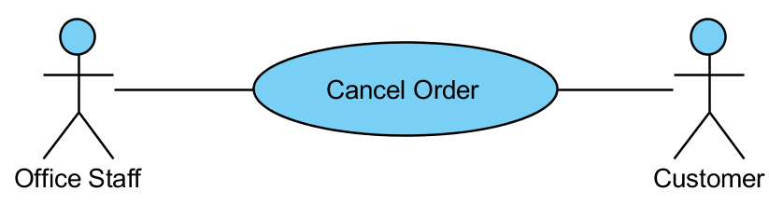

|  |  |  |  |  |
| --- | --- | --- | --- | --- |
| USE CASE – CANCEL ORDERS SPECIFICATION | | | | |
| Use-case No. | UC03.3 | Use-case Version | | 1.0 |
| Use-case Name | Cancel Order | | | |
| Author | ThanhTV | | | |
| Date | 21/11/2012 | Priority | Normal | |
| **Actor:** Office Staff, Customer  **Summary:** This use case is about how to cancel order.  **Goal:** User can cancel order.  **Triggers:** In main page of orders, user click “Cancel” icon.  **Pre-conditions:** User logged in with office staff/ customer role.  **Post-conditions:** Order will be canceled successful.  **Main Success Scenario:**   1. In main page of requests, user clicks “Cancel” icon of that order. 2. System will appear a confirm box to confirm again. 3. User clicks “OK” button to cancel. 4. System will delete that order out of list orders.   **Alternative Scenario:** In Manage Request, user clicks “Edit” icon of “Draft” status. System will redirect to “Add Order to Request” page and next, user can cancel order from step 1.  **Exceptions:** When status of collection plan is not “Draft”, the “Edit” icon will be hidden.  **Relationships:**  N/A  **Business Rules:** N/A | | | | |

#### Mark as Returned

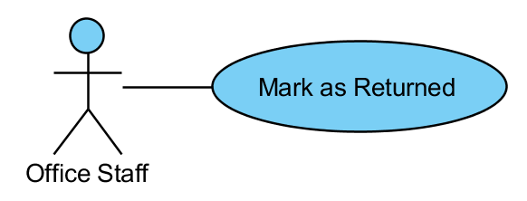

|  |  |  |  |  |
| --- | --- | --- | --- | --- |
| USE CASE – MARK AS RETURNED SPECIFICATION | | | | |
| Use-case No. | UC03.4 | Use-case Version | | 1.0 |
| Use-case Name | Mark as Returned | | | |
| Author | ThanhTV | | | |
| Date | 21/11/2012 | Priority | Normal | |
| **Actor:** Office Staff  **Summary:** This use case is about how to mark as returned for order.  **Goal:** Office staff can mark as returned for order.  **Triggers:** In main page of orders, user click “Mark as Returned” icon of “To Be Returned” status.  **Pre-conditions:** User logged in with office staff role.  **Post-conditions:** Office staff to mark as returned for order.  **Main Success Scenario:**   1. In main page of orders, user click “Mark as Returned” icon of “To Be Returned” status. 2. System will change status of that order become “Returned”.   **Alternative Scenario:** N/A  **Exceptions:** When status of order is not “To Be Returned”, the “Mark as Returned” icon will be hidden.  **Relationships:**  N/A  **Business Rules:** N/A | | | | |

* + - 1. Manage Customers

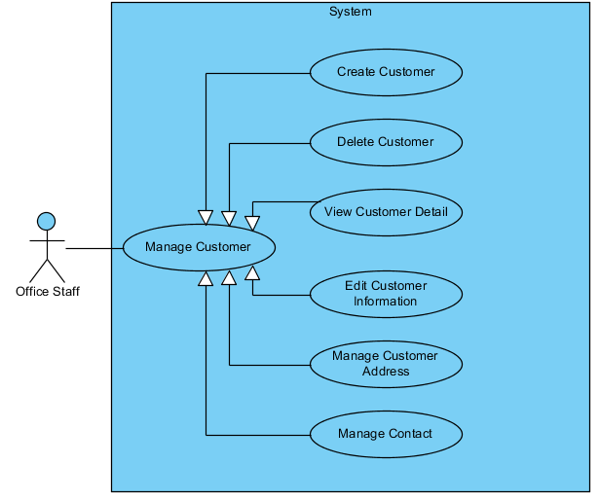

#### Create Customer

**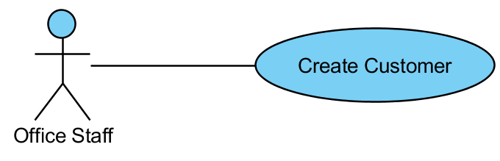**

|  |  |  |  |  |
| --- | --- | --- | --- | --- |
| USE CASE - CREATE CUSTOMER SPECIFICATION | | | | |
| Use-case No. | UC04.1 | Use-case Version | | 1.0 |
| Use-case Name | Create Customer | | | |
| Author | ThanhTV | | | |
| Date | 21/11/2012 | Priority | Normal | |
| **Actor:** Office Staff  **Summary:** This use case is about how office staff creates new customer.  **Goal:** Office staff can create new customer.  **Triggers:** In main page of customer, user click “Add” button.  **Pre-conditions:** User logged in with office staff role.  **Post-conditions:** Customer is created successfully.  **Main Success Scenario:**   1. In main page of customer, user clicks “Add” button. 2. System will appear a popup with any fields (Company Name, Display Name, Phone Number, Current Contract Code and Note) to input. 3. User inputs information (Company Name, Display Name, Phone Number, Current Contract Code and Note) and clicks “Create” button. 4. System will create new customer in customer list.   **Alternative Scenario:** N/A  **Exceptions:** When inputs require information (Company Name, Display Name, Phone Number, Current Contract Code) is invalid format or missed require information, the system will notify and require input again.  **Relationships:**  N/A  **Business Rules:** N/A | | | | |

#### Delete Customer

**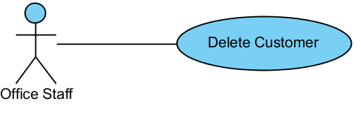**

|  |  |  |  |  |
| --- | --- | --- | --- | --- |
| USE CASE – DELETE CUSTOMER SPECIFICATION | | | | |
| Use-case No. | UC04.2 | Use-case Version | | 1.0 |
| Use-case Name | Delete Customer | | | |
| Author | ThanhTV | | | |
| Date | 21/11/2012 | Priority | Normal | |
| **Actor:** Office Staff  **Summary:** This use case is about how to delete a customer.  **Goal:** Office staff can delete a customer.  **Triggers:** In Customer page, user click “Delete” button.  **Pre-conditions:** User logged in with office staff role.  **Post-conditions:** Customer is deleted successfully.  **Main Success Scenario:**   1. In “Customer Details” page, user clicks “Delete Customer” button in Customer Information area. 2. System will appear a confirm box to selects. 3. User clicks “Yes” button to delete. 4. System will delete that customer in customer list.   **Alternative Scenario:** N/A  **Exceptions:** If that customer has order/ request in system, that customer will be unable to delete.  **Relationships:**  N/A  **Business Rules:** N/A | | | | |

#### View Customer Detail

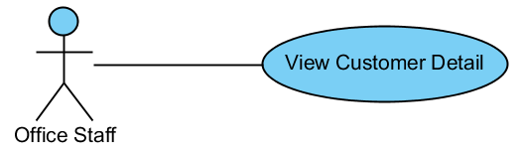

|  |  |  |  |  |
| --- | --- | --- | --- | --- |
| USE CASE – VIEW CUSTOMER DETAIL SPECIFICATION | | | | |
| Use-case No. | UC04.3 | Use-case Version | | 1.0 |
| Use-case Name | View Customer Detail | | | |
| Author | ThanhTV | | | |
| Date | 21/11/2012 | Priority | Normal | |
| **Actor:** Office Staff  **Summary:** This use case is about how to view customer detail.  **Goal:** Office staff can view customer detail.  **Triggers:** In main page of customer, user click “View customer detail” button.  **Pre-conditions:** User logged in with office staff role.  **Post-conditions:** User will view customer detail.  **Main Success Scenario:**   1. In main page of customer, user clicks “View customer detail” icon. 2. System will redirect to “Customer Details” page with customer information, contacts and addresses.   **Alternative Scenario:** N/A  **Exceptions:** N/A  **Relationships:**  N/A  **Business Rules:** N/A | | | | |

#### Edit Customer Information

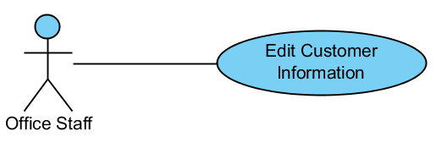

|  |  |  |  |  |
| --- | --- | --- | --- | --- |
| USE CASE - EDIT CUSTOMER INFORMATION SPECIFICATION | | | | |
| Use-case No. | UC04.4 | Use-case Version | | 1.0 |
| Use-case Name | Edit Customer Information | | | |
| Author | ThanhTV | | | |
| Date | 21/11/2012 | Priority | Normal | |
| **Actor:** Office Staff  **Summary:** This use case is about how to edit customer information.  **Goal:** Office staff can edit customer information.  **Triggers:** In “Customer Details” page, user click “Edit” icon in Customer Information area.  **Pre-conditions:** User logged in with office staff role.  **Post-conditions:** Customer information is edited successfully.  **Main Success Scenario:**   1. In “Customer Details” page, user click “Edit” icon in Customer Information area. 2. System will appear a popup to input information (Company Name, Display Name, Phone Number, Current Contract Code and Note). 3. User inputs information and clicks “Save” button. 4. System will update new customer information appears in Customer Information area.   **Alternative Scenario:** N/A  **Exceptions:** When inputs require information (Company Name, Display Name, Phone Number, Current Contract Code) is invalid format or missed require information, the system will notify and require input again.  **Relationships:**  N/A  **Business Rules:** N/A | | | | |

#### Create Customer Address

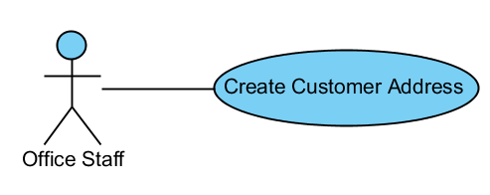

|  |  |  |  |  |
| --- | --- | --- | --- | --- |
| USE CASE - CREATE CUSTOMER ADDRESS SPECIFICATION | | | | |
| Use-case No. | UC04.5 | Use-case Version | | 1.0 |
| Use-case Name | Create Customer Address | | | |
| Author | ThanhTV | | | |
| Date | 21/11/2012 | Priority | Normal | |
| **Actor:** Office Staff  **Summary:** This use case is about how to create customer address.  **Goal:** Office staff can create customer address.  **Triggers:** In “Customer Details” page, user click “Add” icon in Address area.  **Pre-conditions:** User logged in with office staff role.  **Post-conditions:** Customer address is created successfully.  **Main Success Scenario:**   1. In “Customer Details” page, user click “Add” icon in Address area. 2. System will appear a popup to input information (City/Province, District, Ward and Address). 3. User inputs information and clicks “Create” button. 4. System will create new customer address in Address area.   **Alternative Scenario:** N/A  **Exceptions:** When inputs require information (City/Province, District and Address) is invalid format or missed require information, the system will notify and require input again.  **Relationships:**  N/A  **Business Rules:** N/A | | | | |

#### Delete Customer Address

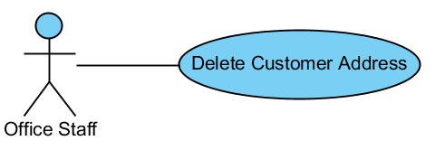

|  |  |  |  |  |
| --- | --- | --- | --- | --- |
| USE CASE – DELETE CUSTOMER ADDRESS SPECIFICATION | | | | |
| Use-case No. | UC04.6 | Use-case Version | | 1.0 |
| Use-case Name | Delete Customer Address | | | |
| Author | ThanhTV | | | |
| Date | 21/11/2012 | Priority | Normal | |
| **Actor:** Office Staff  **Summary:** This use case is about how to delete a customer address.  **Goal:** Office staff can delete a customer address.  **Triggers:** In “Customer Details” page, user click “Delete” icon in Address area.  **Pre-conditions:** User logged in with office staff role.  **Post-conditions:** Customer address is deleted successfully.  **Main Success Scenario:**   1. In “Customer Details” page, user click “Delete” icon in Address area. 2. System will appear a confirm box to selects. 3. User clicks “Yes” button to delete. 4. System will delete that customer address out of address list.   **Alternative Scenario:** N/A  **Exceptions:** N/A  **Relationships:**  N/A  **Business Rules:** N/A | | | | |

#### Edit Customer Address

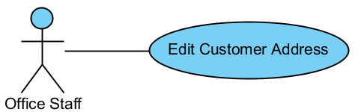

|  |  |  |  |  |
| --- | --- | --- | --- | --- |
| USE CASE - EDIT CUSTOMER ADDRESS SPECIFICATION | | | | |
| Use-case No. | UC04.7 | Use-case Version | | 1.0 |
| Use-case Name | Edit Customer Address | | | |
| Author | ThanhTV | | | |
| Date | 21/11/2012 | Priority | Normal | |
| **Actor:** Office Staff  **Summary:** This use case is about how to edit customer address.  **Goal:** Office staff can edit customer address.  **Triggers:** In “Customer Details” page, user click “Edit” icon in Customer Address area.  **Pre-conditions:** User logged in with office staff role.  **Post-conditions:** Customer address is edited successfully.  **Main Success Scenario:**   1. In “Customer Details” page, user click “Edit” icon in Customer Address area. 2. System will appear a popup to input information (City/Province, District, Ward and Address). 3. User inputs information and clicks “Save” button. 4. System will update new customer address in Customer Address area.   **Alternative Scenario:** N/A  **Exceptions:** When inputs require information (City/Province, District and Address) is invalid format or missed require information, the system will notify and require input again.  **Relationships:**  N/A  **Business Rules:** N/A | | | | |

* + - 1. Manage Master Data

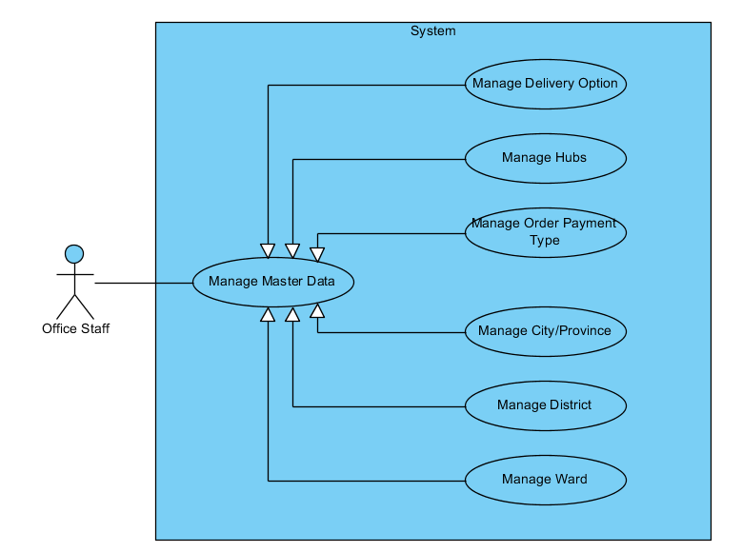

#### Create New Hub

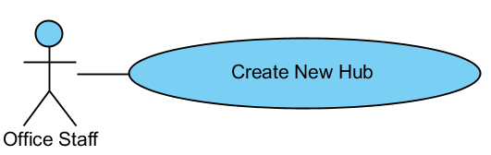

|  |  |  |  |  |
| --- | --- | --- | --- | --- |
| USE CASE - CREATE NEW HUB SPECIFICATION | | | | |
| Use-case No. | UC05.1.1 | Use-case Version | | 1.0 |
| Use-case Name | Create New Hub | | | |
| Author | ThanhTV | | | |
| Date | 21/11/2012 | Priority | Normal | |
| **Actor:** Office Staff  **Summary:** This use case is about how to create new hub.  **Goal:** Office staff can create new hub.  **Triggers:** In “Hubs” page, user click “Add” button.  **Pre-conditions:** User logged in with office staff role.  **Post-conditions:** Hub is created successfully.  **Main Success Scenario:**   1. In “Hub” page, user click “Add” button. 2. System will appear a popup to input information (Name, City/Province, District, Ward and Address). 3. User inputs information and clicks “OK” button. 4. System will create new hub in hub list.   **Alternative Scenario:** N/A  **Exceptions:** When inputs require information (Name, City/Province, District and Address) is invalid format or missed require information, the system will notify and require input again.  **Relationships:**  N/A  **Business Rules:** N/A | | | | |

#### Edit Hub

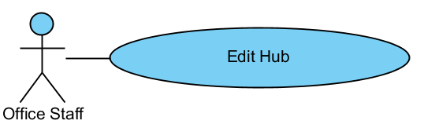

|  |  |  |  |  |
| --- | --- | --- | --- | --- |
| USE CASE - EDIT HUB SPECIFICATION | | | | |
| Use-case No. | UC05.1.2 | Use-case Version | | 1.0 |
| Use-case Name | Edit Hub | | | |
| Author | ThanhTV | | | |
| Date | 21/11/2012 | Priority | Normal | |
| **Actor:** Office Staff  **Summary:** This use case is about how to edit hub.  **Goal:** Office staff can edit hub.  **Triggers:** In “Hub” page, user click “Edit” icon of that hub.  **Pre-conditions:** User logged in with office staff role.  **Post-conditions:** Hub is edited successfully.  **Main Success Scenario:**   1. In “Hub” page, user click “Edit” icon of that hub. 2. System will appear a popup to input information (Name, City/Province, District, Ward and Address) again. 3. User inputs information and clicks “Save” button. 4. System will update new hub in hub list.   **Alternative Scenario:** N/A  **Exceptions:** When inputs require information (Name, City/Province, District and Address) is invalid format or missed require information, the system will notify and require input again.  **Relationships:**  N/A  **Business Rules:** N/A | | | | |

#### Delete Hub

#### 

|  |  |  |  |  |
| --- | --- | --- | --- | --- |
| USE CASE – DELETE HUB SPECIFICATION | | | | |
| Use-case No. | UC05.1.3 | Use-case Version | | 1.0 |
| Use-case Name | Delete Hub | | | |
| Author | ThanhTV | | | |
| Date | 21/11/2012 | Priority | Normal | |
| **Actor:** Office Staff  **Summary:** This use case is about how to delete hub.  **Goal:** Office staff can delete hub.  **Triggers:** In “Hub” page, user click “Delete” icon of that hub.  **Pre-conditions:** User logged in with office staff role.  **Post-conditions:** Hub is canceled successfully.  **Main Success Scenario:**   1. In “Hub” page, user click “Delete” icon of that hub. 2. System will appear a confirm box to confirm again. 3. User clicks “Yes” button to cancel. 4. System will delete that hub out of hub list.   **Alternative Scenario:** N/A  **Exceptions:** N/A  **Relationships:**  N/A  **Business Rules:** N/A | | | | |

#### Set Location for Hub

#### 

|  |  |  |  |  |
| --- | --- | --- | --- | --- |
| USE CASE – SET LOCATION SPECIFICATION | | | | |
| Use-case No. | UC05.1.4 | Use-case Version | | 1.0 |
| Use-case Name | Set Location | | | |
| Author | ThanhTV | | | |
| Date | 21/11/2012 | Priority | Normal | |
| **Actor:** Office Staff  **Summary:** This use case is about how to set location.  **Goal:** Office staff can set location.  **Triggers:** In “Hub” page, user click “Set Location” icon of that hub.  **Pre-conditions:** User logged in with office staff role.  **Post-conditions:** Location is set successful.  **Main Success Scenario:**   1. In “Hub” page, user click “Set Location” icon of that hub. 2. User selects new location of that hub in the map. 3. User clicks “Confirm Set Location” icon to set. 4. System will set new location to that hub.   **Alternative Scenario:** N/A  **Exceptions:** N/A  **Relationships:**  N/A  **Business Rules:** N/A | | | | |

* + - 1. Manage Collection Plan

#### Create Collection Plan

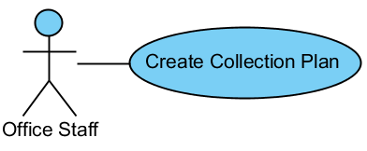

|  |  |  |  |  |
| --- | --- | --- | --- | --- |
| USE CASE - CREATE COLLECTION PLAN SPECIFICATION | | | | |
| Use-case No. | UC06.1 | Use-case Version | | 1.0 |
| Use-case Name | Create Collection Plan | | | |
| Author | ThanhTV | | | |
| Date | 21/11/2012 | Priority | Normal | |
| **Actor:** Office Staff  **Summary:** This use case is about how office staff creates new collection plan.  **Goal:** Office staff can create new collection plan.  **Triggers:** In main page of collection plan, user click “Add” button.  **Pre-conditions:** User logged in with office staff role.  **Post-conditions:** Collection plan is created successfully.  **Main Success Scenario:**   1. In main page of collection plan, user clicks “Add” button. 2. System will redirect to “Create New Collection Plan” page. 3. User selects city, district and ward to list all requests in that. 4. User clicks to “Add to plan” icon in that requests to add requests to plan and clicks “Create Plan” button. 5. System will redirect to “Collection Plan Details” page and new collection plan will appears in collection plan list.   **Alternative Scenario:**   1. In main page of collection plan, user clicks “Add” button. 2. System will redirect to “Create New Collection Plan” page. 3. User clicks “Not Use Map” button to create plan without using map. 4. System will redirect to “Create New Collection Plan” page that without map. 5. User selects city, district and ward to list all requests in that. 6. User clicks to “Add to plan” icon in that requests to add requests to plan and clicks “Create Plan” button. 7. System will redirect to “Collection Plan Details” page and new collection plan will appears in collection plan list.   **Exceptions:** When inputs require information is invalid format or missed require information, the system will notify and require input again.  **Relationships:**  N/A  **Business Rules:** N/A | | | | |

#### Filter Collection Plan

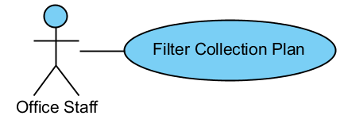

|  |  |  |  |  |
| --- | --- | --- | --- | --- |
| USE CASE – FILTER COLLECTION PLAN SPECIFICATION | | | | |
| Use-case No. | UC06.2 | Use-case Version | | 1.0 |
| Use-case Name | Filter Collection Plan | | | |
| Author | ThanhTV | | | |
| Date | 21/11/2012 | Priority | Normal | |
| **Actor:** Office Staff  **Summary:** This use case is about how office staff filters collection plan.  **Goal:** Office staff can filter collection plan.  **Triggers:** In main page of collection plan, user click “Filter” button.  **Pre-conditions:** User logged in with office staff role.  **Post-conditions:** Collection plan is filtered successfully.  **Main Success Scenario:**   1. In main page of collection plan, user selects conditions (status, start date, end date) and clicks “Filter” button. 2. System will show collection plans tally with conditions.   **Alternative Scenario:** N/A  **Exceptions:** N/A  **Relationships:**  N/A  **Business Rules:** N/A | | | | |

#### Cancel Collection Plan

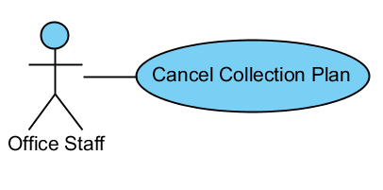

|  |  |  |  |  |
| --- | --- | --- | --- | --- |
| USE CASE – CANCEL COLLECTION PLAN SPECIFICATION | | | | |
| Use-case No. | UC06.3 | Use-case Version | | 1.0 |
| Use-case Name | Cancel Collection Plan | | | |
| Author | ThanhTV | | | |
| Date | 21/11/2012 | Priority | Normal | |
| **Actor:** Office Staff  **Summary:** This use case is about how office staff cancel collection plan.  **Goal:** Office staff can cancel collection plan.  **Triggers:** In Collection Plan Details page, user click “Cancel” button.  **Pre-conditions:** User logged in with office staff role.  **Post-conditions:** Collection plan is canceled successfully.  **Main Success Scenario:**   1. In Collection Plan Details page, user clicks “Cancel” button. 2. System will show a confirm box to confirm again. 3. User clicks “Yes” button to cancel. 4. Plan will be deleted in collection plan list.   **Alternative Scenario:** N/A  **Exceptions:** When status of collection plan is finished, the “Cancel” button will be hidden.  **Relationships:**  N/A  **Business Rules:** N/A | | | | |

#### View Collection Plan Detail

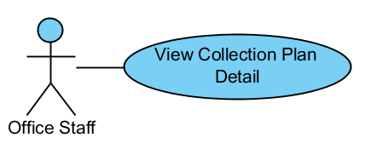

|  |  |  |  |  |
| --- | --- | --- | --- | --- |
| USE CASE – VIEW COLLECTION PLAN DETAIL SPECIFICATION | | | | |
| Use-case No. | UC06.4 | Use-case Version | | 1.0 |
| Use-case Name | View Collection Plan Detail | | | |
| Author | ThanhTV | | | |
| Date | 21/11/2012 | Priority | Normal | |
| **Actor:** Office Staff  **Summary:** This use case is about how to view collection plan detail.  **Goal:** Office staff can view collection plan detail.  **Triggers:** In main page of collection plan, user click “View” icon.  **Pre-conditions:** User logged in with office staff role.  **Post-conditions:** User will view collection plan detail.  **Main Success Scenario:**   1. In main page of collection plan, user clicks “View” icon of plan that user wants to view detail information. 2. System will navigate to “Collection Plan Details” page with all information of that plan.   **Alternative Scenario:** N/A  **Exceptions:** N/A  **Relationships:**  N/A  **Business Rules:** N/A | | | | |

#### Assign

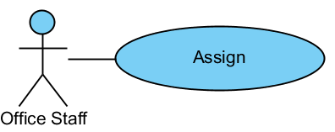

|  |  |  |  |  |
| --- | --- | --- | --- | --- |
| USE CASE – ASSIGN SPECIFICATION | | | | |
| Use-case No. | UC06.5 | Use-case Version | | 1.0 |
| Use-case Name | Assign To Staff | | | |
| Author | ThanhTV | | | |
| Date | 21/11/2012 | Priority | Normal | |
| **Actor:** Office Staff  **Summary:** This use case is about how office staff to assign work to staff.  **Goal:** Office staff can assign work to staff.  **Triggers:** In Collection Plan Details page, user click “Assign” button.  **Pre-conditions:** User logged in with office staff role.  **Post-conditions:** Office staff to assign work to staff.  **Main Success Scenario:**   1. In Collection Plan Details, user clicks “Assign” button. 2. System will show a popup with a dropdown list that list all delivery staff. 3. User selects a staff and clicks OK. 4. Plan will be assigned to that staff.   **Alternative Scenario:** N/A  **Exceptions:** N/A  **Relationships:**  N/A  **Business Rules:** N/A | | | | |

#### Mark as Finished

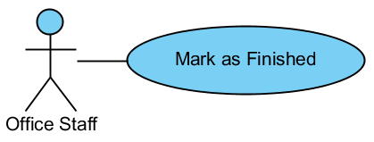

|  |  |  |  |  |
| --- | --- | --- | --- | --- |
| USE CASE – MARK AS FINISHED SPECIFICATION | | | | |
| Use-case No. | UC06.6 | Use-case Version | | 1.0 |
| Use-case Name | Mark as Finished | | | |
| Author | ThanhTV | | | |
| Date | 21/11/2012 | Priority | Normal | |
| **Actor:** Office Staff  **Summary:** This use case is about how mark as finished for collection plan.  **Goal:** Office staff can mark as finished for collection plan.  **Triggers:** In Collection Plan Details page, user click “Mark as Finished” button.  **Pre-conditions:** User logged in with office staff role.  **Post-conditions:** Office staff to mark as finished for collection plan.  **Main Success Scenario:**   1. In Collection Plan Details, user clicks “Mark as Finished” button. 2. Collection plan status will changed to “Finished”.   **Alternative Scenario:** N/A  **Exceptions:** That button will be shown when that collection plan has at least request with status is “collected”.  **Relationships:**  N/A  **Business Rules:** N/A | | | | |

#### Mark Request as Collected

#### C:\Users\Kim\Desktop\Untitled.png

|  |  |  |  |  |
| --- | --- | --- | --- | --- |
| USE CASE – MARK REQUEST AS COLLECTED SPECIFICATION | | | | |
| Use-case No. | UC06.7 | Use-case Version | | 1.0 |
| Use-case Name | Mark Request as Collected | | | |
| Author | ThanhTV | | | |
| Date | 21/11/2012 | Priority | Normal | |
| **Actor:** Office Staff  **Summary:** This use case is about how mark as collected for request.  **Goal:** Office staff can mark as collected request.  **Triggers:** In Collection Plan Details page, user click “Mark as Finished” button.  **Pre-conditions:** User logged in with office staff role.  **Post-conditions:** Office staff to mark as collected for request.  **Main Success Scenario:**   1. In Collection Plan Details, user selects requests which collected complete. 2. User clicks “Mark as Collected” button. 3. Request status will changed to “Collected”.   **Alternative Scenario:** N/A  **Exceptions:** That button will be shown when that collection plan has at least request with status is “Planned For Collecting”.  **Relationships:**  N/A  **Business Rules:** N/A | | | | |

#### Remove Request from Plan

#### 

|  |  |  |  |  |
| --- | --- | --- | --- | --- |
| USE CASE – REMOVE REQUEST FROM PLAN SPECIFICATION | | | | |
| Use-case No. | UC06.8 | Use-case Version | | 1.0 |
| Use-case Name | Remove Request From Plan | | | |
| Author | ThanhTV | | | |
| Date | 21/11/2012 | Priority | Normal | |
| **Actor:** Office Staff  **Summary:** This use case is about how to remove request.  **Goal:** Office staff can remove request.  **Triggers:** In Collection Plan Details page, user click “Remove from Plan” icon of that request.  **Pre-conditions:** User logged in with office staff role.  **Post-conditions:** User will remove request complete.  **Main Success Scenario:**   1. In main page of collection plan, user clicks “View” icon of plan that user wants to view detail information. 2. System will redirect to “Collection Plan Details” page. 3. User click “Remove from Plan” icon of request that user wants remove from plan. 4. System will show a confirm box to confirm again. 5. User clicks “OK” button to remove. 6. Request will be removed from requests list.   **Alternative Scenario:** N/A  **Exceptions:** The “Delete” button will be shown when status of collection plan is “new”.  **Relationships:**  N/A  **Business Rules:** N/A | | | | |

* + - 1. Manage Delivery Plan

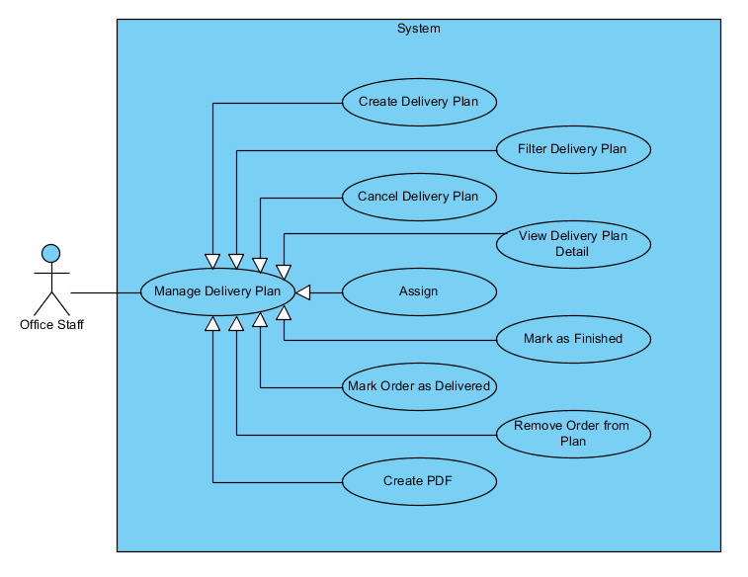

#### Create Delivery Plan

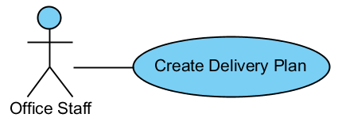

|  |  |  |  |  |
| --- | --- | --- | --- | --- |
| USE CASE - CREATE DELIVERY PLAN SPECIFICATION | | | | |
| Use-case No. | UC07.1 | Use-case Version | | 1.0 |
| Use-case Name | Create Delivery Plan | | | |
| Author | ThanhTV | | | |
| Date | 21/11/2012 | Priority | Normal | |
| **Actor:** Office Staff  **Summary:** This use case is about how office staff creates new delivery plan.  **Goal:** Office staff can create new delivery plan.  **Triggers:** In main page of delivery plan, user click “Add” button.  **Pre-conditions:** User logged in with office staff role.  **Post-conditions:** Delivery plan is created successfully.  **Main Success Scenario:**   1. In main page of delivery plan, user clicks “Add” button. 2. System will redirect to “Create New Delivery Plan” page. 3. User selects city, district and ward to list all orders in that. 4. User clicks to “Add to plan” icon in that orders to add orders to plan and clicks “Create Plan” button. 5. System will redirect to “Delivery Plan Details” page and new delivery plan will appears in delivery plan list.   **Alternative Scenario:**   1. In main page of delivery plan, user clicks “Add” button. 2. System will redirect to “Create New Delivery Plan” page. 3. User clicks “Not Use Map” button to create plan without using map. 4. System will redirect to “Create New Delivery Plan” page that without map. 5. User selects city, district and ward to list all orders in that. 6. User clicks to “Add to plan” icon in that orders to add orders to plan and clicks “Create Plan” button. 7. System will redirect to “Delivery Plan Details” page and new delivery plan will appears in delivery plan list.     **Exceptions:** When inputs require information is invalid format or missed require information, the system will notify and require input again.  **Relationships:**  N/A  **Business Rules:** N/A | | | | |

#### Filter Delivery Plan

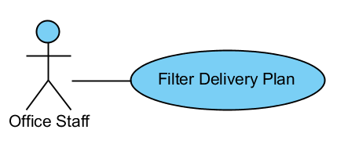

|  |  |  |  |  |
| --- | --- | --- | --- | --- |
| USE CASE – FILTER DELIVERY PLAN SPECIFICATION | | | | |
| Use-case No. | UC07.2 | Use-case Version | | 1.0 |
| Use-case Name | Filter Delivery Plan | | | |
| Author | ThanhTV | | | |
| Date | 21/11/2012 | Priority | Normal | |
| **Actor:** Office Staff  **Summary:** This use case is about how office staff filters delivery plan.  **Goal:** Office staff can filter delivery plan.  **Triggers:** In main page of delivery plan, user click “Filter” button.  **Pre-conditions:** User logged in with office staff role.  **Post-conditions:** Delivery plan is filtered successfully.  **Main Success Scenario:**   1. In main page of delivery plan, user selects conditions (status, start date, end date) and clicks “Filter” button. 2. System will show delivery plans tally with conditions.   **Alternative Scenario:** N/A  **Exceptions:** N/A  **Relationships:**  N/A  **Business Rules:** N/A | | | | |

#### Cancel Delivery Plan

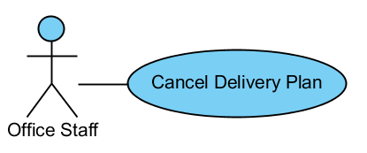

|  |  |  |  |  |
| --- | --- | --- | --- | --- |
| USE CASE – CANCEL DELIVERY PLAN SPECIFICATION | | | | |
| Use-case No. | UC07.3 | Use-case Version | | 1.0 |
| Use-case Name | Cancel Delivery Plan | | | |
| Author | ThanhTV | | | |
| Date | 21/11/2012 | Priority | Normal | |
| **Actor:** Office Staff  **Summary:** This use case is about how office staff cancel delivery plan.  **Goal:** Office staff can cancel delivery plan.  **Triggers:** In Delivery Plan Details page, user click “Cancel” button.  **Pre-conditions:** User logged in with office staff role.  **Post-conditions:** Delivery plan is canceled successfully.  **Main Success Scenario:**   1. In Delivery Plan Details page, user clicks “Cancel” button. 2. System will navigate a confirm box to selects. 3. User clicks “Yes” button to cancel. 4. Plan will be deleted from delivery plan list.   **Alternative Scenario:** N/A  **Exceptions:** When status of delivery plan is finished, the “Cancel” button will be hidden.  **Relationships:**  N/A  **Business Rules:** N/A | | | | |

#### View Delivery Plan Detail

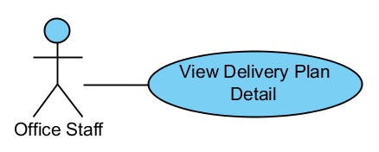

|  |  |  |  |  |
| --- | --- | --- | --- | --- |
| USE CASE – VIEW DELIVERY PLAN DETAIL SPECIFICATION | | | | |
| Use-case No. | UC07.4 | Use-case Version | | 1.0 |
| Use-case Name | View Delivery Plan Detail | | | |
| Author | ThanhTV | | | |
| Date | 21/11/2012 | Priority | Normal | |
| **Actor:** Office Staff  **Summary:** This use case is about how to view delivery plan detail.  **Goal:** Office staff can view delivery plan detail.  **Triggers:** In main page of delivery plan, user click “View” icon.  **Pre-conditions:** User logged in with office staff role.  **Post-conditions:** User will view delivery plan detail.  **Main Success Scenario:**   1. In main page of delivery plan, user clicks “View” icon of plan that user wants to view detail information. 2. System will redirect to “Delivery Plan Details” page with all information of that plan.   **Alternative Scenario:** N/A  **Exceptions:** N/A  **Relationships:**  N/A  **Business Rules:** N/A | | | | |

#### Assign

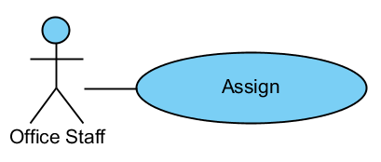

|  |  |  |  |  |
| --- | --- | --- | --- | --- |
| USE CASE – ASSIGN SPECIFICATION | | | | |
| Use-case No. | UC07.5 | Use-case Version | | 1.0 |
| Use-case Name | Assign To Staff | | | |
| Author | ThanhTV | | | |
| Date | 21/11/2012 | Priority | Normal | |
| **Actor:** Office Staff  **Summary:** This use case is about how office staff to assign work to staff.  **Goal:** Office staff can assign work to staff.  **Triggers:** In Delivery Plan Details page, user click “Assign” button.  **Pre-conditions:** User logged in with office staff role.  **Post-conditions:** Office staff to assign work to staff.  **Main Success Scenario:**   1. In Delivery Plan Details, user clicks “Assign” button. 2. System will show a popup with a dropdown list that list all delivery staff. 3. User selects a staff and clicks OK. 4. Plan will be assigned to that staff.   **Alternative Scenario:** N/A  **Exceptions:** N/A  **Relationships:**  N/A  **Business Rules:** N/A | | | | |

#### Mark as Finished

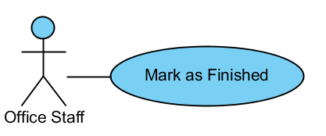

|  |  |  |  |  |
| --- | --- | --- | --- | --- |
| USE CASE – MARK AS FINISHED SPECIFICATION | | | | |
| Use-case No. | UC07.6 | Use-case Version | | 1.0 |
| Use-case Name | Mark as Finished | | | |
| Author | ThanhTV | | | |
| Date | 21/11/2012 | Priority | Normal | |
| **Actor:** Office Staff  **Summary:** This use case is about how to mark as finished for delivery plan.  **Goal:** Office staff can mark as finished for delivery plan.  **Triggers:** In Delivery Plan Details page, user click “Mark as Finished” button.  **Pre-conditions:** User logged in with office staff role.  **Post-conditions:** Office staff to mark as finished for delivery plan.  **Main Success Scenario:**   1. In Delivery Plan Details, user clicks “Mark as Finished” button. 2. Delivery plan status will changed to “Finished”   **Alternative Scenario:** N/A  **Exceptions:** That button will be shown when that delivery plan has at least order with status is “delivered”.  **Relationships:**  N/A  **Business Rules:** N/A | | | | |

#### Mark Order as Delivered

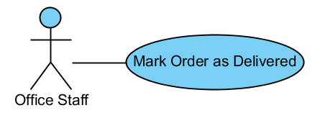

|  |  |  |  |  |
| --- | --- | --- | --- | --- |
| USE CASE – MARK ORDER AS DELIVERED SPECIFICATION | | | | |
| Use-case No. | UC07.7 | Use-case Version | | 1.0 |
| Use-case Name | Mark Order as Delivered | | | |
| Author | ThanhTV | | | |
| Date | 21/11/2012 | Priority | Normal | |
| **Actor:** Office Staff  **Summary:** This use case is about how mark as delivered for order.  **Goal:** Office staff can mark as delivered for order.  **Triggers:** In Delivery Plan Details page, user click “Mark as Delivered” button.  **Pre-conditions:** User logged in with office staff role.  **Post-conditions:** Office staff to mark as delivered for order.  **Main Success Scenario:**   1. In Delivery Plan Details, user selects orders which delivered complete. 2. User click to “Mark as Delivered” button. 3. Order status will changed to “Delivered”.   **Alternative Scenario:** N/A  **Exceptions:** That button will be shown when that delivery plan has at least order with status is “Planned For Delivering”.  **Relationships:**  N/A  **Business Rules:** N/A | | | | |

#### Remove Order from Plan

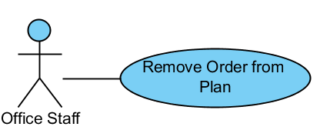

|  |  |  |  |  |
| --- | --- | --- | --- | --- |
| USE CASE – REMOVE ORDER FROM PLAN SPECIFICATION | | | | |
| Use-case No. | UC07.8 | Use-case Version | | 1.0 |
| Use-case Name | Remove Order From Plan | | | |
| Author | ThanhTV | | | |
| Date | 21/11/2012 | Priority | Normal | |
| **Actor:** Office Staff  **Summary:** This use case is about how to remove order.  **Goal:** Office staff can remove order.  **Triggers:** In Delivery Plan Details page, user click “Remove from Plan” icon of that order.  **Pre-conditions:** User logged in with office staff role.  **Post-conditions:** User will remove order completed.  **Main Success Scenario:**   1. In main page of delivery plan, user clicks “View” icon of plan that user wants to view detail information. 2. System will redirect to “Delivery Plan Details” page. 3. User clicks “Remove from Plan” icon of order that user wants to remove from plan. 4. System will show confirm box to confirm again. 5. User clicks “OK” button to remove order. 6. Order will be removed from order list.   **Alternative Scenario:** N/A  **Exceptions:** The “Delete” button will be shown when status of delivery plan is “new”.  **Relationships:**  N/A  **Business Rules:** N/A | | | | |

#### Create PDF

**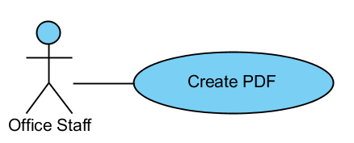**

|  |  |  |  |  |
| --- | --- | --- | --- | --- |
| USE CASE – CREATE PDF SPECIFICATION | | | | |
| Use-case No. | UC07.9 | Use-case Version | | 1.0 |
| Use-case Name | Create PDF | | | |
| Author | ThanhTV | | | |
| Date | 21/11/2012 | Priority | Normal | |
| **Actor:** Office Staff  **Summary:** This use case is about how to create PDF.  **Goal:** Office staff can create PDF.  **Triggers:** In Delivery Plan Details page, user click “Create PDF” button.  **Pre-conditions:** User logged in with office staff role.  **Post-conditions:** User will create PDF completed.  **Main Success Scenario:**   1. In main page of delivery plan, user clicks “View” icon of plan that user wants to view detail information. 2. System will redirect to “Delivery Plan Details” page. 3. User clicks “Create PDF” button. 4. The pdf file that list all order in delivery plan will be created.   **Alternative Scenario:** N/A  **Exceptions:** N/A  **Relationships:**  N/A  **Business Rules:** N/A | | | | |

* + 1. Software System Attributes
       1. Reliability
* The database can be backed up easily and recovered if necessary.
* The system should never crash or hang, except for the cause from an operating system or network error.
* Mean Time Between Failures (MTBF): The acceptable failure is once a year. The failure should not be because of the database, or else the data may be lost and cannot be recovered.
* Mean Time To Repair (MTTR): When the failure occurs, it should take as little time as possible to repair. The acceptable mean time for a particular failure must be less than 8 hours.
* Maximum Bugs or Defect Rate: 05 bugs / KLOC
  + - 1. Availability
* The uptime percentage should be at least 99.95%.
* The acceptable time for maintenance or backup should not be more than 8 hours per month.
* When the system goes in under-maintenance, the website should display a message to inform that.
  + - 1. Security
* Only users with proper account can access certain information of the system. All the information of users must not be available for anyone or software that is not part of the system. User password is also encrypted and not available to the system administrators.
  + - 1. Maintainability
* The code must follow C#.NET coding and naming convention.
* There should be comments in code files that explain the functions of each code segment.
* All the errors should be logged, which supports bug fixing and maintenance.

# Software Design Description

* 1. System Overview

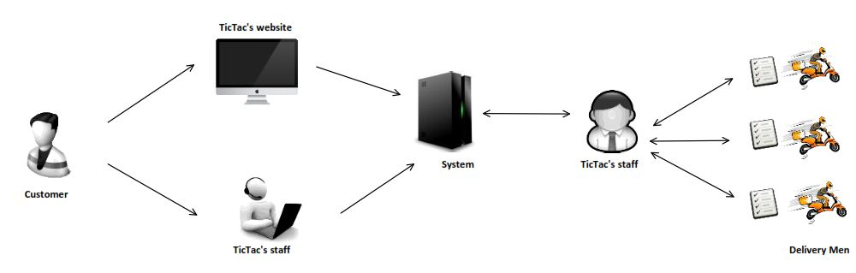

Figure 3 - System Overview

* 1. System Architectural Design
     1. Choice of System Architecture

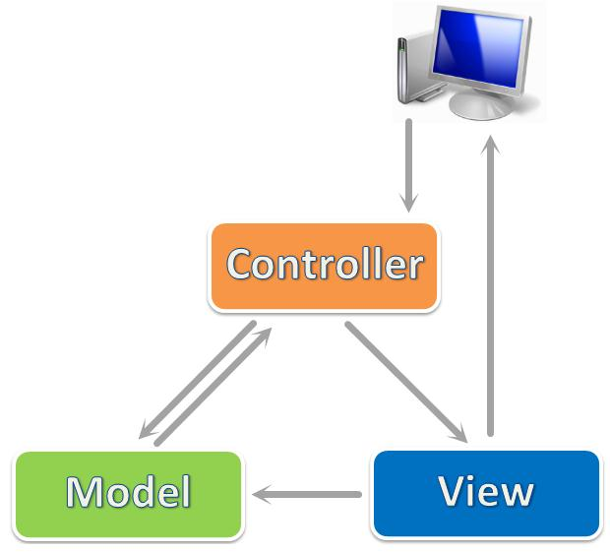

Figure 4 - MVC

We use ASP.NET MVC 3, which is a framework for building scalable, standards-based web applications using well-established design patterns and the power of ASP.NET and the .NET Framework. MVC stands for model-view-controller. MVC is a pattern for developing applications that are well architected and easy to maintain. MVC-based applications contain:

* **View**s are template files that your application uses for dynamically generating HTML responses.
* **Model**s are classes that represent the data of the application and that use validation logic to enforce business rules for that data.
* **Controller**s are classes that handle incoming requests to the application, retrieve model data, and then specify view templates that return a response to the client.
  1. Package Diagram

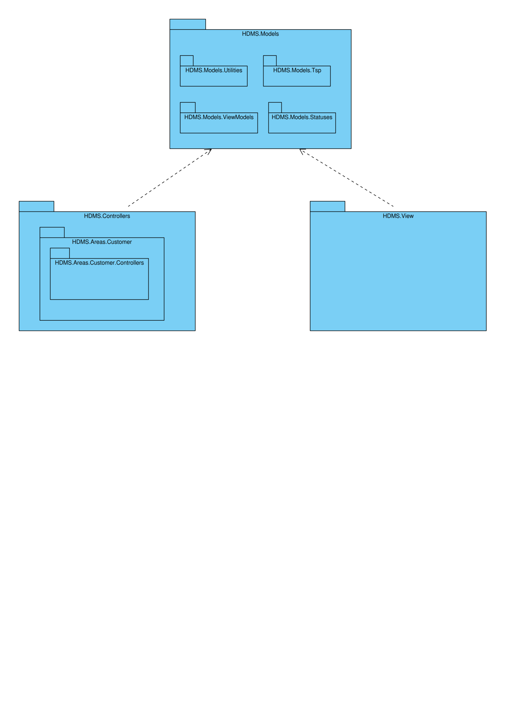

Figure 5 - General Package Diagram

* 1. Classes Detail Description
     1. HDMS.Models Package

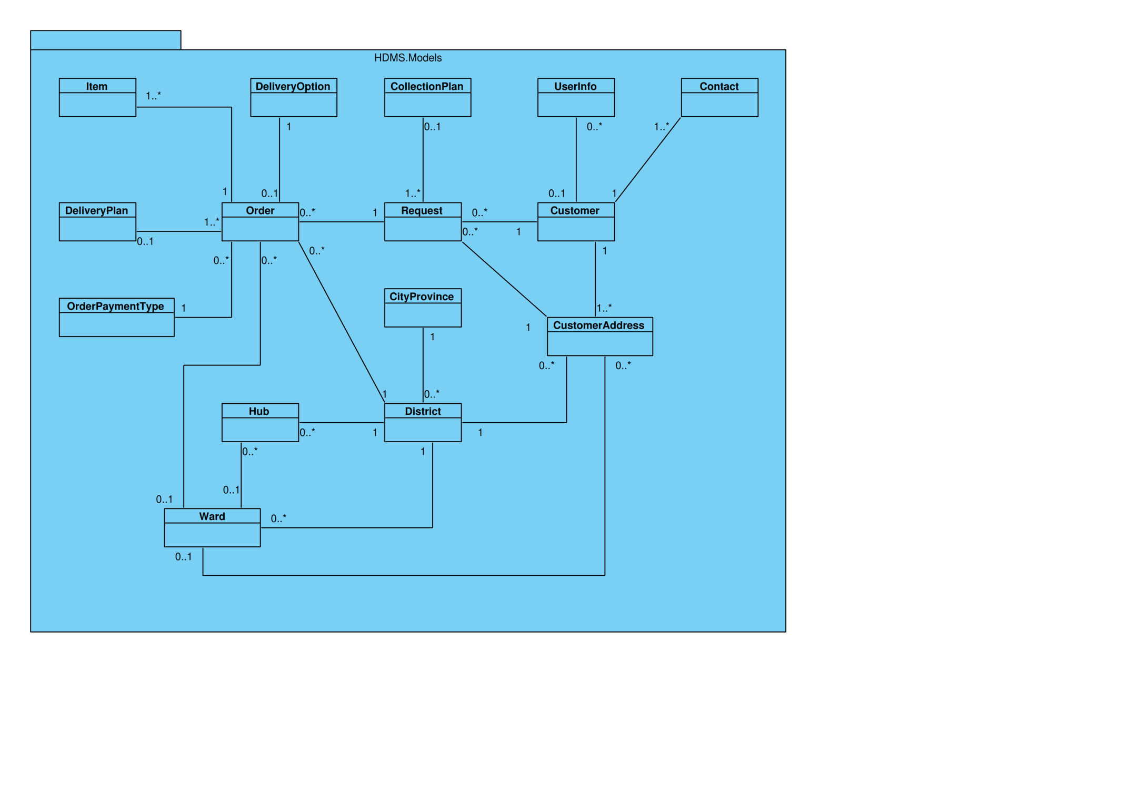

Figure 6 - HDMS.Models Package

#### CityProvince

|  |  |  |
| --- | --- | --- |
| Field | Type | Description |
| CityProvinceId | int | Unique ID of each City/Province |
| Name | string | Name of City/Province |
| IsActive | bool | Status of City/Province |
| Districts | virtual ICollection<District> | Districts associate with each City/Province |

#### Contact

|  |  |  |
| --- | --- | --- |
| Field | Type | Description |
| ContactId | int | Unique ID of each Contact |
| CustomerId | int | ID of Customer associates with Contact |
| Title | string | Title of Contact person |
| Name | string | Name of Contact person |
| Position | string | Position of Contact person |
| EmailAddress | string | Email address of Contact person |
| PhoneNumber | string | Phone number of Contact person |
| IsActive | bool | Status of Contact |
| Customer | virtual Customer | Customer associates with Contact |

#### Customer

|  |  |  |
| --- | --- | --- |
| Field | Type | Description |
| CustomerId | int | Unique ID of each Customer |
| CompanyName | string | Name of Customer’s company |
| DisplayName | string | A more familiar name of Customer’s company |
| PhoneNumber | string | Phone number of Customer |
| CurrentContractNumber | string | Number of current contract with Customer |
| IsActive | bool | Status of Customer |
| Note | string | Optional information |
| Contacts | virtual ICollection<Contact> | Contacts associate with each Customer |
| CustomerAddresses | virtual ICollection<CustomerAddress> | Customer Addresses associate with each Customer |
| Requests | virtual ICollection<Request> | Requests associate with each Customer |
| UserInfoes | virtual ICollection<UserInfo> | UserInfoes associate with each Customer |

#### CustomerAddress

|  |  |  |
| --- | --- | --- |
| Field | Type | Description |
| CustomerAddressId | int | Unique ID of each Customer Address |
| CustomerId | int | ID of Customer associates with Customer Address |
| Address | string | Address and street name |
| WardId | Nullable<int> | ID of Ward associate with Customer Address |
| DistrictId | int | ID of district in each Customer Address |
| Latitude | Nullable<decimal> | Latitude of each Customer Address in the map |
| Longitude | Nullable<decimal> | Longitude of each Customer Address in the map |
| IsActive | bool | Status of Customer Address |
| Note | string | Optional information |
| Customer | virtual Customer | Customer associates with Customer Address |
| Ward | virtual Ward | Ward associates with Customer Address |
| District | virtual District | District associates with Customer Address |
| Requests | virtual ICollection<Request> | Requests associate with each Customer Address |

#### DeliveryOption

|  |  |  |
| --- | --- | --- |
| Field | Type | Description |
| DeliveryOptionId | int | Unique id of each delivery option |
| Name | string | Name of delivery option |
| Description | string | Describe about delivery option |
| IsActive | bool | Status of delivery option |
| Orders | virtual ICollection<Order> | Order associate with delivery option |

#### District

|  |  |  |
| --- | --- | --- |
| Field | Type | Description |
| DistrictId | int | Unique id of each District |
| CityProvinceId | int | Unique id of each City/Province |
| Name | string | Name of District |
| IsActive | bool | Status of District |
| CityProvince | virtual CityProvince | City/province associate with District |
| CustomerAddresses | virtual ICollection<CustomerAddress> | Customer Address associate with District |
| Hubs | virtual ICollection<Hub> | Hubs associate with District |
| Orders | virtual ICollection<Order> | Order associate with District |
| Wards | virtual ICollection<Ward> | Ward associate with District |

#### Hub

|  |  |  |
| --- | --- | --- |
| Field | Type | Description |
| HubId | int | Unique id of each Hub |
| Name | string | Name of each Hub |
| Address | string | Address and street name of each Hub |
| WardId | Nullable<int> | ID of Ward associate with Hub |
| DistrictId | int | ID of district in each Hub |
| Latitude | Nullable<decimal> | Latitude of each Customer Address in the map |
| Longitude | Nullable<decimal> | Longitude of each Customer Address in the map |
| IsActive | bool | Status of Hub |
| District | virtual District | District associates with Hub |
| Ward | virtual Ward | Ward associates with Hub |

#### Item

|  |  |  |
| --- | --- | --- |
| Field | Type | Description |
| ItemId | int | Unique id of each item |
| OrderId | int | Unique id of each order |
| Name | string | Name of items |
| Quantity | int | Quantity of each item |
| IsFragile | bool | It is fragile or not? |
| HasHighValue | bool | It has high value or not? |
| Size | string | Size of item |
| Weight | string | Weight of item |
| Note | string | Comment about items |
| Order | virtual Order | Order associate with item |

#### Order Payment Type

|  |  |  |
| --- | --- | --- |
| Field | Type | Description |
| OrderPaymentTypeId | int | Unique id of each order payment type |
| Name | string | Name of order payment type |
| Description | string | Describe about order payment type |
| IsActive | bool | Status of order payment type |
| Orders | virtual ICollection<Order> | Order associate with order payment type |

#### User Info

|  |  |  |
| --- | --- | --- |
| Field | Type | Description |
| UserId | System.Guid | Unique id of each User |
| FullName | string | Full name of each user |
| Customer | virtual Customer | Customer associate with UserInfo |

#### Ward

|  |  |  |
| --- | --- | --- |
| Field | Type | Description |
| WardId | int | Unique id of each Ward |
| DistrictId | int | Unique id of each District |
| Name | string | Name of Ward |
| IsActive | bool | Status of Ward |
| CustomerAddresses | virtual ICollection<CustomerAddress> | Customer address associate with Ward |
| District | virtual District | District associate with Ward |
| Hubs | virtual ICollection<Hub> | Hubs associate with Ward |
| Orders | virtual ICollection<Order> | Order associate with Ward |

#### Order

|  |  |  |
| --- | --- | --- |
| Field | Type | Description |
| OrderId | int | Unique id of each order |
| RequestId | int | Id of the request that the order belong to |
| DeliveryOptionId | int | Id of the Delivery Option that apply to this order |
| OrderPaymentTypeId | int | Id of the Order Payment Type that apply to this order |
| DeliveryPlanId | Nullable<int> | Id of the Delivery Plan that the order belong to |
| DueDate | Nullable<DateTime> | Deadline for the order to be delivered |
| CollectedDate | Nullable<DateTime> | Date of collection |
| DeliveryDate | Nullable<DateTime> | Date of delivery |
| ReceiverName | string | Name of the receiver |
| ReceiverPhone | string | Phone number of the receiver |
| ReceiverAddress | string | Address of the receiver |
| ReceiverAddressWardId | Nullable<int> | Id of the ward that the receiver address belong to |
| ReceiverAddressDistrictId | int | Id of the district that the receiver address belong to |
| AmountToBeCollectedFromReceiver | int | The amount to be collected from receiver |
| Latitude | Nullable<int> | Latitude of the receiver address |
| Longitude | Nullable<int> | Longitude of the receiver address |
| Fee | Nullable<int> | Amount of fee to be charged for the order |
| OrderStatus | int | Status Id of the order |
| Note | string | Comment about order |
| Request | virtual CollectionRequest | Request associate with order |
| DeliveryPlan | virtual Delivery | Delivery Plan associate with order |
| DeliveryOption | virtual DeliveryOption | Delivery option associate with order |
| Items | virtual ICollection<Item> | Item associate with order |
| Ward | virtual Ward | Ward associate with order |
| District | virtual District | District associate with order |
| OrderPaymentType | virtual OrderPaymentType | Order payment type associate with order |
| Status | OrderStatus | Status of the order |
| FullAddress | string | Full address of the receiver |
| AddToRequest(HDMSEntities context, Request request) | bool | Add the order to a request |
| Approve(HDMSEntities context, DateTime dueDate, int fee) | bool | Approve and set due date, fee to the order |
| Reject(HDMSEntities context) | bool | Reject order |
| Disapprove(HDMSEntities context) | bool | Disapprove order |
| Cancel(HDMSEntities context) | bool | Cancel order |
| Cancel(HDMSEntities context, bool commit) | bool | Cancel order |
| CustomerCancel(HDMSEntities context) | bool | Cancel order by customer |
| CustomerCancel(HDMSEntities context, bool commit) | bool | Cancel order by customer |
| MarkAsCollected(HDMSEntities context) | bool | Mark order as collected |
| MarkAsCollected(HDMSEntities context, bool commit) | bool | Mark order as collected |
| MarkAsDelivered(HDMSEntities context, List<Order> orders) | static bool | Mark orders as delivered |
| MarkAsDelivered(HDMSEntities context) | bool | Mark order as delivered |
| MarkAsDelivered(HDMSEntities context, bool commit) | bool | Mark order as delivered |
| MarkAsReturned(HDMSEntities context) | bool | Mark order as returned |
| AddToDeliveryPlan(HDMSEntities context, DeliveryPlan deliveryPlan) | bool | Add order to delivery plan |
| AddToDeliveryPlan(HDMSEntities context, DeliveryPlan deliveryPlan, bool commit) | bool | Add order to delivery plan |
| Delete(HDMSEntities context) | bool | Delete order |
| Delete(HDMSEntities context, bool commit) | bool | Delete order |
| AddToDeliveryPlan(HDMSEntities context, DeliveryPlan deliveryPlan, List<Order> orders) | static bool | Add orders to delivery plan |
| AddToDeliveryPlan(HDMSEntities context, DeliveryPlan deliveryPlan, List<Order> orders, bool commit) | static bool | Add orders to delivery plan |
| RemoveFromDeliveryPlan(HDMSEntities context, List<Order> orders) | static bool | Remove orders from delivery plan |
| RemoveFromDeliveryPlan(HDMSEntities context) | bool | Remove order from delivery plan |
| RemoveFromDeliveryPlan(HDMSEntities context, bool commit) | bool | Remove order from delivery plan |
| UpdateLocation(HDMSEntities context, decimal latitude, decimal longitude) | bool | Update location of the receiver address |
| BackToDraft(HDMSEntities context) | bool | Switch order back to draft |
| BackToDraft(HDMSEntities context, bool commit) | bool | Switch order back to draft |

#### Request

|  |  |  |
| --- | --- | --- |
| Field | Type | Description |
| RequestId | int | Unique ID of each Request |
| CreatedByUserId | Guid | Id of the user that create the request |
| CustomerId | int | ID of Customer associates with Collection Request |
| CollectionAddressId | int | ID of address where goods will be collected |
| RequestedDate | Nullable<DateTime> | Date Collection Request was created |
| CollectionPlanId | Nullable<int> | ID of Collection Plan associates with Collection Request |
| RequestStatus | int | Status of the Request |
| Note | string | Optional information |
| CollectionPlan | virtual Collection | Collection plan associates with Collection Request |
| Customer | virtual Customer | Customer associates with Collection Request |
| CustomerAddress | virtual CustomerAddress | Customer Address associates with Collection Request |
| Orders | virtual ICollection<Order> | Orders associate with each Collection Request |
| Status | RequestStatus | Status of the Request |
| CollectionAddress | string | Collection address of the request |
| TotalFee | int | Total fee of orders in the request |
| TotalAmountToBeCollected | int | Total amount to collect of orders in the request |
| NumberOfItems | int | Number of items in the request |
| ValidOrders | List<Order> | Valid orders of the request at a specific time |
| AddToCollectionPlan(HDMSEntities context, CollectionPlan collectionPlan, List<Request> requests) | static bool | Add requests to a collection plan |
| AddToCollectionPlan(HDMSEntities context, CollectionPlan collectionPlan, bool commit) | bool | Add request to a collection plan |
| RemoveFromCollectionPlan(HDMSEntities context, List<Request> requests) | static bool | Remove requests from a collection plan |
| RemoveFromCollectionPlan(HDMSEntities context) | bool | Remove request from a collection plan |
| RemoveFromCollectionPlan(HDMSEntities context, bool commit) | bool | Remove request from a collection plan |
| Create(HDMSEntities context) | bool | Create new request |
| Confirm(HDMSEntities context) | bool | Submit request from processing |
| Approve(HDMSEntities context) | bool | Approve request |
| Reject(HDMSEntities context) | bool | Reject request |
| Cancel(HDMSEntities context) | bool | Cancel request |
| Cancel(HDMSEntities context, bool commit) | bool | Cancel request |
| CustomerCancel(HDMSEntities context) | bool | Cancel request by customer |
| CustomerCancel(HDMSEntities context, bool commit) | bool | Cancel request by customer |
| MarkAsCollected(HDMSEntities context, List<Request> requests) | static bool | Mark requests as collected |
| MarkAsCollected(HDMSEntities context) | bool | Mark request as collected |
| MarkAsCollected(HDMSEntities context, bool commit) | bool | Mark request as collected |
| Delete(HDMSEntities context) | bool | Delete request |
| Delete(HDMSEntities context, bool commit) | bool | Delete request |
| BackToDraft(HDMSEntities context) | bool | Switch request back to draft |
| BackToDraft(HDMSEntities context, bool commit) | bool | Switch request back to draft |

#### CollectionPlan

|  |  |  |
| --- | --- | --- |
| Field | Type | Description |
| CollectionPlanId | int | Unique ID of each Collection Plan |
| CreatedDate | DateTime | Date collection was created |
| CreatedByUserId | Guid | ID of User created Collection |
| AssignedDeliveryStaffId | Nullable<Guid> | ID of assigned staff |
| FinishedDate | Nullable<DateTime> | Finished date |
| CollectionPlanStatus | int | Status id of Collection Plan |
| Note | string | Note |
| Requests | virtual ICollection<Request> | Requests that are included in the Collection Plan |
| CollectionOrder | string | Order of the collection locations |
| Status | CollectionPlanStatus | Current status of collection plan |
| CreatedByUserInfo | UserInfo | User that created the collection plan |
| AssignedUserInfo | UserInfo | User that is assigned to the collection plan |
| CreatedByUser | MembershipUser | User that created the collection plan |
| AssignedUser | MembershipUser | User that is assigned to the collection plan |
| Create(HDMSEntities context, int[] requestIds) | bool | Create new Collection Plan |
| Cancel(HDMSEntities context) | bool | Cancel the collection plan |
| MarkAsFinished(HDMSEntities context, bool removeUncollectedRequests) | bool | Mark the collection plan as finished |

#### Delivery Plan

|  |  |  |
| --- | --- | --- |
| Field | Type | Description |
| DeliveryPlanId | int | Unique ID of each Delivery Plan |
| CreatedDate | DateTime | Date delivery was created |
| CreatedByUserId | Guid | ID of User created Delivery |
| AssignedDeliveryStaffId | Nullable<Guid> | ID of assigned staff |
| FinishedDate | Nullable<DateTime> | Finished date |
| DeliveryPlanStatus | int | Status id of Delivery Plan |
| Note | string | Note |
| Orders | virtual ICollection<Order> | Orders that are included in the Delivery Plan |
| DeliveryOrder | string | Order of the delivery locations |
| Status | DeliveryPlanStatus | Current status of delivery plan |
| CreatedByUserInfo | UserInfo | User that created the delivery plan |
| AssignedUserInfo | UserInfo | User that is assigned to the delivery plan |
| CreatedByUser | MembershipUser | User that created the delivery plan |
| AssignedUser | MembershipUser | User that is assigned to the delivery plan |
| Create(HDMSEntities context, int[] orderIds) | bool | Create new Delivery Plan |
| Cancel(HDMSEntities context) | bool | Cancel the delivery plan |
| MarkAsFinished(HDMSEntities context, bool removeUnfinishedOrders) | bool | Mark the delivery plan as finished |
| CalculateRoute(HDMSEntities context) | void | Calculate the optimal route for the delivery plan |
| CalculateRoute(HDMSEntities context, bool commit) | void | Calculate the optimal route for the delivery plan |
| CalculateOrderList(HDMSEntities context, List<Distance> distances, bool commit) | void | Calculate the optimal order of locations for the delivery plan |

* + 1. HDMS.Controllers Package

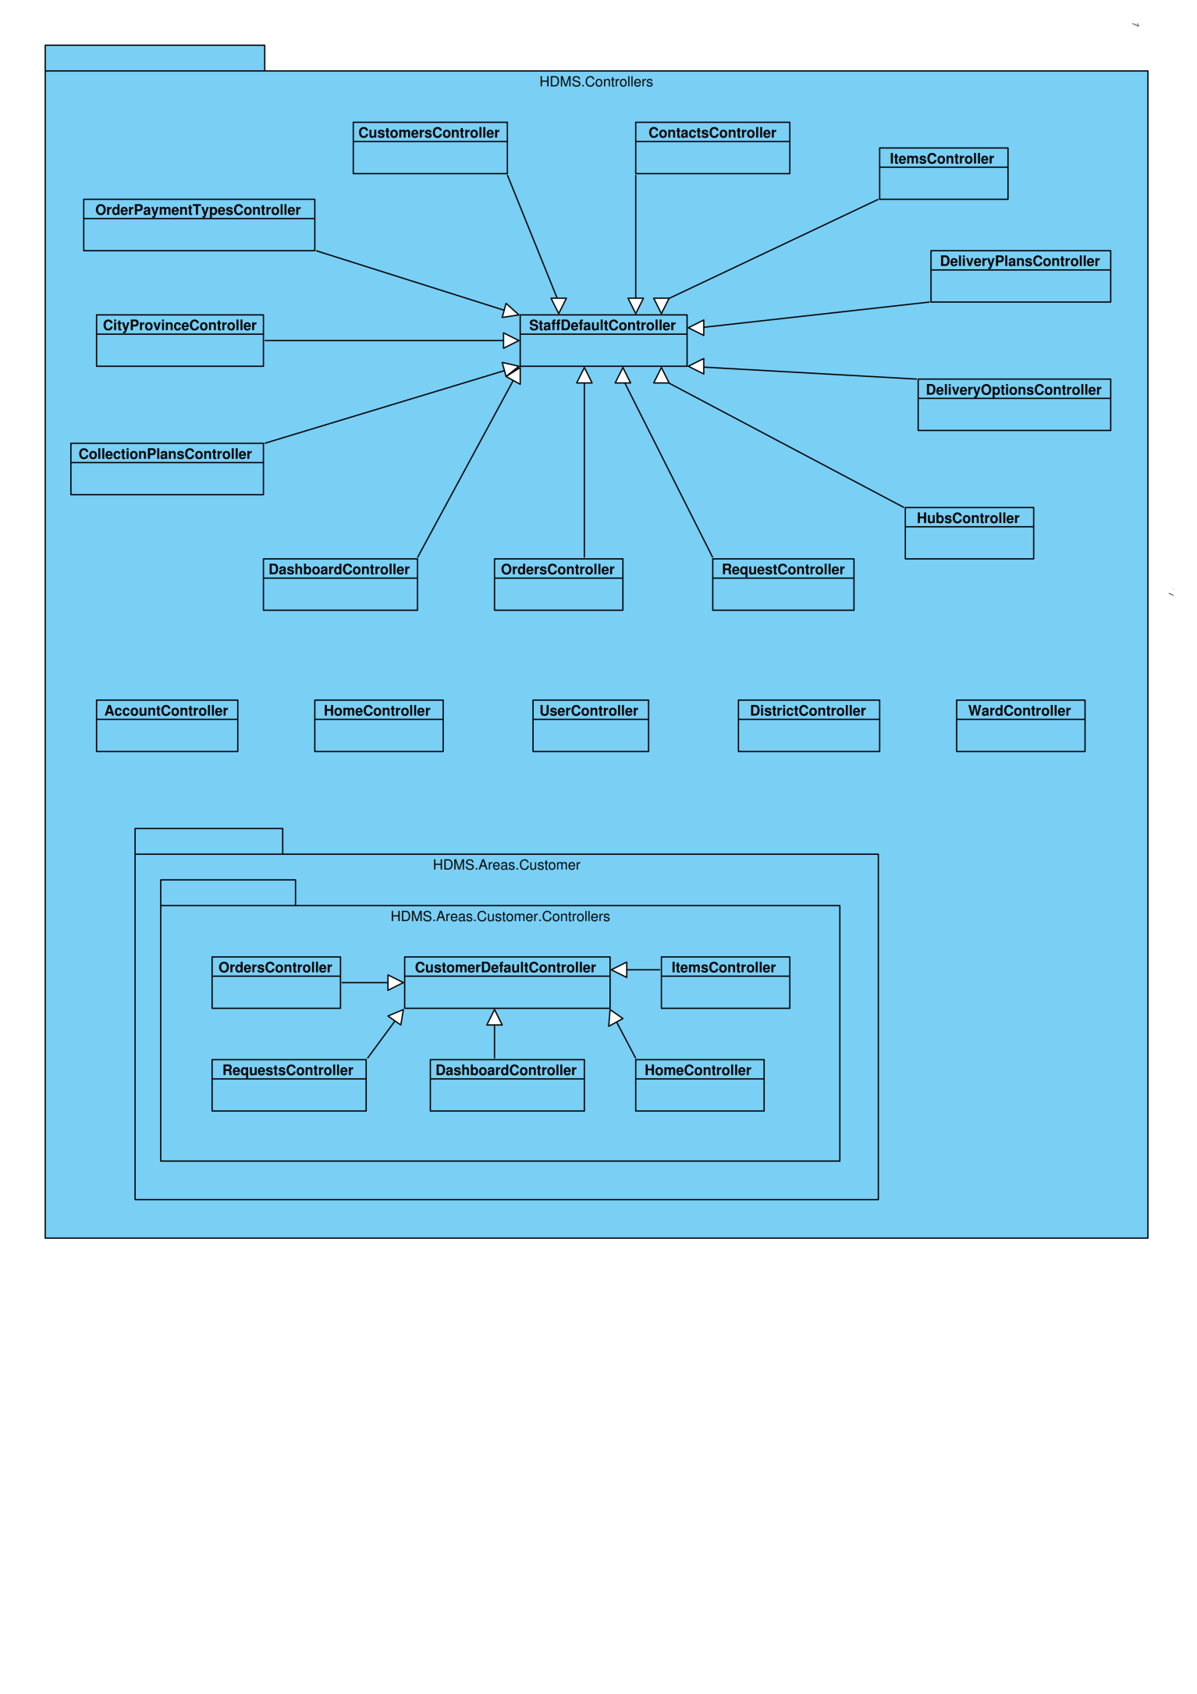

Figure 7 - HDMS.Controllers Package

#### Account controller

|  |  |  |
| --- | --- | --- |
| Method | Return type | Description |
| LogOn() | ActionResult | Display a form for login |
| LogOn(LogOnModel model, string returnUrl) | ActionResult | Allow user to login to system |
| LogOff() | ActionResult | Allow user to logout from system |
| Register() | ActionResult | Display a form for register |
| Register(RegisterModel model) | ActionResult | Allow user to create new account |
| ChangePassword() | ActionResult | Display a form for changing password |
| ChangePassword (ChangePasswordModel model) | ActionResult | Allow user to change their password |
| ChangePasswordSuccess() | ActionResult | Display a form to show that password was change successfully. |
| ErrorCodeToString(MembershipCreateStatus createStatus) | ActionResult | Display a message about creating account unsuccessfully. |

#### CityProvince controller

|  |  |  |
| --- | --- | --- |
| Method | Return type | Description |
| Index() | ViewResult | Display all city/province |
| Details(int id) | ViewResult | Display city/province based on City/Province Id |
| Create() | ActionResult | Display form for creating city/ province |
| ConfirmCreate(CityProvince cityprovince) | ActionResult | Add a city/province to Database |
| Edit(int id) | ActionResult | Display form for editing city/ province |
| ConfirmEdit(CityProvince cityprovince) | ActionResult | Save change of a city/province to Database |
| Remove(int id) | ActionResult | Remove a city/province based on City/Province Id |

***CollectionPlans Controller***

|  |  |  |
| --- | --- | --- |
| Method | Return type | Description |
| Index() | ViewResult | Display all collection plans |
| Details(int id) | ViewResult | Display collection plan based on Collection Plan Id |
| Create() | ActionResult | Display form for creating a collection plan |
| ConfirmCreate() | ActionResult | Add a collection plan to database |
| GetUnplannedRequestsByCityProvince(int id, int[] selectedRequestIds) | ActionResult | Get unplanned request by city/ province |
| GetUnplannedRequestsByDistrict(int id, int[] selectedRequestIds) | ActionResult | Get unplanned request by district |
| GetUnplannedRequestsByWard(int id, int[] selectedRequestIds) | ActionResult | Get unplanned request by ward |
| Assign(int collectionPlanId, Guid staffUserId) | ActionResult | Assign collection plan to Staff for collecting |
| Cancel(int id) | ActionResult | Cancel collection plan |
| MarkAsFinished(int id, bool removeUncollectedRequests) | ActionResult | Mark a collection plan as finished |

#### Create Collection Plan

#### Assign Delivery Staff to Collection Plan

#### Mark Collection Plan as Finished

#### Contact Controller

|  |  |  |
| --- | --- | --- |
| Method | Return type | Description |
| Create() | ActionResult | Display form for creating contact |
| ConfirmCreate(Contact  contact) | ActionResult | Add a contact to Database |
| Edit(int id) | ActionResult | Display form for editing contact |
| ConfirmEdit(Contact  contact) | ActionResult | Save change of a contact to Database |
| Delete(int id) | ActionResult | Display form for deleting contact |
| DeleteConfirmed(int id) | ActionResult | Delete a contact based on Contact Id |
| ToggleActivate(int id) | ActionResult | Change the active status that display on screen. |

#### CustomerAddress controller

|  |  |  |
| --- | --- | --- |
| Method | Return type | Description |
| Details(int id) | ViewResult | Display customer address based on Customer Address Id |
| Create() | ActionResult | Display form for creating customer address |
| ConfirmCreate(CustomerAddress  customeraddress) | ActionResult | Add a customer address to Database |
| Edit(int id) | ActionResult | Display form for editing customer address |
| ConfirmEdit(CustomerAddress  customeraddress) | ActionResult | Save change of a customer address to Database |
| GetAddressesOfCustomer(int id) | ActionResult | Get address of a customer based on Customer Id |
| UpdateLocation(int id, decimal latitude, decimal longitude) | ActionResult | Update location of customer on map. |
| Remove(int id) | ActionResult | Remove an address of customer based on Customer Address Id |

#### CustomerController

|  |  |  |
| --- | --- | --- |
| Method | Return type | Description |
| Index() | ViewResult | Display all customer |
| Details(int id) | ViewResult | Display customer based on Customer Id |
| Create() | ActionResult | Display form for creating customer |
| ConfirmCreate(Customer  customer) | ActionResult | Add a customer to Database |
| Edit(int id) | ActionResult | Display form for editing customer |
| ConfirmEdit(Customer  customer) | ActionResult | Save change of a customer to Database |
| GetAddressTable(int customerId) | ActionResult | Display form for insert customer addresses |
| GetContactTable(int customerId) | ActionResult | Display form for insert customer contacts |
| Remove(int id) | ActionResult | Remove customer based on Customer Id |

#### Create Customers

#### Delete Customer

#### Edit Customer Information

***DashboardController***

|  |  |  |
| --- | --- | --- |
| Method | Return type | Description |
| Index() | ViewResult | Display main page |

#### DeliveryOptionsController

|  |  |  |
| --- | --- | --- |
| Method | Return Type | Description |
| Index() | ViewResult | Display list of delivery options |
| Create() | ActionResult | Display form for create new delivery option |
| ConfirmCreate(DeliveryOption deliveryoption) | ActionResult | Add new delivery option to Database |
| Edit(int id) | ActionResult | Display form for edit delivery option information |
| ConfirmEdit(DeliveryOption deliveryoption) | ActionResult | Add new delivery option information to Database |
| Remove(int id) | ActionResult | Remove delivery option based on Delivery Option Id |

***DeliveryPlansController***

|  |  |  |
| --- | --- | --- |
| Method | Return Type | Description |
| Index() | ViewResult | Display all customer |
| Details(int id) | ViewResult | Display customer based on Customer Id |
| PdfDetails(int id) | ActionResult |  |
| Create() | ActionResult | Display form for create new delivery plan |
| ConfirmCreate(DeliveryOption deliveryoption) | ActionResult | Add new delivery plan to Database |
| Assign(int deliveryPlanId, Guid staffUserId) | ActionResult | Assign plan to staff for delivering |
| GetUnplannedOrdersByCityProvince(int id, int[] selectedOrderIds) | ActionResult | Get unplanned orders by city/province |
| GetUnplannedOrdersByDistrict(int id, int[] selectedOrderIds) | ActionResult | Get unplanned orders by district |
| GetUnplannedOrdersByWard(int id, int[] selectedOrderIds) | ActionResult | Get unplanned orders by ward |
| MarkAsFinished(int id, bool removeUnfinishedOrders) | ActionResult | Mark a collection plan as finished |
| Cancel(int id) | ActionResult | Cancel collection plan |
| RecalculateRoute(int id) | ActionResult | Recalculate the route for delivery plan |

#### Create Delivery Plan

#### Assign Delivery Staff to Delivery Plan

#### Mark Delivery as Finished

#### Create Delivery Plan PDF

#### DistrictController

|  |  |  |
| --- | --- | --- |
| Method | Return Type | Description |
| Index() | ViewResult | Display list of districts |
| Create() | ActionResult | Display form for create new district |
| ConfirmCreate(District district) | ActionResult | Add new district to Database |
| Edit(int id) | ActionResult | Display form for edit district information |
| ConfirmEdit(District district) | ActionResult | Add new district information to Database |
| GetDistrictsOfCityProvince(int id) | ActionResult | Use to get districts of city/province based on City/Province Id |
| Remove(int id) | ActionResult | Remove district based on District Id |

***HomeController***

|  |  |  |
| --- | --- | --- |
| Method | Return type | Description |
| Index() | ViewResult | Redirect to appropriate page |

***HubsController***

|  |  |  |
| --- | --- | --- |
| Method | Return Type | Description |
| Index() | ActionResult | Display list of hubs |
| Create() | ActionResult | Display form for create new hub |
| ConfirmCreate(Hub hub) | ActionResult | Add new hub to database |
| Edit(int id) | ActionResult | Display form for edit hub information |
| ConfirmEdit(Hub hub) | ActionResult | Add new hub’s information to Database |
| UpdateLocation(int id, decimal latitude, decimal longitude) | ActionResult | Update hub’s location |
| Remove(int id) | ActionResult | Remove hub based on hub Id |

#### Create Option

#### Delete Option

#### Edit Option

#### Set Location for Hub

***ItemsController***

|  |  |  |
| --- | --- | --- |
| Method | Return Type | Description |
| Create(int orderId) | ActionResult | Display form for create new item |
| ConfirmCreate(Item item) | ActionResult | Add new item to Database |
| Edit(int id) | ActionResult | Display form for edit |
| ConfirmEdit(Item item) | ActionResult | Update new item’s information to database |
| Cancel(int id) | ActionResult | Cancel this item |

#### Add New Item

#### OrderPaymentTypesController

|  |  |  |
| --- | --- | --- |
| Method | Return Type | Description |
| Index() | ViewResult | Display list of order payment types |
| Create() | ActionResult | Display form for create new order payment type |
| ConfirmCreate(OrderPaymentType orderpaymenttype) | ActionResult | Add new order payment type to Database |
| Edit(int id) | ActionResult | Display form for edit order payment type information |
| ConfirmEdit(OrderPaymentType orderpaymenttype) | ActionResult | Add new order payment type information to Database |
| Remove(int id) | ActionResult | Display form for delete order payment type information |

#### OrdersController

|  |  |  |
| --- | --- | --- |
| Method | Return Type | Description |
| Index() | ActionResult | Display list of orders |
| Details(int id) | ActionResult | Display detail of an order based on Order Id |
| Create(int requestId) | ActionResult | Display form for create new order |
| ConfirmCreate(Order order) | ActionResult | Add new order to database |
| Edit(int id) | ActionResult | Display form for edit order’s information |
| ConfirmEdit(Order order) | ActionResult | Add new order’s information to Database |
| Cancel(int id) | ActionResult | Cancel this order |
| Approve() | ActionResult | Approve this order |
| Reject(int id) | ActionResult | Reject this order |
| Disapprove(int id) | ActionResult | Disapprove this order |
| MarkAsDelivered() | ActionResult | Mark this order as delivered |
| MarkAsReturned(int id) | ActionResult | Mark this order as returned |
| UpdateLocation(int id, decimal latitude, decimal longitude) | ActionResult | Update location of this order |
| RemoveFromDeliveryPlan(int id) | ActionResult | Remove this order from delivery plan |

#### Add New Order

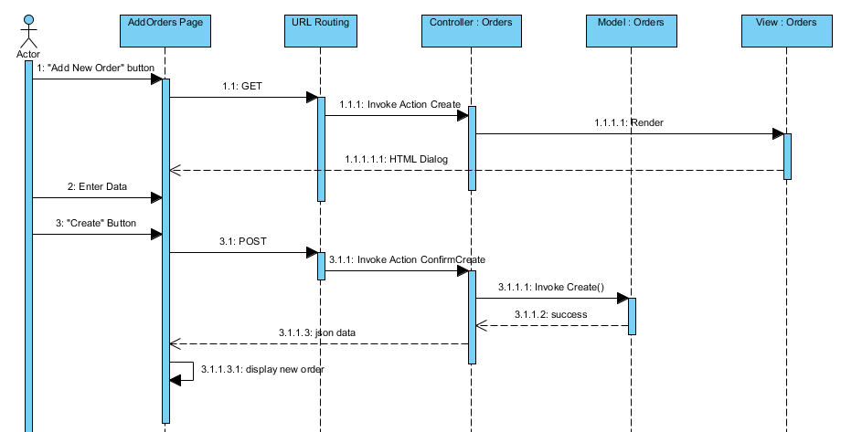

#### Edit Order

#### 

#### Cancel Order

#### Mark Orders As Delivered

#### Mark Order As Returned

***RequestController***

|  |  |  |
| --- | --- | --- |
| Method | Return Type | Description |
| Index() | ViewResult | Display list of requests |
| Details(int id) | ViewResult | Display detail of a request based on Request Id |
| Create(int requestId) | ActionResult | Display form for create new request |
| ConfirmCreate(int CustomerId, int CollectionAddressId, string Note, HttpPostedFileBase excelFile) | ActionResult | Add new request to database |
| AddOrders(int id) | ActionResult | Add Orders to request |
| Submit(int id) | ActionResult | Submit this request |
| RemoveFromDeliveryPlan(int id) | ActionResult | Remove this order from delivery plan |
| GetTotalFee(int id) | ActionResult | Get total fee of this request |
| ApproveOrders(int id) | ActionResult | Approve orders of this request |
| Approve(int id) | ActionResult | Approve this request |
| Reject(int id) | ActionResult | Reject this request |
| Cancel(int id) | ActionResult | Cancel this request |
| MarkAsCollected() | ActionResult | Mark this request as collected |
| UpdateLocation(int id, decimal latitude, decimal longitude) | ActionResult | Update location of this request |

#### Create Request

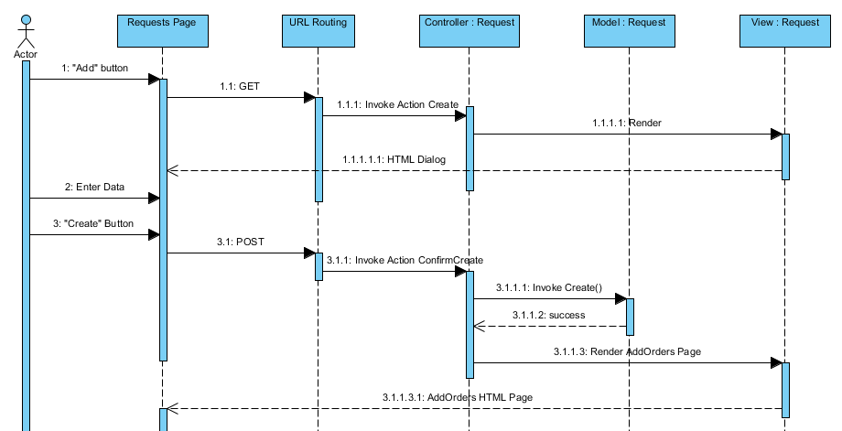

#### Approve Request

#### Reject Request

#### Mark Requests As Collected

#### Cancel Request

***UserController***

|  |  |  |
| --- | --- | --- |
| Method | Return Type | Description |
| Index() | ActionResult | Display users table |
| LoadUser(string searchUser, string roleName, JQueryDataTableParamModel param, bool showDisabledUsers) | ActionResult | List all users based on parameter or list all active user |
| getRoleUserList(string username) | string | Get roles of users |
| getCustomerName(string username) | string | Get customer name of users |
| ResetPassword(string username) | ActionResult | Reset password of this user |
| Update(string username) | ActionResult | Display form for update user role |
| UpdateUserRole(string username) | ActionResult | Update user role |
| DeleteUser(string username, string rolename) | ActionResult | Disable/enable user |

#### WardController

|  |  |  |
| --- | --- | --- |
| Method | Return Type | Description |
| Index() | ViewResult | Display list of wards |
| Create() | ActionResult | Display form for create new ward |
| ConfirmCreate(Ward ward) | ActionResult | Add new ward to Database |
| Edit(int id) | ActionResult | Display form for edit ward information |
| ConfirmEdit(Ward ward) | ActionResult | Add new ward information to Database |
| GetWardsOfDistrict(int id) | ActionResult | Use to get wards of district based on District Id |
| Remove(int id) | ActionResult | Remove this ward |

* 1. State Diagrams
     1. Request State Diagram

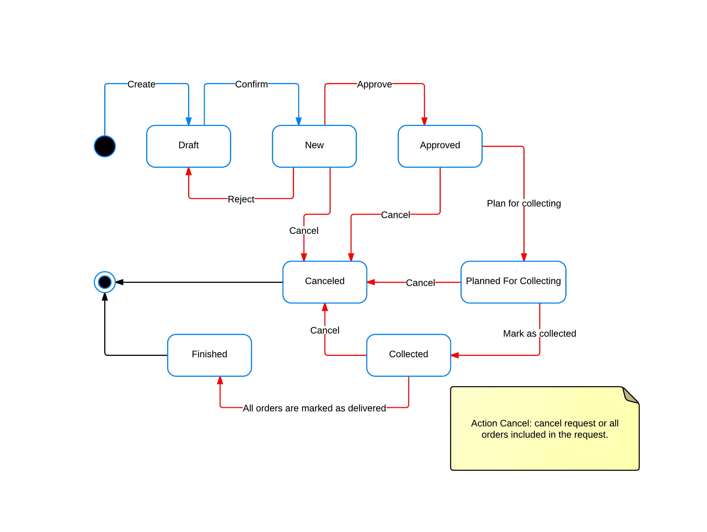

Figure 8 - Request State Diagram

States Description:

* **Draft**: the request is created by customers or staffs but not submitted for processing yet.
* **New**: the request is submitted for processing but not approved by staffs yet.
* **Approved**: the request and all included orders are approved.
* **Planned** **for collecting**: the request is in a collection plan but not collected yet.
* **Collected**: All orders included in the request have been collected to the warehouse.
* **Finished**: All orders included in the request have been processed completely (deliver, return)
* **Canceled**: the request is canceled by customers or staffs and will not continue being processed.
  + 1. Order State Diagram

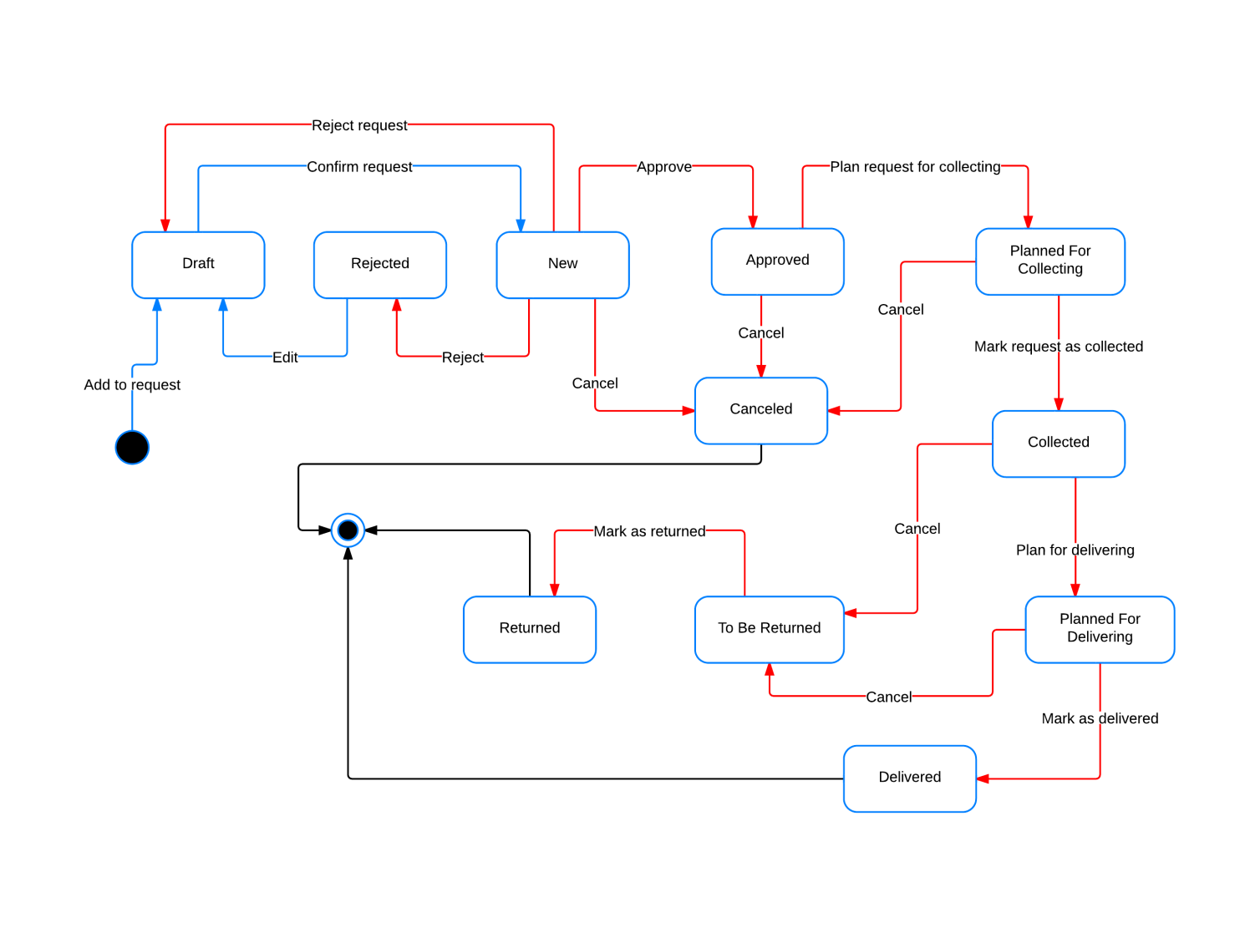

Figure 9 - Order State Diagram

States Description:

* **Draft**: Order is added to a request by customers or staffs but the request is not submitted for processing yet.
* **New**: the request containing the order is submitted for processing but the order is not approved by staffs yet.
* **Approved**: the order is approved, due date and fee have been set.
* **Rejected**: the order is identified as invalid by staffs and rejected.
* **Planned** **for collecting**: the request containing the order is in a collection plan but not collected yet.
* **Collected**: the order has been collected to the warehouse.
* **Planned** **for collecting**: the order is in a delivery plan but not delivered yet.
* **Delivered**: the order has been delivered to the receiver.
* **To be returned**: the order is canceled after collected to the warehouse and needs to be returned to the customer.
* **Returned**: the order has been returned to the customer.
* **Canceled**: the order is canceled by customers or staffs and will not continue being processed.
  1. Algorithms

To help reduce time and fuel cost, the system should find the best route for delivery mans to deliver all packages in a delivery plan. This problem is similar to a common problem named **Traveling Salesman Problem** (<http://en.wikipedia.org/wiki/Travelling_salesman_problem>).

There are many algorithms to solve this problem. In this project, we use a **Genetic Algorithm** published at <http://www.lalena.com/AI/TSP/>.

# Software Test Documentation

* 1. Introduction
     1. System Overview

This document describes the approach and methodologies used by the testing group to plan, organize and manage the testing of this system. It describes implementation details of test cases or technical details of how the product features should work.

The system will be tested is also the system our team are currently developing. This system is developed based on MVC3 framework. It is a website providing Home Delivery service for online and offline shops.

* + 1. Test Approach

The testing for this project will consist of Unit, System/Integration (combined) and Acceptance test levels. It is hoped that there will be at least one full time independent test person for system/integration testing. Most testing will be done by the test lead with the development team’s participation.

Unit Testing will be done by the developers and will be approved by the implementing team leader. All unit test information (sample, output, data printouts, and defect information…) will be managed by developers and it must be showed when team required.

System/Integration Testing will be performed by the test lead and implementing team leader with assistance from the individual developers as required.

Acceptance Testing will be performed by the test lead and development team leader. The acceptance test will be done for a period of 2 weeks after completion of the System/Integration test process. Program will enter into Acceptance test after all critical and major defects have been corrected. A program may have one major defect as long as it does not obstruct testing of the program (There is a work around for the error). Prior to completion of acceptance testing all open critical and major defects must be corrected.

* 1. Test Plan

The following is a list of areas to be focus on during testing of website:

* + 1. Functions

**Login**

Test all functions in Login module including:

* Login
* Logout
* Change Password

**Role ‘Administrator’**

Test all functions of role ‘Administrator’ including:

* Create New Account
* Enable/Disable Account
* Reset Password
* Update Role

**Role ‘Office Staff’**

Test all functions of role ‘Office Staff’ including:

**Request:**

* + - Create New Request
    - Filter Requests
    - Approve Request
    - Add New Order
    - Edit Order
    - Add New Item
    - View Request Details
    - Cancel Request
    - Approve Order
    - Edit Item
    - Cancel Item
    - Reject Request
    - Reject Order

**Order:**

* + - Filter Orders
    - View Order Detail
    - Cancel Order
    - Mark as Returned

**Customers:**

* + - Create Customer
    - Delete Customer
    - View Customer Detail
    - Edit Customer Information
    - Create Customer Address
    - Delete Customer Address
    - Edit Customer Address
    - Create Contact
    - Delete Contact
    - Edit Contact

**Collection Plans:**

* + - Create Collection Plan
    - Filter Collection Plan
    - Cancel Collection Plan
    - View Collection Plan Detail
    - Assign Collection Plan
    - Mark as Finished Collection Plan
    - Mark Request as Collected
    - Remove Request from Plan

**Delivery Plans:**

* + - Create Delivery Plan
    - Filter Delivery Plan
    - Cancel Delivery Plan
    - View Delivery Plan Detail
    - Assign Delivery Plan
    - Mark as Finished Delivery Plan
    - Mark Order as Delivered
    - Remove Order from Plan
    - Create PDF

**Options:**

**Hubs:**

* + - * Create New Hub
      * Edit Hub
      * Delete Hub
      * Set Location

**Order Payment Type:**

* + - * Create New Order Payment Type
      * Edit Order Payment Type
      * Delete Order Payment Type

**Delivery Option:**

* + - * Create New Delivery Option
      * Edit Delivery Option
      * Delete Delivery Option

**City/Province:**

* + - * Create New City/Province
      * Edit City/Province
      * Delete City/Province

**District:**

* + - * Create New District
      * Edit District
      * Delete District

**Ward:**

* + - * Create New Ward
      * Edit Ward
      * Delete Ward

**Role ‘Customer’**

Test all functions of role ‘Customer’ including:

**Request:**

* + - Create New Request
    - Filter Requests
    - Add New Order
    - Edit Order
    - Add New Item
    - View Request Details
    - Cancel Request
    - Edit Item
    - Cancel Item

**Order:**

* + - Filter Orders
    - View Order Detail
    - Cancel Order
    1. Features not to be tested

#### Performance test

There was not enough time so we cannot optimize source code and improve performance. We can only ensure the system work well but not at its best performance.

* + 1. Testing Tools and Environment
* Windows 7 operating system
* Google Chrome 19 or higher
* Microsoft Visual Studio 2010 SP1
* Microsoft SQL Server 2008 R2
  1. Test Cases
     1. Functions
        1. Login

1. **Case – Login**

**Purpose**

Check the authority of user.

**Inputs**

Username

Password

**Expected Output & Pass/Fail criteria**

|  |  |
| --- | --- |
| **Pass** | **Fail** |
| Button menu ‘${username}’ on the top right corner.  Go to the Home Page with all functionalities corresponding to the user’s authority shown on the top. | Message ‘Login was unsuccessful. Please enter your username and password again.’ |

**Test Procedure**

Click ‘Login’ button on the top right corner.

Input username ‘admin’.

Input password ‘admin’.

Click ‘Login’ button.

1. **Case – Logout**

**Purpose**

Check whether user can log out.

**Inputs**

N/A

**Expected Output & Pass/Fail criteria**

|  |  |
| --- | --- |
| **Pass** | **Fail** |
| Back to Home page with ‘Login’ button on top right corner | Cannot go back to Home page |

**Test Procedure**

Click ‘${username}’ button menu.

Click ‘Log out’.

1. **Case – Change Password**

**Purpose**

Check whether user can change password.

**Inputs**

Current password

New password

Confirm new password

**Expected Output & Pass/Fail criteria**

|  |  |
| --- | --- |
| **Pass** | **Fail** |
| Message ‘Your password has been changed successfully’ | Warning of required fields |

**Test Procedure**

Click ‘${username}’ button menu.

Click ‘Change Password’.

Input Current password ‘admin’.

Input New password ‘admin1’.

Input Confirm new password ‘admin1’.

Click ‘Change Password’ button.

* + - 1. Role ‘Administrator’

1. **Case – Create New Account**

**Purpose**

Check whether admin can create new account.

**Inputs**

User name

Full name

Email address

Password

Confirm password

User and Roles

**Expected Output & Pass/Fail criteria**

|  |  |
| --- | --- |
| **Pass** | **Fail** |
| Added Account is displayed in Account list | Warning of required fields  New account is not added to Account list |

**Test Procedure**

Login with ‘Admin’ role

Click ‘Account’ button. System will redirect to ‘Account’ page.

Click ‘Create new Account’ button. System will redirect to ‘Create new Account’ page.

Input User name ‘admin’.

Input Full name ‘Admin’.

Input Email address ‘admin@gmail.com’.

Input Password ‘admin’.

Input Confirm password ‘admin’.

Click Staff.

Click Admin, Office Staff checkbox.

Click ‘Register’ button.

1. **Case – Enable Account**

**Purpose**

Check whether admin can enable account or not

**Inputs**

Nothing

**Expected Output & Pass/Fail criteria**

|  |  |
| --- | --- |
| Pass | Fail |
| Enabled account will be shown again in user’s list | Enabled account was not shown in user’s list |

**Test Procedure**

Login with role “Admin”

Click “Show disabled user” button

Click “Enable” icon of a disabled user

Click “Yes” button to enable

1. **Case – Disable Account**

**Purpose**

Check whether admin can disable account or not

**Inputs**

Nothing

**Expected Output & Pass/Fail criteria**

|  |  |
| --- | --- |
| Pass | Fail |
| Disabled account will be hidden from user’s list | Disabled account still be shown in user’s list |

**Test Procedure**

Login with role “Admin”

Click “Disable” icon of a user

Click “Yes” button to disable

1. **Case – Reset Password**

**Purpose**

Check whether admin reset password or not

**Inputs**

Nothing

**Expected Output & Pass/Fail criteria**

|  |  |
| --- | --- |
| Pass | Fail |
| Password of user will be reset | Password of user will not reset |

**Test Procedure**

Login with role “Admin”

Click “Reset Password” button of a user

Click “Yes” button to enable

1. **Case – Update Role**

**Purpose**

Check whether admin can update account’s role.

**Inputs**

N/A

**Expected Output & Pass/Fail criteria**

|  |  |
| --- | --- |
| **Pass** | **Fail** |
| Updated Account’s role is displayed in Account list | Warning of required fields  New Account information is not updated |

**Test Procedure**

Logged in with ‘Admin’ role

Click ‘Account’ button. System will redirect to ‘Account’ page.

Click ‘Update Role’ icon of account ‘admin’.

Uncheck Office Staff checkbox.

Click ‘Save’ button.

* + - 1. Role ‘Office Staff’

1. **Case – Create New Request**

**Purpose**

Check whether office staff can create new request.

**Inputs**

Customer

Collection Address

Note

**Expected Output & Pass/Fail criteria**

|  |  |
| --- | --- |
| **Pass** | **Fail** |
| Go to ‘Add Order to Request’ page with request’s information displayed in the top  Added Request is displayed in Request list with ‘Draft’ status | Warning of required fields  Cannot go to ‘Add Order to Request’ page  New request is not added to Request list |

**Test Procedure**

Logged in with ‘Office Staff’ role

Click “Request” button. System will redirect to Request page.

In Request page, click ‘Add’ button.

Choose customer ‘ladaza.vn’ from dropdown list.

Choose customer address ‘214 Trần Quang Khải, Phường Tân Định, Quận 1, Thành Phố Hồ Chí Minh’ for ladaza.vn from dropdown list.

Input note ‘Request 1’

Click ‘Create’ button.

1. **Case – Filter Requests**

**Purpose**

Check whether office staff can filter requests.

**Inputs**

Status

Requested date

**Expected Output & Pass/Fail criteria**

|  |  |
| --- | --- |
| **Pass** | **Fail** |
| Requests that have status or requested date will show in request table when filter | Requests is not corresponding to search data |

**Test Procedure**

Logged in with ‘Office Staff’ role

Click “Request” button. System will redirect to Request page.

In Request page, choose request status ‘New’ or requested date from ‘10/10/2012’ to ‘03/12/2012’.

Click ‘Filter’ button.

1. **Case – Approve Request**

**Purpose**

Check whether office staff can approve request.

**Inputs**

Due Date

Fee

**Expected Output & Pass/Fail criteria**

|  |  |
| --- | --- |
| **Pass** | **Fail** |
| Request was approved successfully and request’s status change from ‘New’ to ‘Approved’ | Approve request unsuccessful |

**Test Procedure**

Logged in with ‘Office Staff’ role

Click “Request” button. System will redirect to Request page.

In Request page, click ‘Approve Request’ icon of ‘New’ status. System will redirect to ‘Approve Request’ page.

Input Due Date ’05/12/2012’ and Fee ‘20000’ for Order

Click ‘Approve Order’ icon of Order.

Click ‘Approve Request’ button.

1. **Case – Add New Order**

**Purpose**

Check whether office staff can create new order.

**Inputs**

Receiver Name

Receiver Phone No

Delivery Address

Delivery Option

Payment Type

Amount to collect

Notes

**Expected Output & Pass/Fail criteria**

|  |  |
| --- | --- |
| **Pass** | **Fail** |
| Added Order is displayed in Order list | Warning of required fields  New Order is not added to Order list |

**Test Procedure**

Logged in with ‘Office Staff’ role

Click “Request” button. System will navigate to Request page.

In Request page, click ‘Edit’ icon of ‘Draft’ status. System will redirect to ‘Add Order to Request’ page.

Click ‘Add new Order’ button.

Input Receiver Name ‘Lê Anh Đảo’

Input Receiver Phone No ‘01654123456’.

Choose ‘Thành Phố Hồ Chí Minh’, ‘Quận 1’, ‘Phường Tân Định’ from dropdown list and input address ’15 Lê Duẩn’.

Choose Delivery Option ‘Normal’.

Choose Payment Type ‘COD’.

Input Amount to collected ‘200000’

Input Notes ‘Order 1’.

Click ‘Create’ button.

1. **Case – Edit Order**

**Purpose**

Check whether office staff can update order information.

**Inputs**

Receiver Name

Receiver Phone No

Delivery Address

Delivery Option

Payment Type

Amount to collected

Notes

**Expected Output & Pass/Fail criteria**

|  |  |
| --- | --- |
| **Pass** | **Fail** |
| Updated Order information is displayed in Order list | Warning of required fields  New Order information is not updated |

**Test Procedure**

Logged in with ‘Office Staff’ role

Click “Request” button. System will navigate to Request page.

In Request page, click ‘Edit’ icon of ‘Draft’ status. System will redirect to ‘Add Order to Request’ page.

Click ‘Edit Order’ icon of Order.

Change Receiver Name from ‘Lê Anh Đảo’ to ‘Hồ Hữu Tài’.

Click ‘OK’ button.

1. **Case – Add New Item**

**Purpose**

Check whether office staff can create new item.

**Inputs**

Item

Quantity

Fragile

High Value

Size

Weight

Note

**Expected Output & Pass/Fail criteria**

|  |  |
| --- | --- |
| **Pass** | **Fail** |
| Added Item is displayed in Item list | Warning of required fields  New Item is not added to Item list |

**Test Procedure**

Logged in with ‘Office Staff’ role

Click “Request” button. System will navigate to Request page.

In Request page, click ‘Edit’ icon of ‘Draft’ status. System will redirect to ‘Add Order to Request’ page.

Click ‘Add new Item’ icon of Order.

Input Name ‘Chuột quang’.

Input Quantity ‘5’

Check Fragile.

Check High Value.

Input Size ‘100x200x300 mm’

Input Weight ‘500g’

Input Note ‘Item 1’

Click ‘Create’ button.

1. **Case – View Request Detail**

**Purpose**

Check whether office staff can view request information.

**Inputs**

N/A

**Expected Output & Pass/Fail criteria**

|  |  |
| --- | --- |
| **Pass** | **Fail** |
| Go to ‘Request Details’ page with all request, order, item information of that request | Cannot go to ‘Request Details’ page |

**Test Procedure**

Logged in with ‘Office Staff’ role

Click “Request” button. System will redirect to Request page.

In Request page, click ‘View’ icon of Request.

1. **Case – Cancel Request**

**Purpose**

Check whether office staff can cancel request.

**Inputs**

N/A

**Expected Output & Pass/Fail criteria**

|  |  |
| --- | --- |
| **Pass** | **Fail** |
| Confirmation dialog with message ‘Are you sure to cancel/delete this request’  Request status change to ‘Canceled’ | Request status don’t change to ‘Canceled’ |

**Test Procedure**

Logged in with ‘Office Staff’ role

Click “Request” button. System will redirect to Request page.

In Request page, click ‘Cancel’ icon of Request.

Click ‘OK’ button.

1. **Case – Approve Order**

**Purpose**

Check whether office staff can approve order.

**Inputs**

Due Date

Fee

**Expected Output & Pass/Fail criteria**

|  |  |
| --- | --- |
| **Pass** | **Fail** |
| Order was approved successfully | Approve order unsuccessful |

**Test Procedure**

Logged in with ‘Office Staff’ role

Click “Request” button. System will redirect to Request page.

In Request page, click ‘Approve Request’ icon of ‘New’ status. System will redirect to ‘Approve Request’ page.

Input Due Date ’05/12/2012’ and Fee ‘20000’ for Order

Click ‘Approve Order’ icon of Order.

1. **Case – Edit Item**

**Purpose**

Check whether office staff can update item information.

**Inputs**

Item

Quantity

Fragile

High Value

Size

Weight

Note

**Expected Output & Pass/Fail criteria**

|  |  |
| --- | --- |
| **Pass** | **Fail** |
| Updated Item information is displayed in Item list | Warning of required fields  New Item information is not updated |

**Test Procedure**

Logged in with ‘Office Staff’ role

Click “Request” button. System will navigate to Request page.

In Request page, click ‘Edit’ icon of ‘Draft’ status. System will redirect to ‘Add Order to Request’ page.

Click ‘Edit’ icon of Item.

Change Item from ‘Chuột quang’ to ‘Chuột thường’.

Click ‘OK’ button.

1. **Case – Cancel Item**

**Purpose**

Check whether office staff can delete item.

**Inputs**

N/A

**Expected Output & Pass/Fail criteria**

|  |  |
| --- | --- |
| **Pass** | **Fail** |
| Confirmation dialog with message ‘Are you sure to cancel/delete this item’  Item is deleted from Item list | Deleted Item is still displayed in Item list |

**Test Procedure**

Logged in with ‘Office Staff’ role

Click “Request” button. System will navigate to Request page.

In Request page, click ‘Edit’ icon of ‘Draft’ status. System will redirect to ‘Add Order to Request’ page.

Click ‘Delete’ icon of Item.

Click ‘OK’ button.

1. **Case – Reject Request**

**Purpose**

Check whether office staff can reject request.

**Inputs**

N/A

**Expected Output & Pass/Fail criteria**

|  |  |
| --- | --- |
| **Pass** | **Fail** |
| Confirmation dialog with message ‘Reject this request’  Request status change to ‘Draft’  Order status change to ‘Draft’ | Request status don’t change to ‘Draft’  Order status don’t change to ‘Draft’ |

**Test Procedure**

Logged in with ‘Office Staff’ role

Click ‘Request’ button. System will redirect to Request page.

In Request page, click ‘Approve Request’ icon of ‘New’ status. System will redirect to ‘Approve Request’ page.

Click ‘Disapprove order’ icon of Order and click ‘OK’ button on message box.

Click ‘Reject Request’ button.

Click ‘OK’ button.

1. **Case – Reject Order**

**Purpose**

Check whether office staff can reject order.

**Inputs**

N/A

**Expected Output & Pass/Fail criteria**

|  |  |
| --- | --- |
| **Pass** | **Fail** |
| Confirmation dialog with message ‘Disapprove this order’  Order status change to ‘Rejected’ | Order status don’t change to ‘Rejected’ |

**Test Procedure**

Logged in with ‘Office Staff’ role

Click ‘Request’ button. System will redirect to Request page.

In Request page, click ‘Approve Request’ icon of ‘New’ status. System will redirect to ‘Approve Request’ page.

Click ‘Disapprove order’ icon of Order.

Click ‘OK’ button.

1. **Case – Filter Orders**

**Purpose**

Check whether office staff can filter orders.

**Inputs**

N/A

**Expected Output & Pass/Fail criteria**

|  |  |
| --- | --- |
| **Pass** | **Fail** |
| Orders that have status or requested date will show in order table when filter | Orders is not corresponding to search data |

**Test Procedure**

Logged in with ‘Office Staff’ role

Click “Order” button. System will redirect to Order page.

In Order page, choose order status ‘New’ or requested date from ‘10/10/2012’ to ‘03/12/2012’.

Click ‘Filter’ button.

1. **Case – View Order Detail**

**Purpose**

Check whether office staff can view order information.

**Inputs**

N/A

**Expected Output & Pass/Fail criteria**

|  |  |
| --- | --- |
| **Pass** | **Fail** |
| Go to ‘Order Details’ page with all order, item information of that order | Cannot go to ‘Order Details’ page |

**Test Procedure**

Logged in with ‘Office Staff’ role

Click “Order” button. System will redirect to Order page.

In Order page, click ‘View’ icon of Order.

1. **Case – Cancel Order**

**Purpose**

Check whether office staff can delete order.

**Inputs**

N/A

**Expected Output & Pass/Fail criteria**

|  |  |
| --- | --- |
| **Pass** | **Fail** |
| Confirmation dialog with message ‘Are you sure to cancel/delete this order’  Order is deleted from Order list | Deleted Order is still displayed in Order list |

**Test Procedure**

Logged in with ‘Office Staff’ role

Click “Request” button. System will navigate to Request page.

In Request page, click ‘Edit’ icon of ‘Draft’ status. System will redirect to ‘Add Order to Request’ page.

Click ‘Cancel Order’ icon of Order.

Click ‘OK’ button.

1. **Case – Mark as Returned**

**Purpose**

Check whether office staff can mark as returned for order.

**Inputs**

N/A

**Expected Output & Pass/Fail criteria**

|  |  |
| --- | --- |
| **Pass** | **Fail** |
| Order status change to ‘Returned’ | Order status don’t change to ‘Returned’ |

**Test Procedure**

Logged in with ‘Office Staff’ role

Click “Order” button. System will redirect to Order page.

In Order page, click ‘Mark as Returned’ icon of ‘To Be Returned’ status.

1. **Case – Create Customer**

**Purpose**

Check whether office staff can create new customer.

**Inputs**

Company Name

Display Name

Phone Number

Current Contract Code

Note

**Expected Output & Pass/Fail criteria**

|  |  |
| --- | --- |
| **Pass** | **Fail** |
| Added Customer is displayed in Customer list | Warning of required fields  New customer is not added to Customer list |

**Test Procedure**

Logged in with ‘Office Staff’ role

Click “Customer” button. System will redirect to Customer page.

In Customer page, click ‘Add’ button.

Input Company Name ‘Lazada Việt Nam’.

Input Display Name ‘lazada.vn’.

Input Phone Number ‘0836265724’

Input Current Contract Code ‘5yh7j2f’.

Input Note ‘Customer 1’

Click ‘Create’ button.

1. **Case – View Customer Detail**

**Purpose**

Check whether office staff can view customer information.

**Inputs**

N/A

**Expected Output & Pass/Fail criteria**

|  |  |
| --- | --- |
| **Pass** | **Fail** |
| Go to ‘Customer Details’ page with all information of that customer | Cannot go to ‘Customer Details’ page |

**Test Procedure**

Logged in with ‘Office Staff’ role

Click “Customer” button. System will redirect to Customer page.

In Customer page, click ‘View Details’ icon of Company Name ‘Lazada Việt Nam’.

1. **Case – Edit Customer Information**

**Purpose**

Check whether office staff can update customer information.

**Inputs**

Company Name

Display Name

Phone Number

Current Contract Code

Note

**Expected Output & Pass/Fail criteria**

|  |  |
| --- | --- |
| **Pass** | **Fail** |
| Updated Customer information is displayed in Customer list | Warning of required fields  New Customer information is not updated |

**Test Procedure**

Logged in with ‘Office Staff’ role

Click “Customer” button. System will redirect to Customer page.

In Customer page, click ‘View Details’ icon of Company Name ‘Lazada Việt Nam’. System will redirect to ‘Customer Details’ page.

Click ‘Edit’ icon in Customer Information area.

Change Display Name from ‘lazada.vn’ to ‘lazada.com’.

Click ‘Save’ button.

1. **Case – Delete Customer**

**Purpose**

Check whether office staff can delete customer.

**Inputs**

N/A

**Expected Output & Pass/Fail criteria**

|  |  |
| --- | --- |
| **Pass** | **Fail** |
| Confirmation dialog with message ‘Are you sure to delete this customer’  Customer is deleted from Customer list | Deleted Customer is still displayed in Customer list |

**Test Procedure**

Logged in with ‘Office Staff’ role

Click “Customer” button. System will redirect to Customer page.

In Customer page, click ‘View Details’ icon of Company Name ‘Lazada Việt Nam’. System will redirect to ‘Customer Details’ page.

Click ‘Delete Customer’ icon in Customer Information area.

Click ‘OK’ button.

1. **Case – Create Customer Address**

**Purpose**

Check whether office staff can create new customer address.

**Inputs**

City/Province

District

Ward

Address

**Expected Output & Pass/Fail criteria**

|  |  |
| --- | --- |
| **Pass** | **Fail** |
| Added Address is displayed in Address list | Warning of required fields  New address is not added to Address list |

**Test Procedure**

Logged in with ‘Office Staff’ role

Click “Customer” button. System will redirect to Customer page.

In Customer page, click ‘View Details’ icon of Company Name ‘Lazada Việt Nam’. System will redirect to ‘Customer Details’ page.

Click ‘Add’ button in Addresses area.

Choose City/Province ‘Thành Phố Hồ Chí Minh’.

Choose District ‘Quận 1’.

Choose Ward ‘Phường Tân Định’.

Input Address ‘214 Trần Quang Khải’

Click ‘Create’ button.

1. **Case – Edit Customer Address**

**Purpose**

Check whether office staff can create edit customer address information.

**Inputs**

City/Province

District

Ward

Address

**Expected Output & Pass/Fail criteria**

|  |  |
| --- | --- |
| **Pass** | **Fail** |
| Updated Address information is displayed in Address list | Warning of required fields  New Address information is not updated |

**Test Procedure**

Logged in with ‘Office Staff’ role

Click “Customer” button. System will redirect to Customer page.

In Customer page, click ‘View Details’ icon of Company Name ‘Lazada Việt Nam’. System will redirect to ‘Customer Details’ page.

Click ‘Edit’ icon of Address ‘214 Trần Quang Khải, Phường Tân Định, Quận 1, Thành Phố Hồ Chí Minh’.

Change Address from ‘214 Trần Quang Khải’ to ‘73/15 Hoàng Diệu’

Click ‘Save’ button.

1. **Case – Delete Customer Address**

**Purpose**

Check whether office staff can delete customer address.

**Inputs**

N/A

**Expected Output & Pass/Fail criteria**

|  |  |
| --- | --- |
| **Pass** | **Fail** |
| Confirmation dialog with message ‘Delete this address’  Address is deleted from Address list | Deleted Address is still displayed in Address list |

**Test Procedure**

Logged in with ‘Office Staff’ role

Click “Customer” button. System will redirect to Customer page.

In Customer page, click ‘View Details’ icon of Company Name ‘Lazada Việt Nam’. System will redirect to ‘Customer Details’ page.

Click ‘Delete’ icon of Address ‘73/15 Hoàng Diệu, Phường Tân Định, Quận 1, Thành Phố Hồ Chí Minh’.

Click ‘OK’ button.

1. **Case – Create Contact**

**Purpose**

Check whether office staff can create new customer contact.

**Inputs**

Title

Full Name

Position

Email Address

Phone Number

**Expected Output & Pass/Fail criteria**

|  |  |
| --- | --- |
| **Pass** | **Fail** |
| Added Contact is displayed in Contact list | Warning of required fields  New contact is not added to Contact list |

**Test Procedure**

Logged in with ‘Office Staff’ role

Click “Customer” button. System will redirect to Customer page.

In Customer page, click ‘View Details’ icon of Company Name ‘Lazada Việt Nam’. System will redirect to ‘Customer Details’ page.

Click ‘Add’ button in Contacts area.

Choose Title ‘Ms.’.

Input Full Name ‘Hoàng Thị Tố Như’

Input Position ‘Logistics Manager’.

Input Email Address ‘nhu@lazada.vn’.

Input Phone Number ‘0938532546’

Click ‘Create’ button.

1. **Case – Edit Contact**

**Purpose**

Check whether office staff can create edit customer contact information.

**Inputs**

Title

Full Name

Position

Email Address

Phone Number

**Expected Output & Pass/Fail criteria**

|  |  |
| --- | --- |
| **Pass** | **Fail** |
| Updated Contact information is displayed in Contact list | Warning of required fields  New Contact information is not updated |

**Test Procedure**

Logged in with ‘Office Staff’ role

Click “Customer” button. System will redirect to Customer page.

In Customer page, click ‘View Details’ icon of Company Name ‘Lazada Việt Nam’. System will redirect to ‘Customer Details’ page.

Click ‘Edit’ icon of Contact Name ‘Hoàng Thị Tố Như’.

Change Email Address from ‘nhu@lazada.vn’ to ‘nhu@lazada.com’.

Click ‘Save’ button.

1. **Case – Delete Contact**

**Purpose**

Check whether office staff can delete customer contact.

**Inputs**

N/A

**Expected Output & Pass/Fail criteria**

|  |  |
| --- | --- |
| **Pass** | **Fail** |
| Confirmation dialog with message ‘Delete this contact’  Contact is deleted from Contact list | Deleted Contact is still displayed in Contact list |

**Test Procedure**

Logged in with ‘Office Staff’ role

Click “Customer” button. System will redirect to Customer page.

In Customer page, click ‘View Details’ icon of Company Name ‘Lazada Việt Nam’. System will redirect to ‘Customer Details’ page.

Click ‘Delete’ icon of Contact Name ‘Hoàng Thị Tố Như’.

Click ‘OK’ button.

1. **Case – Create Collection Plan**

**Purpose**

Check whether user can create new collection plan or not

**Inputs**

City/Province

District

Ward

Staff

**Expected Output & Pass/Fail criteria**

|  |  |
| --- | --- |
| Pass | Fail |
| New Collection Plan is displayed in Collection Plan list | New Collection Plan is not added to the list |

**Test Procedure**

Login with role “Office Staff”

Go to Collection Plan page

Click “Add” button

Select City/Province is “Thành Phố Hồ Chí Minh”

Select District is “All Districts”

Select Ward is “All Wards”

Click “Add to plan” icon

Click “Create Plan” button

Click “Assign to staff” icon

Select staff is “vuph”

Click “Save” button

1. **Case – Filter Collection Plan**

**Purpose**

Check whether user can filter collection plans or not

**Inputs**

Begin Date

End Date

**Expected Output & Pass/Fail criteria**

|  |  |
| --- | --- |
| Pass | Fail |
| Collection Plan which want to see, is displayed in Collection Plan list | Collection Plan which want to see, is not displayed in Collection Plan list |

**Test Procedure**

Login with role “Office Staff”

Go to Collection Plan page

Select “New” and “Finished” status

Input Begin Date is “1/12/2012”

Input End Date is “3/12/2012”

Click “Filter” button

1. **Case – Cancel Collection Plan**

**Purpose**

Check whether user can cancel collection plan or not

**Inputs**

Nothing

**Expected Output & Pass/Fail criteria**

|  |  |
| --- | --- |
| Pass | Fail |
| Canceled Collection Plan is removed from Collection Plan list | Canceled Collection Plan is not removed from Collection Plan list |

**Test Procedure**

Login with role “Office Staff”

Go to Collection Plan page

Click “View” icon

Click “Cancel Plan” button

Click “OK” button

1. **Case – View Collection Plan Detail**

**Purpose**

Check whether user can view collection plan or not

**Inputs**

Nothing

**Expected Output & Pass/Fail criteria**

|  |  |
| --- | --- |
| Pass | Fail |
| Collection Plan is viewed complete | Collection Plan is not viewed complete |

**Test Procedure**

Login with role “Office Staff”

Go to Collection Plan page

Click “View” icon a request

1. **Case – Assign Collection Plan**

**Purpose**

Check whether user can assign to staff or not

**Inputs**

Staff

**Expected Output & Pass/Fail criteria**

|  |  |
| --- | --- |
| Pass | Fail |
| Staff is assigned complete | Staff is not assigned complete |

**Test Procedure**

Login with role “Office Staff”

Go to Collection Plan page

Click “View” icon

“Assign to staff” icon

Select Staff is “binhhn”

Click “Save” button

1. **Case – Mark as Finished Collection Plan**

**Purpose**

Check whether user can mark as finished or not

**Inputs**

Nothing

**Expected Output & Pass/Fail criteria**

|  |  |
| --- | --- |
| Pass | Fail |
| Collection Plan is marked as finished | Collection Plan is not marked as finished |

**Test Procedure**

Login with role “Office Staff”

Go to Collection Plan page

Click “View” icon

Click “Mark as Finished”

1. **Case – Mark Request as Collected**

**Purpose**

Check whether user can mark request as collected or not

**Inputs**

Request

**Expected Output & Pass/Fail criteria**

|  |  |
| --- | --- |
| Pass | Fail |
| Request is marked as collected | Request is not marked as collected |

**Test Procedure**

Login with role “Office Staff”

Go to Collection Plan page

Click “View” icon

Select checkbox of requests which want to marked

Click “Mark as Collected” button

1. **Case – Remove Request from Plan**

**Purpose**

Check whether user can remove request from plan or not

**Inputs**

Nothing

**Expected Output & Pass/Fail criteria**

|  |  |
| --- | --- |
| Pass | Fail |
| Deleted Request is not display in Request list of that Collection Plan | Deleted Request is still display in Request list of that Collection Plan |

**Test Procedure**

Login with role “Office Staff”

Go to Collection Plan page

Click “View” icon of a collection plan

Click “Remove from Plan” icon of that request

Click “OK” button to remove

1. **Case – Create Delivery Plan**

**Purpose**

Check whether user can create new delivery plan or not

**Inputs**

City/Province

District

Ward

Staff

**Expected Output & Pass/Fail criteria**

|  |  |
| --- | --- |
| Pass | Fail |
| New Delivery Plan is displayed in Collection Plan list | New Delivery Plan is not displayed in Collection Plan list |

**Test Procedure**

Login with role “Office Staff”

Go to Delivery Plan page

Click “Add” button

Select City/Province is “Thành Phố Hồ Chí Minh”

Select District is “All Districts”

Select Ward is “All Wards”

Click “Add to plan” icon

Click “Create Plan” button

Click “Assign to staff” icon

Select staff is “vuph”

Click “Save” button

1. **Case – Filter Delivery Plan**

**Purpose**

Check whether user can filter delivery plans or not

**Inputs**

Begin Date

End Date

**Expected Output & Pass/Fail criteria**

|  |  |
| --- | --- |
| Pass | Fail |
| Delivery Plan which want to see, is displayed in Delivery Plan list | Delivery Plan which want to see, is not displayed in Delivery Plan list |

**Test Procedure**

Login with role “Office Staff”

Go to Delivery Plan page

Select “New” and “Finished” status

Input Begin Date is “1/12/2012”

Input End Date is “3/12/2012”

Click “Filter” button

1. **Case – Cancel Delivery Plan**

**Purpose**

Check whether user can cancel delivery plan or not

**Inputs**

Nothing

**Expected Output & Pass/Fail criteria**

|  |  |
| --- | --- |
| Pass | Fail |
| Canceled Delivery Plan is removed from Delivery Plan list | Canceled Delivery Plan is not removed from Delivery Plan list |

**Test Procedure**

Login with role “Office Staff”

Go to Delivery Plan page

Click “View” icon

Click “Cancel Plan” button

Click “OK” button

1. **Case – View Delivery Plan Detail**

**Purpose**

Check whether user can view delivery plan or not

**Inputs**

Nothing

**Expected Output & Pass/Fail criteria**

|  |  |
| --- | --- |
| Pass | Fail |
| Delivery Plan is viewed complete | Delivery Plan is not viewed complete |

**Test Procedure**

Login with role “Office Staff”

Go to Delivery Plan page

Click “View” icon of an order

1. **Case – Assign Delivery Plan**

**Purpose**

Check whether user can assign to staff or not

**Inputs**

Staff

**Expected Output & Pass/Fail criteria**

|  |  |
| --- | --- |
| Pass | Fail |
| Staff is assigned complete | Staff is not assigned complete |

**Test Procedure**

Login with role “Office Staff”

Go to Delivery Plan page

Click “View” icon

“Assign to staff” icon

Select Staff is “tandhd”

Click “Save” button

1. **Case – Mark as Finished Delivery Plan**

**Purpose**

Check whether user can mark as finished or not

**Inputs**

Nothing

**Expected Output & Pass/Fail criteria**

|  |  |
| --- | --- |
| Pass | Fail |
| Delivery Plan is marked as finished | Delivery Plan is not marked as finished |

**Test Procedure**

Login with role “Office Staff”

Go to Delivery Plan page

Click “View” icon

Click “Mark as Finished”

1. **Case – Mark Order as Delivered**

**Purpose**

Check whether user can mark order as delivered or not

**Inputs**

Order

**Expected Output & Pass/Fail criteria**

|  |  |
| --- | --- |
| Pass | Fail |
| Order is marked as delivered | Order is not marked as delivered |

**Test Procedure**

Login with role “Office Staff”

Go to Delivery Plan page

Click “View” icon

Select checkbox of order which want to marked

Click “Mark as Delivered” button

1. **Case – Remove Order from Plan**

**Purpose**

Check whether user can remove order from plan or not

**Inputs**

Nothing

**Expected Output & Pass/Fail criteria**

|  |  |
| --- | --- |
| Pass | Fail |
| Deleted Order is not display in Order list of that Delivery Plan | Deleted Order is still display in Order list of that Delivery Plan |

**Test Procedure**

Login with role “Office Staff”

Go to Delivery Plan page

Click “View” icon of a delivery plan

Click “Remove from Plan” icon of that order

Click “OK” button to remove

1. **Case – Create New Hub**

**Purpose**

Check whether user can create new hub or not

**Inputs**

Name

City/Province

District

Ward

Address

**Expected Output & Pass/Fail criteria**

|  |  |
| --- | --- |
| Pass | Fail |
| New Hub is displayed in Hub list | Warning of required fields  New Hub is not added to the list |

**Test Procedure**

Login with role “Office Staff”

Go to Hub page

Click “Add” button

Input Name is “Warehouse”

Select City/Province is “Thành Phố Hồ Chí Minh”

Select District is “Quận 1”

Select Ward is “Phường Tân Định”

Input Address is “123 Hai Bà Trưng”

Click “Create” button

1. **Case – Edit Hub**

**Purpose**

Check whether user can edit hub or not

**Inputs**

Name

City/Province

District

Ward

Address

**Expected Output & Pass/Fail criteria**

|  |  |
| --- | --- |
| Pass | Fail |
| Updated Hub is displayed in Hub list | Warning of required fields |

**Test Procedure**

Login with role “Office Staff”

Go to Hub page

Click “Edit” icon of that hub

Input Name is “Warehouse 1”

Select City/Province is “Thành Phố Hồ Chí Minh”

Select District is “Quận 1”

Select Ward is “Phường Đa Kao”

Input Address is “123 Đồng Khởi”

Click “Create” button

1. **Case – Set Location**

**Purpose**

Check whether user can set location of hub or not

**Inputs**

Nothing

**Expected Output & Pass/Fail criteria**

|  |  |
| --- | --- |
| Pass | Fail |
| Set Location for Hub is completed | Set Location for Hub is not completed |

**Test Procedure**

Login with role “Office Staff”

Go to Hubs page

Move Location icon of Warehouse in the map to correct address

Click “Set Location” icon of Warehouse

Click “Confirm Set Location” icon to confirm

1. **Case – Delete Hub**

**Purpose**

Check whether user can delete hub or not

**Inputs**

Nothing

**Expected Output & Pass/Fail criteria**

|  |  |
| --- | --- |
| Pass | Fail |
| Confirmation dialog with message “Are you sure to delete this customer payment type?”  Deleted Customer Payment Type is not displayed in Customer Payment Type list | Deleted Customer Payment Type is still displayed in Customer Payment Type list |

**Test Procedure**

Login with role “Office Staff”

Go to Hub page

Click “Delete” icon of that Customer Payment Type

Click ‘OK’ button on confirmation dialog

1. **Case – Create New Order Payment Type**

**Purpose**

Check whether user can create new order payment type or not

**Inputs**

Payment Type

Description

**Expected Output & Pass/Fail criteria**

|  |  |
| --- | --- |
| Pass | Fail |
| New Order Payment Type is displayed in Order Payment Type list | Warning of required fields  New Order Payment Type is not added to the list |

**Test Procedure**

Login with role “Office Staff”

Go to Order Payment Types page

Click “Add” button

Input Payment Type is “Unlimited”

Input Description is “test”

Click “Create” button

1. **Case – Edit Order Payment Type**

**Purpose**

Check whether user can edit order payment type or not

**Inputs**

Payment Type

Description

**Expected Output & Pass/Fail criteria**

|  |  |
| --- | --- |
| Pass | Fail |
| Updated Order Payment Type is displayed in Order Payment Type list | Warning of required fields |

**Test Procedure**

Login with role “Office Staff”

Go to Order Payment Types page

Click “Edit” icon of that Order Payment Type

Input Payment Type is “Unlimited edited”

Input Description is “edited”

Click “Save” button

1. **Case – Delete Order Payment Type**

**Purpose**

Check whether user can delete order payment type or not

**Inputs**

Nothing

**Expected Output & Pass/Fail criteria**

|  |  |
| --- | --- |
| Pass | Fail |
| Confirmation dialog with message “Are you sure to delete this order payment type?”  Deleted Order Payment Type is not displayed in Order Payment Type list | Deleted Order Payment Type is still displayed in Order Payment Type list |

**Test Procedure**

Login with role “Office Staff”

Go to Order Payment Type page

Click “Delete” icon of that Order Payment Type

Click ‘OK’ button on confirmation dialog

1. **Case – Create New Delivery Option**

**Purpose**

Check whether user can create new delivery option or not

**Inputs**

Delivery Option

Description

**Expected Output & Pass/Fail criteria**

|  |  |
| --- | --- |
| Pass | Fail |
| New Delivery Option is displayed in Delivery Option list | Warning of required fields  New Delivery Option is not added to the list |

**Test Procedure**

Login with role “Office Staff”

Go to Delivery Options page

Click “Add” button

Input Delivery Options is “Unlimited”

Input Description is “test”

Click “Create” button

1. **Case – Edit Delivery Option**

**Purpose**

Check whether user can edit delivery option or not

**Inputs**

Delivery Option

Description

**Expected Output & Pass/Fail criteria**

|  |  |
| --- | --- |
| Pass | Fail |
| Updated Delivery Option is displayed in Delivery Option list | Warning of required fields |

**Test Procedure**

Login with role “Office Staff”

Go to Delivery Options page

Click “Edit” icon of that Delivery Option

Input Delivery Options is “Unlimited edited”

Input Description is “edited”

Click “Save” button

1. **Case – Delete Delivery Option**

**Purpose**

Check whether user can delete delivery option or not

**Inputs**

Nothing

**Expected Output & Pass/Fail criteria**

|  |  |
| --- | --- |
| Pass | Fail |
| Confirmation dialog with message “Are you sure to delete this delivery option?”  Deleted Delivery Option is not displayed in Delivery Option list | Deleted Delivery Option is still displayed in Delivery Option list |

**Test Procedure**

Login with role “Office Staff”

Go to Delivery Options page

Click “Delete” icon of that Delivery Option

Click ‘OK’ button on confirmation dialog

1. **Case – Create New City/Province**

**Purpose**

Check whether user can create new city/province or not

**Inputs**

Name

**Expected Output & Pass/Fail criteria**

|  |  |
| --- | --- |
| Pass | Fail |
| New City/Province is displayed in City/Province list | Warning of required fields  New City/Province is not added to the list |

**Test Procedure**

Login with role “Office Staff”

Go to City/Provinces page

Click “Add” button

Input Name is “Hà Nội”

Click “Create” button

1. **Case – Edit City/Province**

**Purpose**

Check whether user can edit city/province or not

**Inputs**

Name

**Expected Output & Pass/Fail criteria**

|  |  |
| --- | --- |
| Pass | Fail |
| Updated City/Province is displayed in City/Provinces list | Warning of required fields |

**Test Procedure**

Login with role “Office Staff”

Go to City/Provinces page

Click “Edit” icon of that City/Province

Input Name is “Hà Nội edited”

Click “Save” button

1. **Case – Delete City/Province**

**Purpose**

Check whether user can delete city/province or not

**Inputs**

Nothing

**Expected Output & Pass/Fail criteria**

|  |  |
| --- | --- |
| Pass | Fail |
| Confirmation dialog with message “Are you sure to delete this city/province?”  Deleted City/Province is not displayed in City/Province list | Deleted City/Province is still displayed in City/Provinces list |

**Test Procedure**

Login with role “Office Staff”

Go to City/Provinces page

Click “Delete” icon of that City/Provinces

Click ‘OK’ button on confirmation dialog

1. **Case – Create New District**

**Purpose**

Check whether user can create new district or not

**Inputs**

City/Province

Name

**Expected Output & Pass/Fail criteria**

|  |  |
| --- | --- |
| Pass | Fail |
| New District is displayed in District list | Warning of required fields  New District is not added to the list |

**Test Procedure**

Login with role “Office Staff”

Go to Districts page

Click “Add” button

Input City/Province is “Hà Nội”

Input Name is “Ba Đình”

Click “Create” button

1. **Case – Edit District**

**Purpose**

Check whether user can edit district or not

**Inputs**

City/Province

Name

**Expected Output & Pass/Fail criteria**

|  |  |
| --- | --- |
| Pass | Fail |
| Updated District is displayed in District list | Warning of required fields |

**Test Procedure**

Login with role “Office Staff”

Go to District page

Click “Edit” icon of that District

Input City/Province is “Hà Nội edited”

Input Name is “Ba Đình edited”

Click “Save” button

1. **Case – Delete District**

**Purpose**

Check whether user can delete district or not

**Inputs**

Nothing

**Expected Output & Pass/Fail criteria**

|  |  |
| --- | --- |
| Pass | Fail |
| Confirmation dialog with message “Are you sure to delete this district?”  Deleted District is not displayed in District list | Deleted District is still displayed in Districts list |

**Test Procedure**

Login with role “Office Staff”

Go to Districts page

Click “Delete” icon of that Districts

Click ‘OK’ button on confirmation dialog

1. **Case – Create New Ward**

**Purpose**

Check whether user can create new ward or not

**Inputs**

City/Province

District

Name

**Expected Output & Pass/Fail criteria**

|  |  |
| --- | --- |
| Pass | Fail |
| New Ward is added to the list | Warning of required fields  New Ward is not added to the list |

**Test Procedure**

Login with role “Office Staff”

Go to Wards page

Click “Add” button

Input City/Province is “Hà Nội”

Input District is “Ba Đình”

Input Name is “Ba Thôn”

Click “Create” button

1. **Case – Edit Ward**

**Purpose**

Check whether user can edit ward or not

**Inputs**

City/Province

District

Name

**Expected Output & Pass/Fail criteria**

|  |  |
| --- | --- |
| Pass | Fail |
| Updated Ward is displayed in District list | Warning of required fields |

**Test Procedure**

Login with role “Office Staff”

Go to Wards page

Click “Add” button

Input City/Province is “Hà Nội edited”

Input District is “Ba Đình edited”

Input Name is “Ba Thôn edited”

Click “Save” button

1. **Case – Delete Ward**

**Purpose**

Check whether user can delete ward or not

**Inputs**

Nothing

**Expected Output & Pass/Fail criteria**

|  |  |
| --- | --- |
| Pass | Fail |
| Confirmation dialog with message “Are you sure to delete this district?”  Deleted District is not displayed in District list | Deleted District is still displayed in Districts list |

**Test Procedure**

Login with role “Office Staff”

Go to Wards page

Click “Delete” icon of that Wards

Click ‘OK’ button on confirmation dialog

1. **Case – Create PDF**

**Purpose**

Check whether user can create PDF or not

**Inputs**

Nothing

**Expected Output & Pass/Fail criteria**

|  |  |
| --- | --- |
| Pass | Fail |
| Export PDF file of delivery plan | Cannot export PDF file of delivery plan |

**Test Procedure**

Login with role “Office Staff”

Go to Delivery Plan page

Click “View” icon of a delivery plan

Click “Create PDF” button

* + - 1. Role ‘Customer’

1. **Case – Create New Request**

**Purpose**

Check whether customer can create new request.

**Inputs**

Collection Address

Note

**Expected Output & Pass/Fail criteria**

|  |  |
| --- | --- |
| **Pass** | **Fail** |
| Go to ‘Add Order to Request’ page with request’s information displayed in the top  Added Request is displayed in Request list with ‘Draft’ status | Warning of required fields  Cannot go to ‘Add Order to Request’ page  New request is not added to Request list |

**Test Procedure**

Logged in with ‘Customer’ role

Click “Request” button. System will redirect to Request page.

In Request page, click ‘Add’ button.

Choose customer address ‘214 Trần Quang Khải, Phường Tân Định, Quận 1, Thành Phố Hồ Chí Minh’ from dropdown list.

Input note ‘Request 1’

Click ‘Create’ button.

1. **Case – Filter Requests**

**Purpose**

Check whether customer can filter requests.

**Inputs**

Status

Requested date

**Expected Output & Pass/Fail criteria**

|  |  |
| --- | --- |
| **Pass** | **Fail** |
| Requests that have status or requested date will show in request table when filter | Requests is not corresponding to search data |

**Test Procedure**

Logged in with ‘Customer’ role

Click “Request” button. System will redirect to Request page.

In Request page, choose request status ‘New’ or requested date from ‘10/10/2012’ to ‘03/12/2012’.

Click ‘Filter’ button.

1. **Case – Add New Order**

**Purpose**

Check whether customer can create new order.

**Inputs**

Receiver Name

Receiver Phone No

Delivery Address

Delivery Option

Payment Type

Amount to collect

Notes

**Expected Output & Pass/Fail criteria**

|  |  |
| --- | --- |
| **Pass** | **Fail** |
| Added Order is displayed in Order list | Warning of required fields  New Order is not added to Order list |

**Test Procedure**

Logged in with ‘Customer’ role

Click “Request” button. System will navigate to Request page.

In Request page, click ‘Edit’ icon of ‘Draft’ status. System will redirect to ‘Add Order to Request’ page.

Click ‘Add new Order’ button.

Input Receiver Name ‘Lê Anh Đảo’

Input Receiver Phone No ‘01654123456’.

Choose ‘Thành Phố Hồ Chí Minh’, ‘Quận 1’, ‘Phường Tân Định’ from dropdown list and input address ’15 Lê Duẩn’.

Choose Delivery Option ‘Normal’.

Choose Payment Type ‘COD’.

Input Amount to collected ‘200000’

Input Notes ‘Order 1’.

Click ‘Create’ button.

1. **Case – Edit Order**

**Purpose**

Check whether customer can update order information.

**Inputs**

Receiver Name

Receiver Phone No

Delivery Address

Delivery Option

Payment Type

Amount to collected

Notes

**Expected Output & Pass/Fail criteria**

|  |  |
| --- | --- |
| **Pass** | **Fail** |
| Updated Order information is displayed in Order list | Warning of required fields  New Order information is not updated |

**Test Procedure**

Logged in with ‘Customer’ role

Click “Request” button. System will navigate to Request page.

In Request page, click ‘Edit’ icon of ‘Draft’ status. System will redirect to ‘Add Order to Request’ page.

Click ‘Edit Order’ icon of Order.

Change Receiver Name from ‘Lê Anh Đảo’ to ‘Hồ Hữu Tài’.

Click ‘OK’ button.

1. **Case – Add New Item**

**Purpose**

Check whether customer can create new item.

**Inputs**

Item

Quantity

Fragile

High Value

Size

Weight

Note

**Expected Output & Pass/Fail criteria**

|  |  |
| --- | --- |
| **Pass** | **Fail** |
| Added Item is displayed in Item list | Warning of required fields  New Item is not added to Item list |

**Test Procedure**

Logged in with ‘Customer’ role

Click “Request” button. System will navigate to Request page.

In Request page, click ‘Edit’ icon of ‘Draft’ status. System will redirect to ‘Add Order to Request’ page.

Click ‘Add new Item’ icon of Order.

Input Name ‘Chuột quang’.

Input Quantity ‘5’

Check Fragile.

Check High Value.

Input Size ‘100x200x300 mm’

Input Weight ‘500g’

Input Note ‘Item 1’

Click ‘Create’ button.

1. **Case – View Request Detail**

**Purpose**

Check whether customer can view request information.

**Inputs**

N/A

**Expected Output & Pass/Fail criteria**

|  |  |
| --- | --- |
| **Pass** | **Fail** |
| Go to ‘Request Details’ page with all request, order, item information of that request | Cannot go to ‘Request Details’ page |

**Test Procedure**

Logged in with ‘Customer’ role

Click “Request” button. System will redirect to Request page.

In Request page, click ‘View’ icon of Request.

1. **Case – Cancel Request**

**Purpose**

Check whether customer can cancel request.

**Inputs**

N/A

**Expected Output & Pass/Fail criteria**

|  |  |
| --- | --- |
| **Pass** | **Fail** |
| Confirmation dialog with message ‘Are you sure to cancel/delete this request’  Request status change to ‘Canceled’ | Request status don’t change to ‘Canceled’ |

**Test Procedure**

Logged in with ‘Customer’ role

Click “Request” button. System will redirect to Request page.

In Request page, click ‘Cancel’ icon of Request.

Click ‘OK’ button.

1. **Case – Edit Item**

**Purpose**

Check whether customer can update item information.

**Inputs**

Item

Quantity

Fragile

High Value

Size

Weight

Note

**Expected Output & Pass/Fail criteria**

|  |  |
| --- | --- |
| **Pass** | **Fail** |
| Updated Item information is displayed in Item list | Warning of required fields  New Item information is not updated |

**Test Procedure**

Logged in with ‘Customer’ role

Click “Request” button. System will navigate to Request page.

In Request page, click ‘Edit’ icon of ‘Draft’ status. System will redirect to ‘Add Order to Request’ page.

Click ‘Edit’ icon of Item.

Change Item from ‘Chuột quang’ to ‘Chuột thường’.

Click ‘OK’ button.

1. **Case – Cancel Item**

**Purpose**

Check whether customer can delete item.

**Inputs**

N/A

**Expected Output & Pass/Fail criteria**

|  |  |
| --- | --- |
| **Pass** | **Fail** |
| Confirmation dialog with message ‘Are you sure to cancel/delete this item’  Item is deleted from Item list | Deleted Item is still displayed in Item list |

**Test Procedure**

Logged in with ‘Customer’ role

Click “Request” button. System will navigate to Request page.

In Request page, click ‘Edit’ icon of ‘Draft’ status. System will redirect to ‘Add Order to Request’ page.

Click ‘Delete’ icon of Item.

Click ‘OK’ button.

1. **Case – Filter Orders**

**Purpose**

Check whether customer can filter orders.

**Inputs**

N/A

**Expected Output & Pass/Fail criteria**

|  |  |
| --- | --- |
| **Pass** | **Fail** |
| Orders that have status or requested date will show in order table when filter | Orders is not corresponding to search data |

**Test Procedure**

Logged in with ‘Customer’ role

Click “Order” button. System will redirect to Order page.

In Order page, choose order status ‘New’ or requested date from ‘10/10/2012’ to ‘03/12/2012’.

Click ‘Filter’ button.

1. **Case – View Order Detail**

**Purpose**

Check whether customer can view order information.

**Inputs**

N/A

**Expected Output & Pass/Fail criteria**

|  |  |
| --- | --- |
| **Pass** | **Fail** |
| Go to ‘Order Details’ page with all order, item information of that order | Cannot go to ‘Order Details’ page |

**Test Procedure**

Logged in with ‘Customer’ role

Click “Order” button. System will redirect to Order page.

In Order page, click ‘View’ icon of Order.

1. **Case – Cancel Order**

**Purpose**

Check whether customer can delete order.

**Inputs**

N/A

**Expected Output & Pass/Fail criteria**

|  |  |
| --- | --- |
| **Pass** | **Fail** |
| Confirmation dialog with message ‘Are you sure to cancel/delete this order’  Order is deleted from Order list | Deleted Order is still displayed in Order list |

**Test Procedure**

Logged in with ‘Customer’ role

Click “Request” button. System will navigate to Request page.

In Request page, click ‘Edit’ icon of ‘Draft’ status. System will redirect to ‘Add Order to Request’ page.

Click ‘Cancel Order’ icon of Order.

Click ‘OK’ button.

# Software User’s Manual

1. 1. User’s Guide
      1. General Guide

#### Login

* Users have to login to continuous using specific functions for each type of users.
* Users will be immediately required to login throughout this login screen.

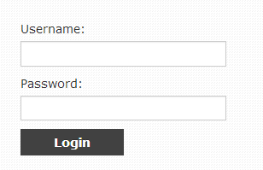

* + Fill username and password information
  + Click “Login” button to finish
* Users will be directly redirected to their specific pages: Dashboard for Staff, Customers Dashboard for customer and Users page for Admin.

#### Logout

* This function is applied for all users in system. Users have to login the system before using this.
* At the up right corner, users will see the user’s navigation bar. Click on it and then click to Log Out button.

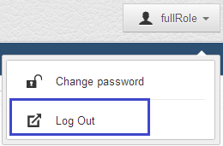

#### Change password

Users have to login the system before using this function.

At the up right corner, users will see the user’s navigation bar. Click on it and then click to Change password button.

Change Password screen appear. User will fill necessary field and then click Change Password”.

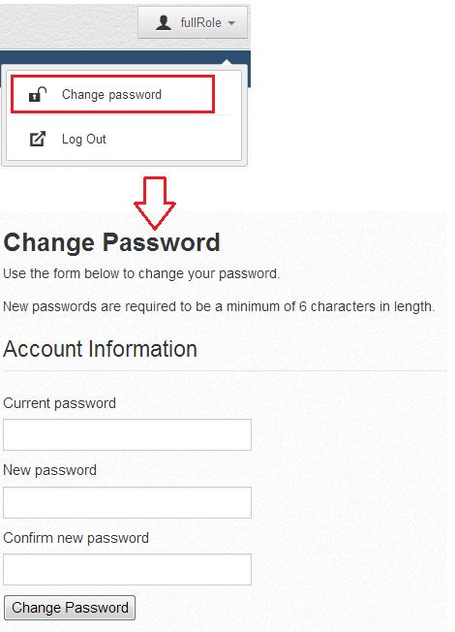

* + 1. Customers Guide

#### Add new Request

* Users login with role customer.
* Customer will be redirected to Customer Dashboard.
* Customer click on Request from menu bar



* Request page will appear.
* Click on “Add” button on the left-top corner above request table. 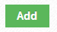
* “Create new request” popup appears.

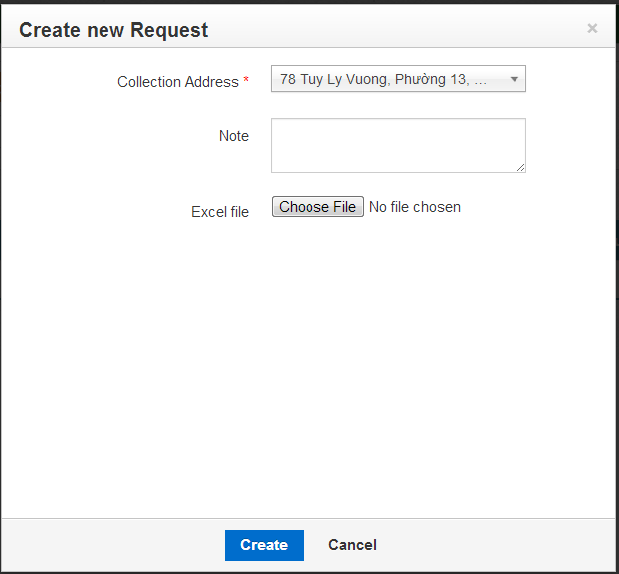

* Users can upload data from excel file then it will add information of Orders and Items of this request.
* After press “Create” button, users will be redirected to “AddOrders” page for this request.

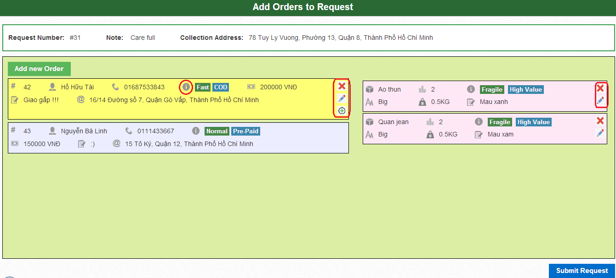

* Users can view item’s information of each order by click on order.
* If users want to add more Orders, they can press “Add new Order” button then “Add order” pop up will appears.

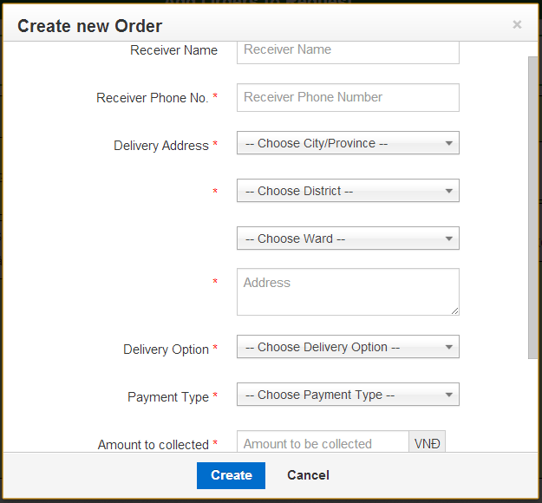

* After create new Order success, new Order will be add to Request and show at Add Order to Request Screen. Then user can add new Items for it by pressing “Add Item” icon ().
* “Create new Item” pop up will appear with interface like the picture below

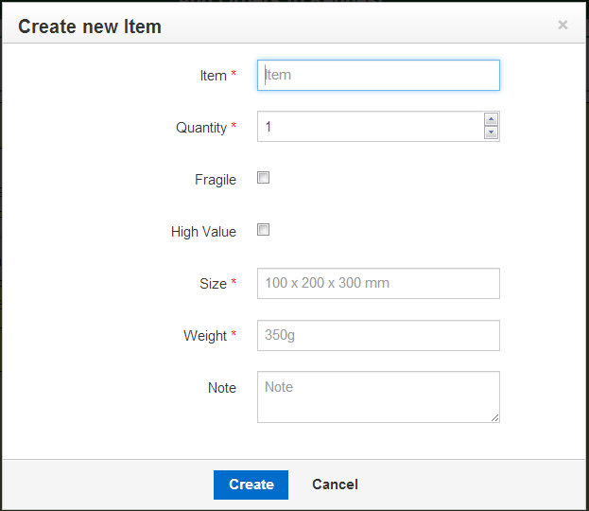

* Finally, press submit request. New request have been sent to server.

#### Filter requests

* User can filter request by status or date from Request Page.



#### Filter Orders

* User can search and view information of orders that created. Pressing “Order” button on menu bar will lead users to Orders pages.

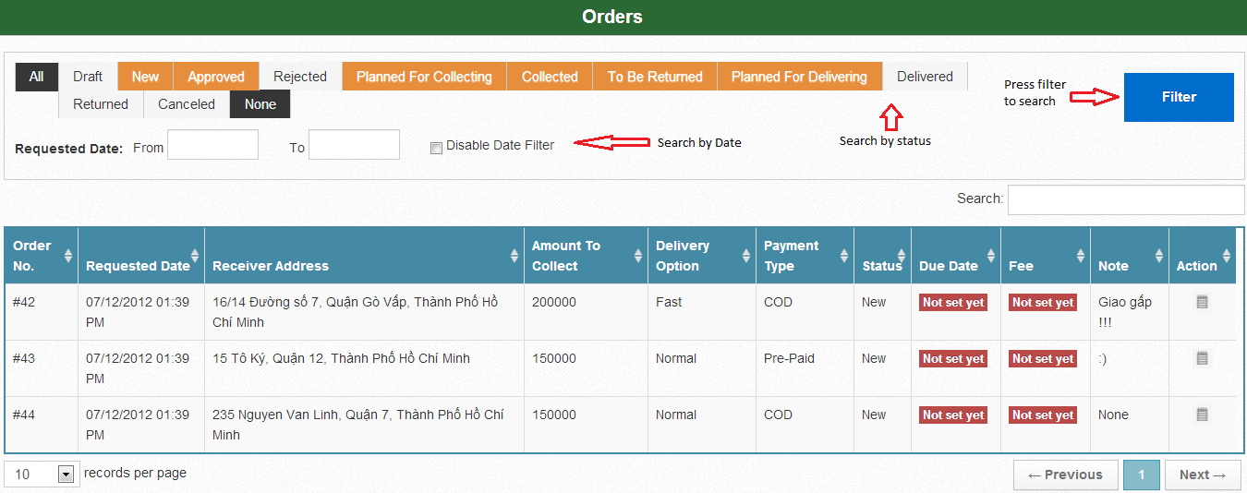

* Press “View” button () to view information of each Order. It will appear as following picture:

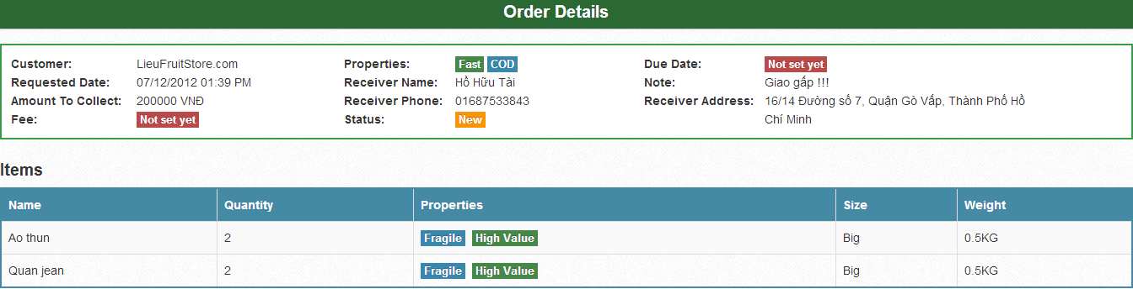

* + 1. Admin guide

Admin after login will be redirected to Users page. From here, admin can control any account that using this system.

#### View and search user

* This function can be only used by admin and directly appeared after admin login. There is the table of users and from that admin can manage user.

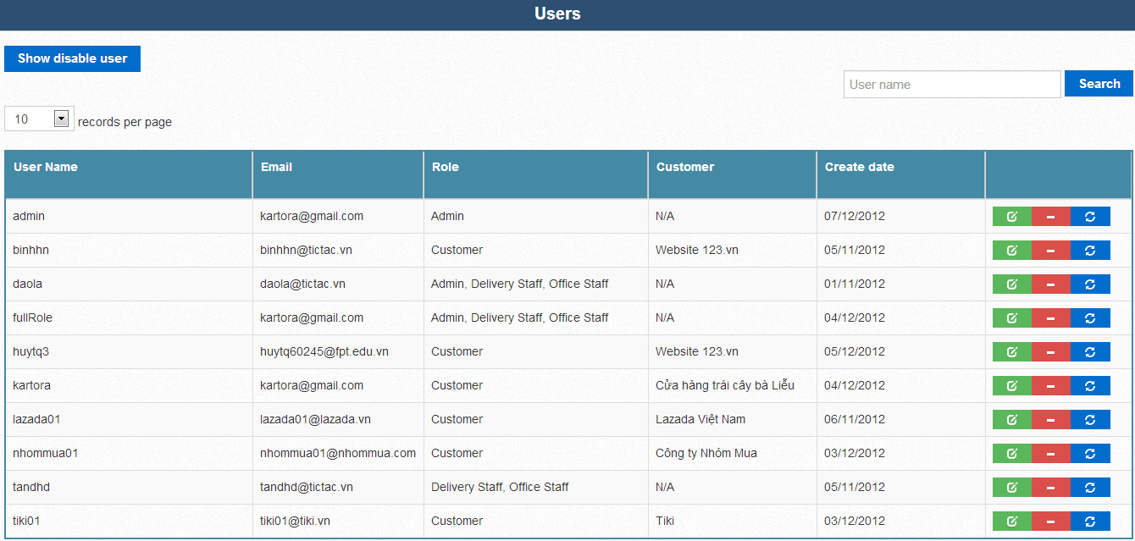

* Admin can search account by user name.

#### Toggle disable user

* This function is used for toggle disable user by pressing 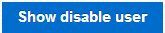 for show all users include users that was disabled or for show active users only.
* This button will toggle name of it each time admin press it.

#### Update role

* Admin can update role for users by pressing  button. After pressing this button, “Update Role” pop up will appear as the follow picture

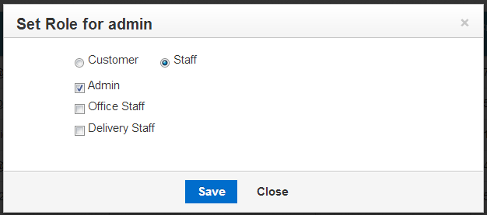 for update staff role or

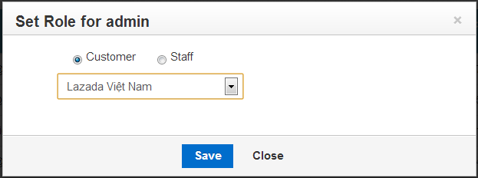

for update customer role and customer name.

* Admin can switch that by pressing Customer or Staff ratio.

#### Disable/Enable user

* Admin can disable activated user by pressing  button. A dialog will appear to ask admin’s confirmation for disable user.
* Admin also can enable deactivated user by pressing  button. A dialog will appear to ask admin’s confirmation for enable user.

#### Reset password

* Admin can reset user password by pressing  button. A dialog will appear to ask admin’s confirmation for reset password of this user.
  + 1. Staff guide

#### Dashboard

* After login, office staff will be redirected to dashboard, where they can quick search requests or orders by pressing  button next each status name.
* Here’s the dashboard page.

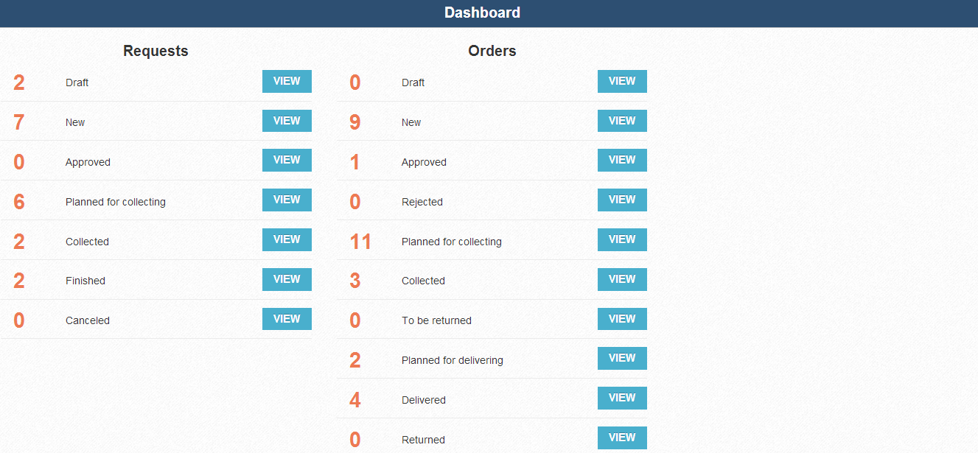

#### Request

* Users will be redirected to Requests page after pressing Request menu bar.
* Here is the main page of request:

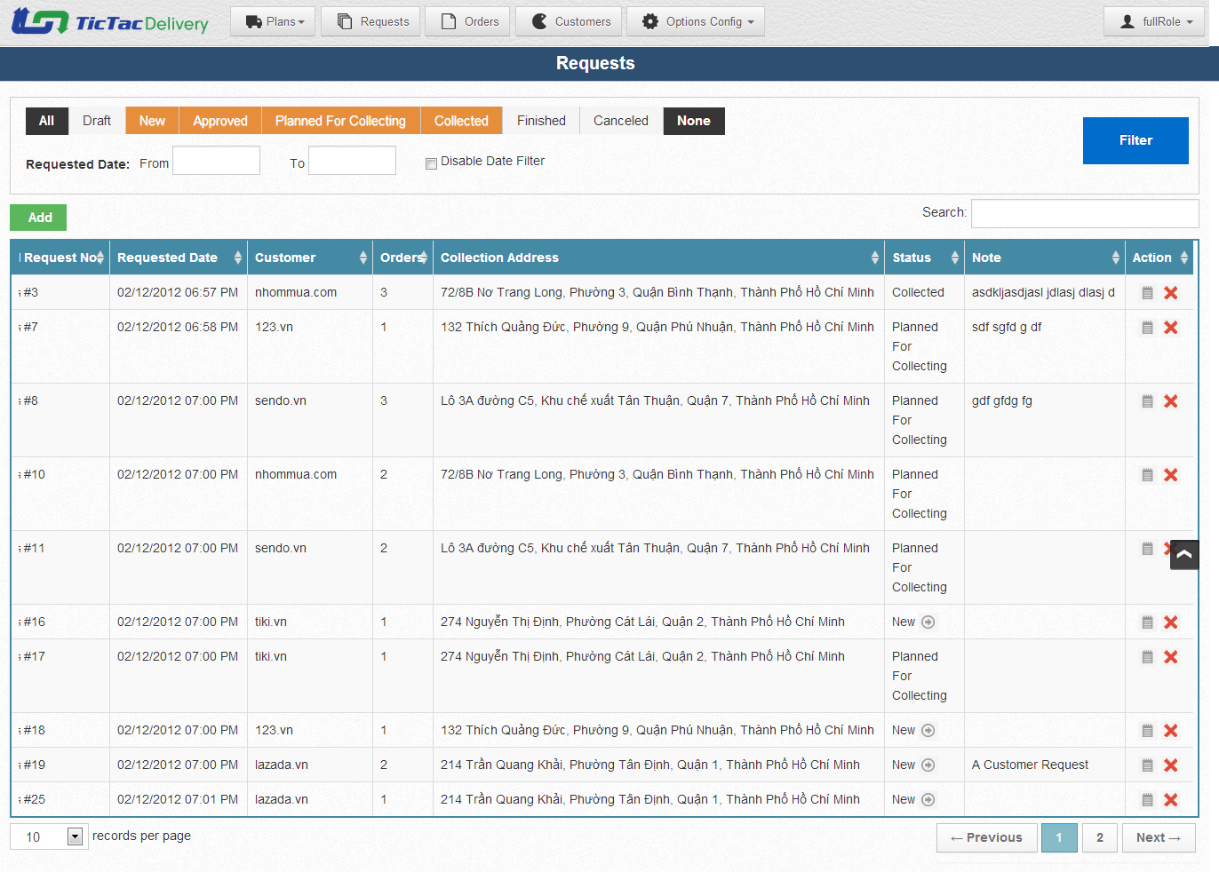

##### View and search

* Staff can view detail of each request by pressing  or search requests by status or requested date filter same as customer.
* Here is sample screen of request detail after pressing  button:

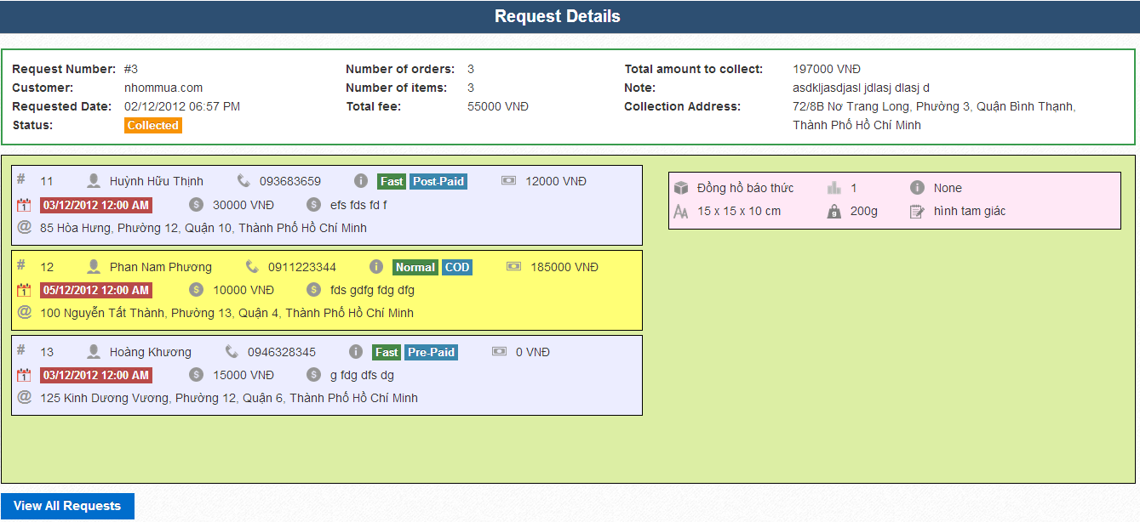

* Press  will bring users back to request main page.
* Click on each Order will show which items follows it.

##### Add new Request

* Click on “Add” button on the left-top corner above request table. 
* “Create new request” popup appears.

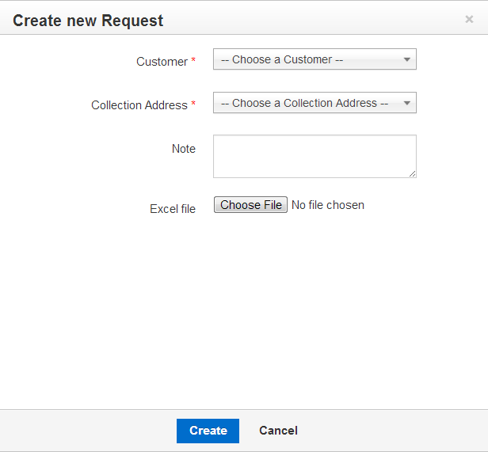

* Users can view item’s information of each order by click on order.
* If users want to add more Orders, they can press “Add new Order” button then “Add order” pop up will appears.



* After create new Order success, new Order will be add to Request and show at Add Order to Request Screen. Then user can add new Items for it by pressing “Add Item” icon ().
* “Create new Item” pop up will appear with interface like the picture below



* Finally, press submit request. New request have been sent to server.

##### Approve Request

* From request list screen, with request that have “new” status, users will see the icon next to status named “New” :  Click on it. Approve request screen will appear as follow screen.

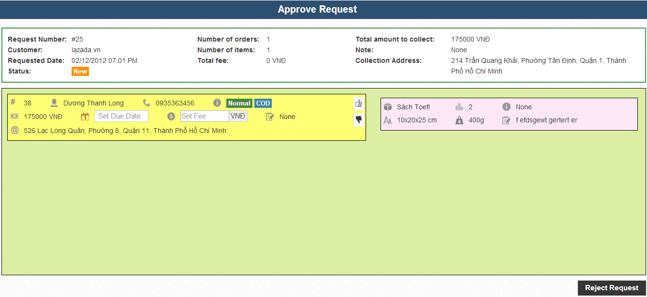

* Set due date and set fee for request, then click  for approve request or press  for reject this order.
* If users want to reject the whole request, they can press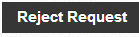.
* If users want to change due date or fee, they can click  to disapprove this order and change due date or fee.
* After approve all order, user now can approve this request by click on 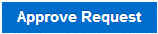.

##### Cancel Request

* Users can cancel request by click on  icon in the request table.

#### Collection Plan

##### Search and view

* Pressing Plan then Collection plan from menu bar will bring staffs to Collection Plan page.
* User can filter status or Date to search collection plan.

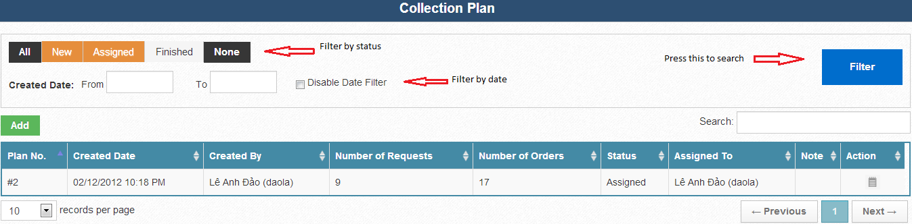

* Staff can view detail of each collection plan by pressing this icon .

Here is one example screen of detail of collection plan.

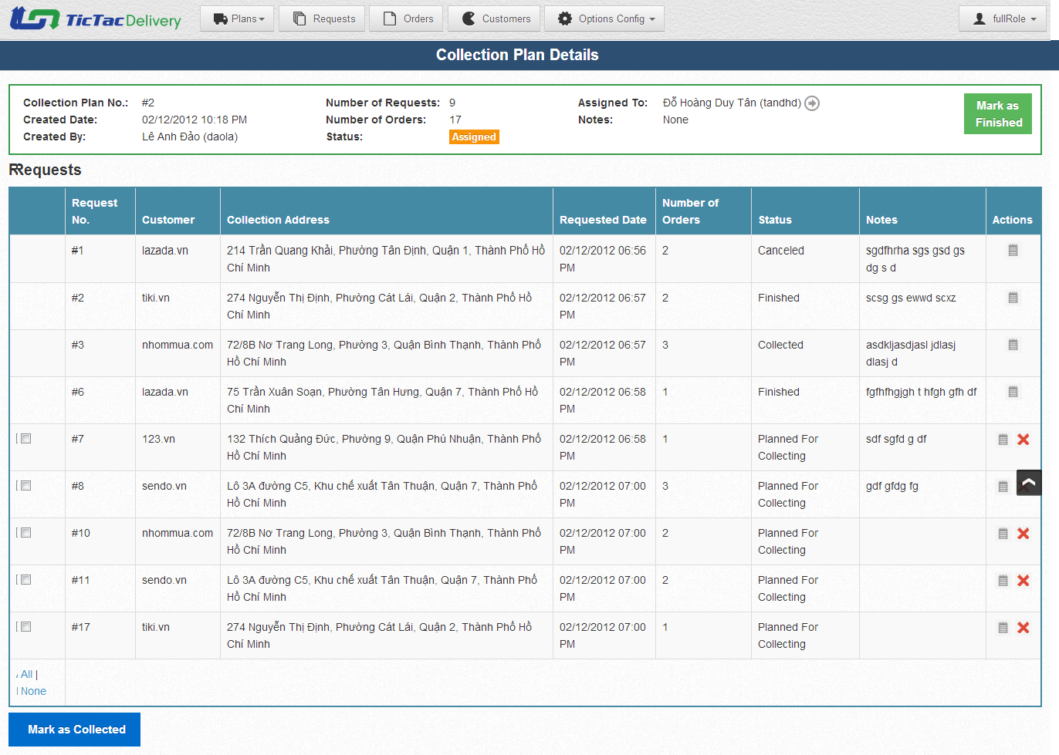

* Users can view detail of each request of collection plan by pressing  icon.

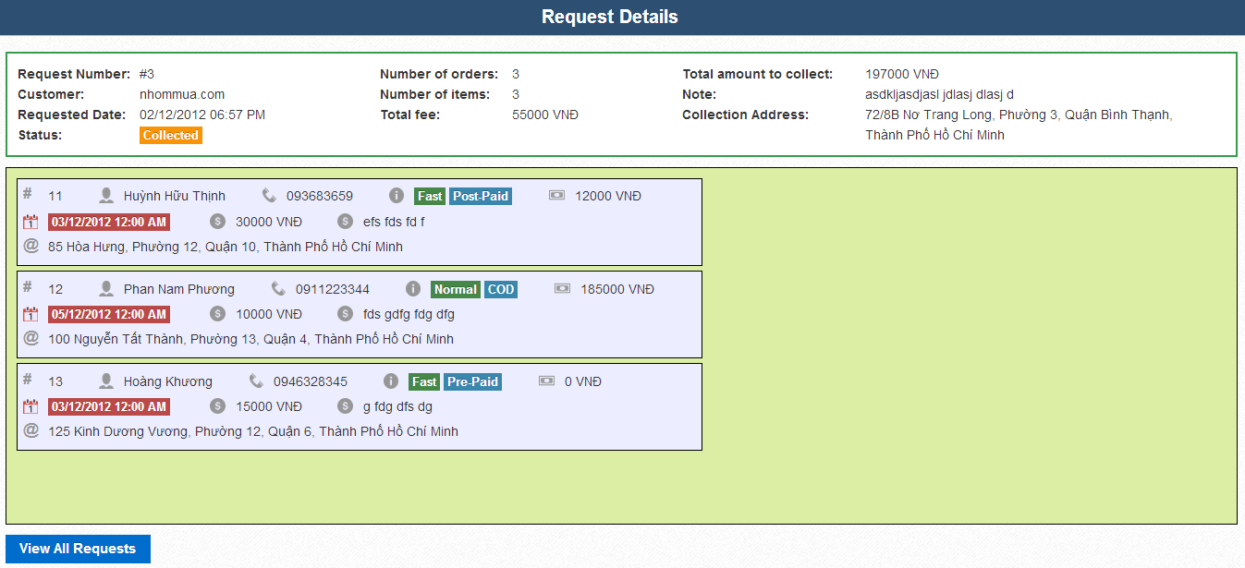

##### Add new Collection Plan

* This is the screen for add new Collection Plan. Click on  button on the left-top corner above request table to go to this screen.

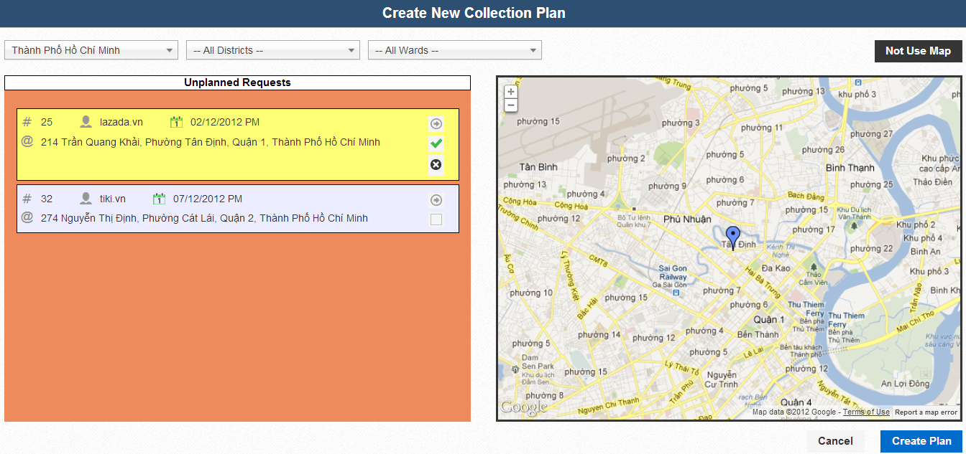

* Pressing  icon will allow users to set location of this request to map if its location on map was wrong.  button for confirm the location and  for cancel set location.
* Adding request to Collection Plan will be done when users click on  button.
* Users can add request from list of unplanned requests on the left to map or to table.
* To toggle “Not use map” screen, users can click 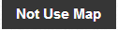 button.
* This is “Not Use Map” screen for creating collection plan

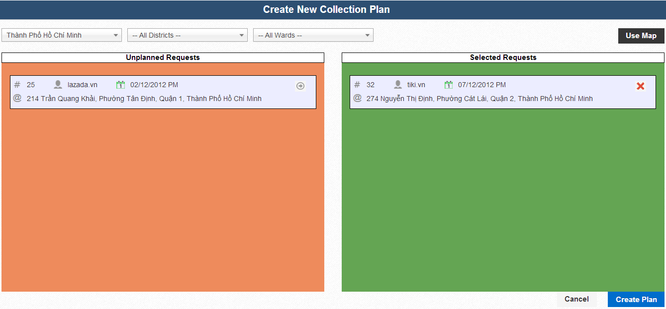

* It’s easily for users to add or remove Requests to plan on this screen just by pressing  for adding request to collection plan or  for removing request from collection plan.
* After add enough requests to plan, users can press 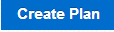 for creating new plan.
* User will be redirected to Collection Plan details of this Collection Plan that has just created.

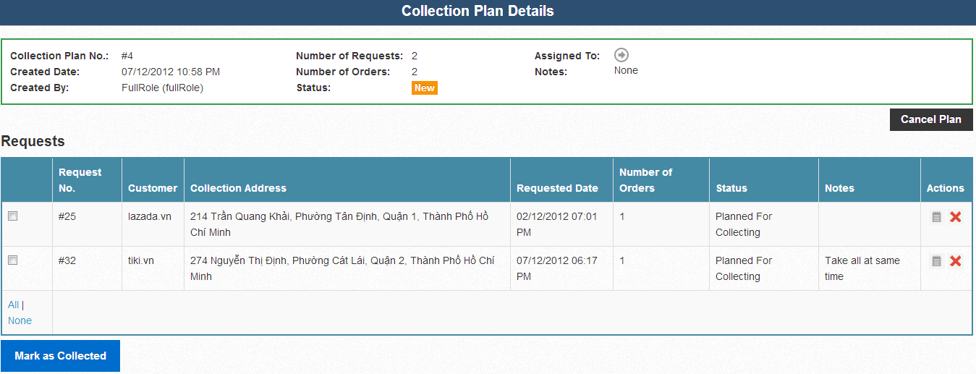

##### Cancel Plan

* If users want to cancel plan, they can press button. Dialog will appear request user’s confirmation.

##### Assigned plan to staff

* Users can assign Collection Plan which has status is “New” to Delivery Staff by pressing button next to “Assigned To”. “Assign plan” pop up will appear as the follow picture

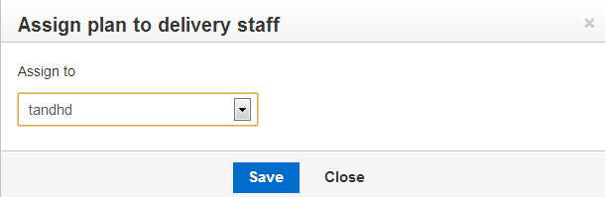

##### Mark as collected /mark as finished /remove request

* Mark request as collected is so simple by using checkbox and “Mark as Collected” button.
* You can select all or none or individual request by click on 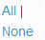 hyperlink or check box. This function can only use for Requests that has “Planned for collecting” status.
* After choose which Requests has been collected, you can press 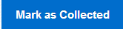 to ensure they have been collected.
* After all Requests of this “Collection Plan” have been processed, you can press 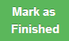 to finish this collection plan. If any Request still have status “Planned for collection”, there will appear a dialog to ask permission for Remove uncollected requests from plan and mark plan as finished.
* Users can cancel request of this collection plan by click on  icon.

#### Delivery Plans

##### Search and view

* Pressing Plan then Delivery Plan from menu bar will bring staffs to Delivery Plan page.
* User can filter status or Date to search Delivery plan.

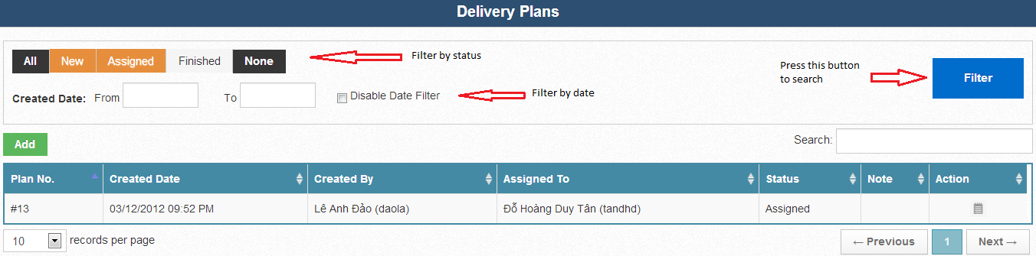

* Staff can view detail of each delivery plan by pressing  icon.

Here is one example screen of detail of a delivery plan.

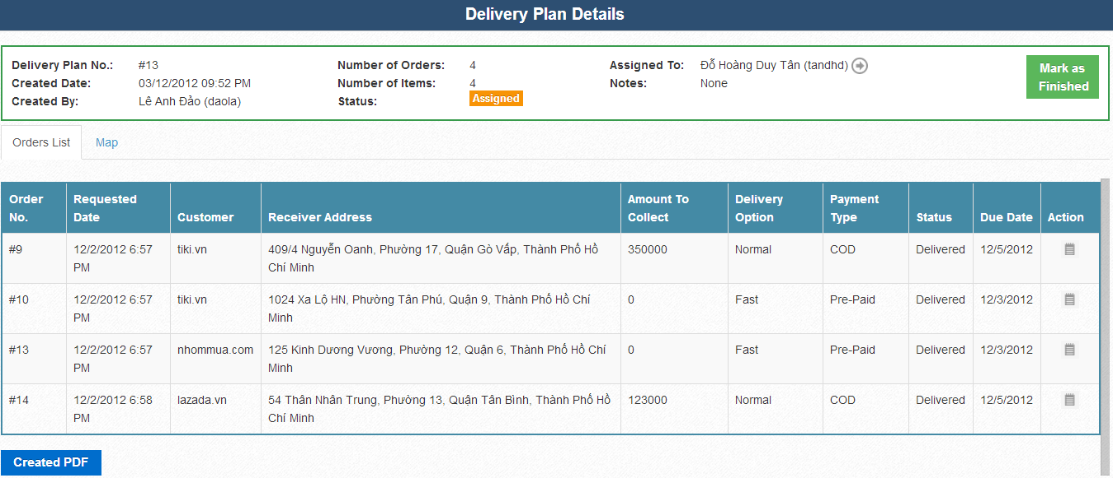

* Users can view detail of each order of delivery plan by pressing  icon.

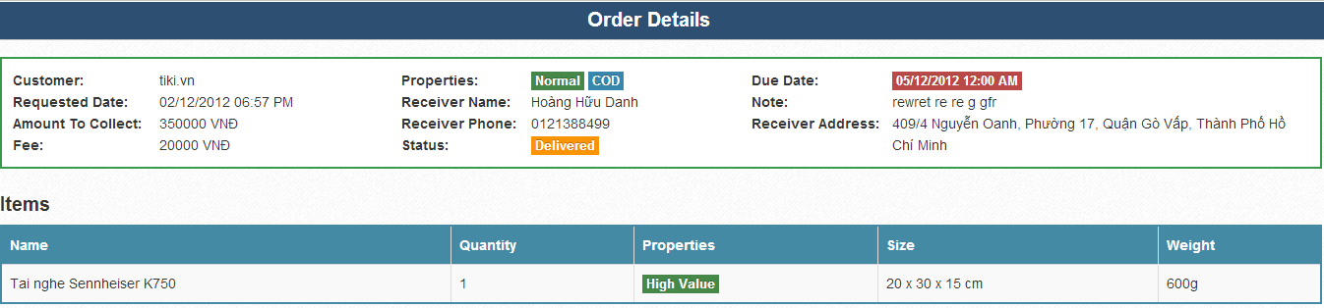

* There is a tab named “Map” next to orders list. From this tab, you can get the map for delivering and route for it.

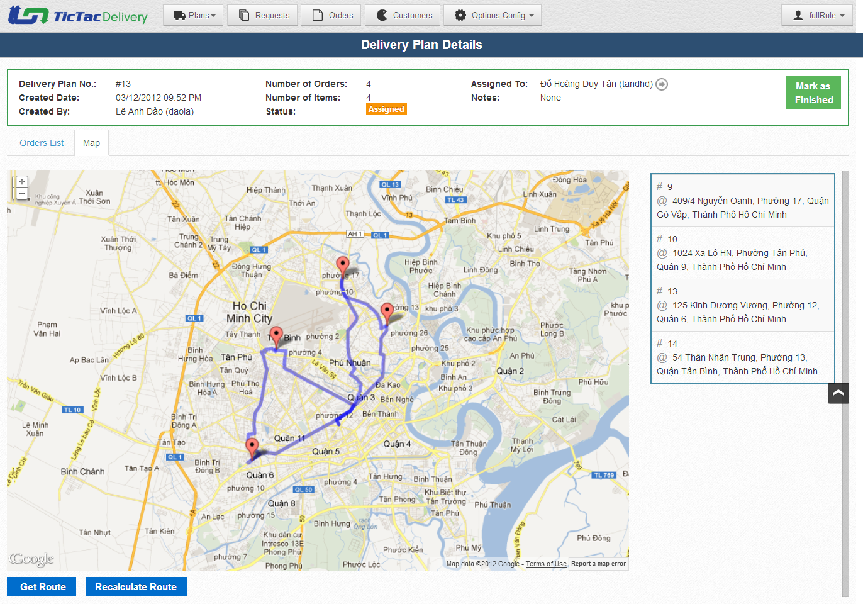

* You can see two buttons helping you getting route here are  button and  button.

##### Add new Collection Plan

* This is the screen for add new Delivery Plan. Click on  button on the left-top corner above Delivery table to go to this screen.

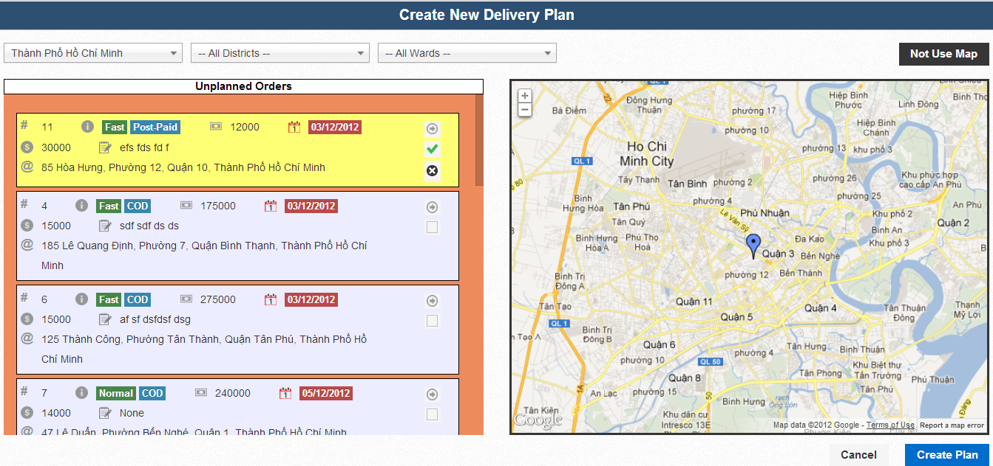

* Pressing  icon will allow users to set location of this order to map if its location on map was wrong.  button for confirm the location and  for cancel set location.
* Adding request to Delivery Plan will be done when users click on  button.
* Users can add Orders from list of unplanned Orders on the left to map or to table.
* To toggle “Not use map” screen, users can click  button.
* This is “Not Use Map” screen for creating Delivery Plan

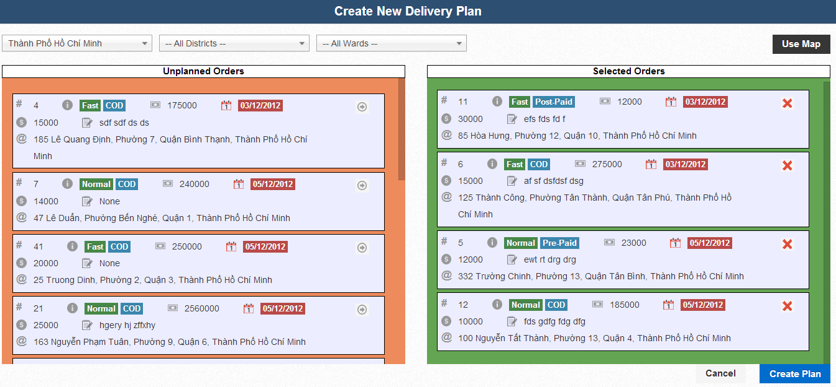

* It’s easily for users to add or remove Orders to plan on this screen just by pressing  for adding order to collection plan or  for removing order from collection plan.
* After add enough orders to plan, users can press  for creating new plan.
* User will be redirected to Delivery Plan details of the Delivery Plan that has just created.

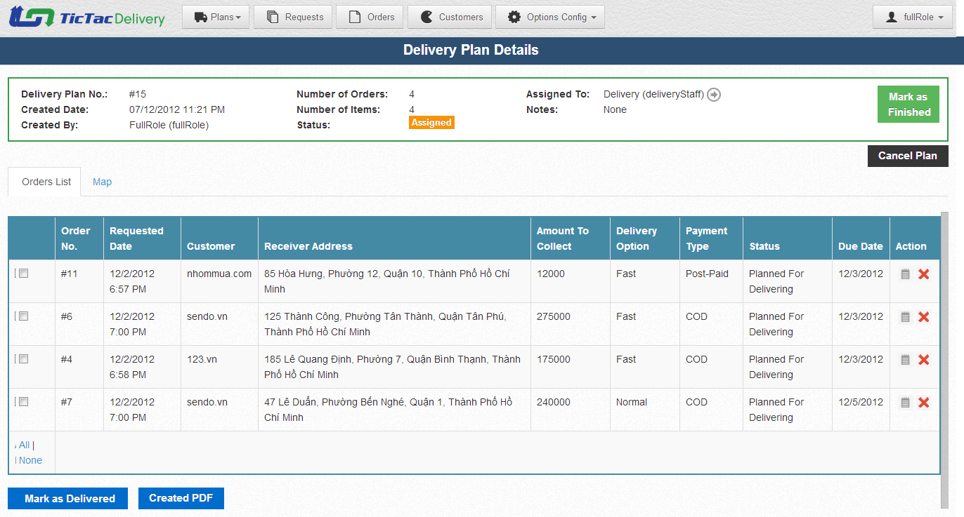

##### Cancel Plan/ Created PDF

* If users want to cancel plan, they can press button. Dialog will appear request user’s confirmation.
* If users want to export this plan to PDF, they can press  button.

##### Assigned plan to staff

* Users can assign Delivery Plan which has status is “New” to Delivery Staff by pressing button next to “Assigned To”. “Assign plan” pop up will appear as the follow picture



##### Mark as collected /mark as finished /remove request

* Mark orders as collected is so simple by using checkbox and “Mark as Collected” button.
* You can select all or none or individual order by click on  hyperlink or check box to mark them as delivered.
* After choose which Requests has been collected, you can press  to ensure they have been collected.
* After all Requests of this “Delivery Plan” have been processed, you can press  to finish this collection plan. If any Orders still have status “Planned for delivering”, there will appear a dialog to ask permission for Remove undelivered orders from plan and mark plan as finished.
* Users can cancel orders of this Delivery plan by click on  icon.

#### Customer

##### View and search

* From menu bar, click to “Customer” will bring user to Customers page, where list all customers of the company also add new customer.

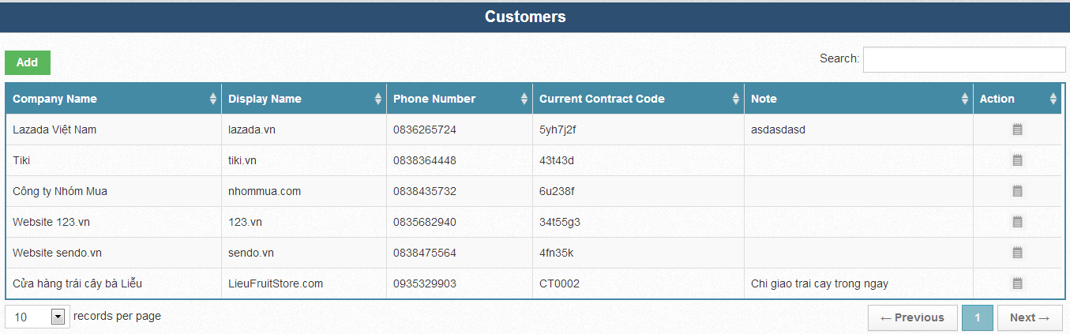

* Users can view detail of individual customer by pressing  button.
* Here is an example of customer’s details

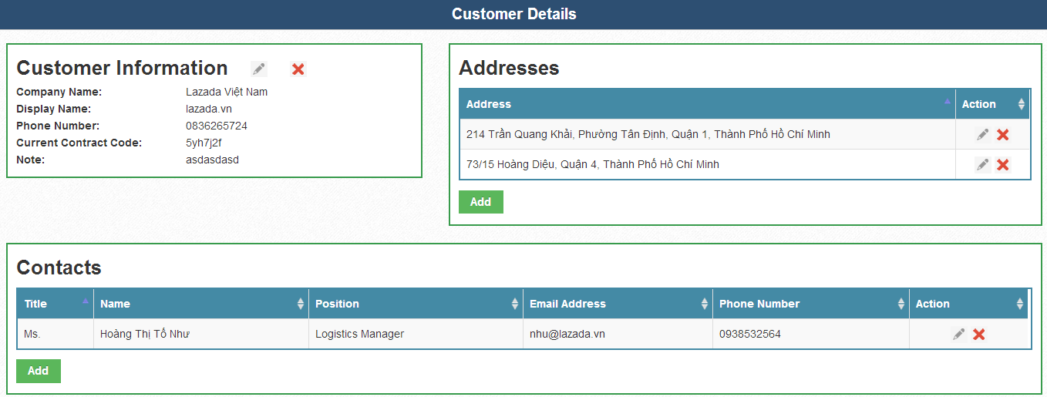

* From there, users can edit main information of customer, adding new Addresses, Contacts or edit, remove them.
*  for edit, for remove and 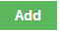 for add new information.

##### Add new Customer

From Customers page, users can add new customer by pressing  button. A pop up will appear allow users to fill information of customer.

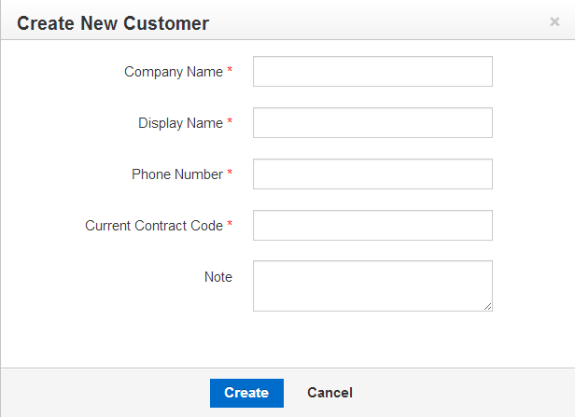

After press create button, users will be redirected to detail page, require them to add Customer Addresses and Contacts.

Here is Adding Addresses form

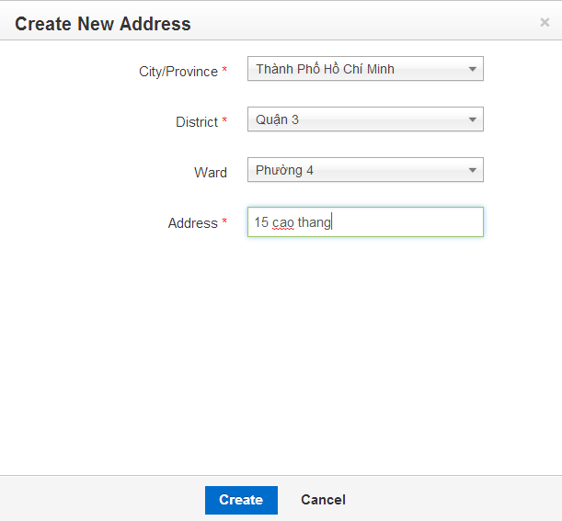

And contact form

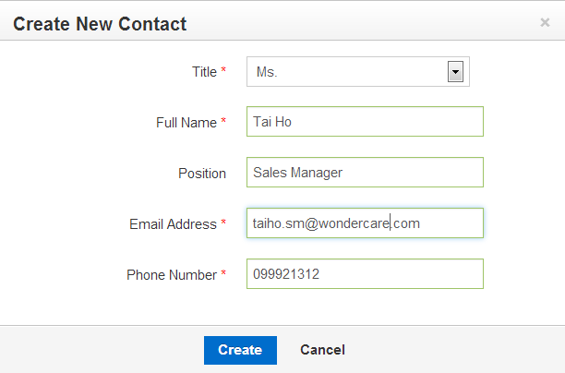

#### Hubs management

From menu bar users click “Option config”. Then click Hubs. List of hubs will appears as the follow picture

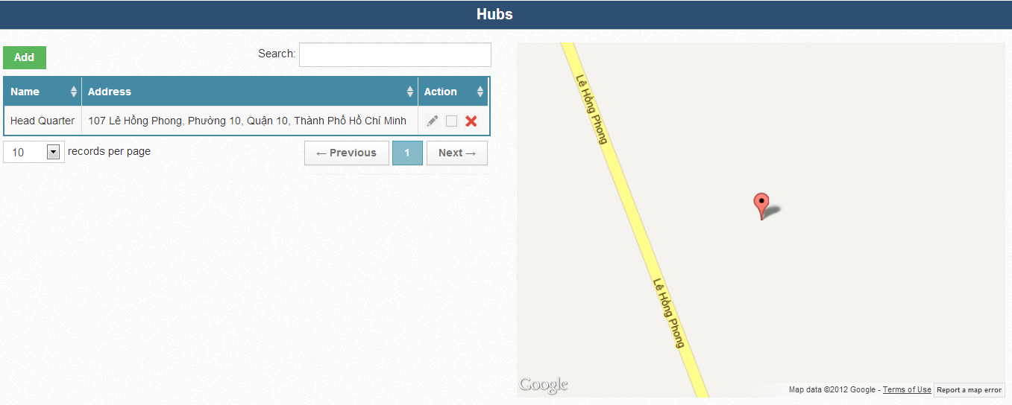

From this page, users can Edit, set location or remove hub.

Press to edit,  to set location and to remove hub.

Add new Hub by click 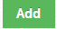 button. Adding hub pop up will appeared as the followed picture:

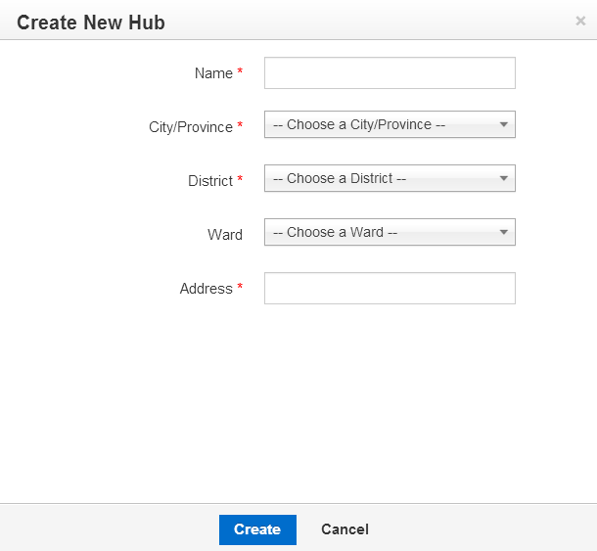

After fill all data and press Create button, new Hub will be added to system.

#### Order Payment Type Management

From menu bar users click “Option config”. Then click “Order Payment Type”. List of payment type will appears as the follow picture

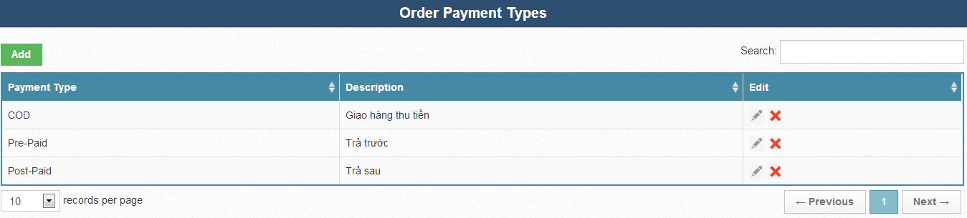

From this page, users can Edit, set location or remove Order Payment Types.

Press to edit , to remove Order Payment Type.

Add new Order Payment Type by click  button. Adding Order Payment Type pop up will appeared as the followed picture:

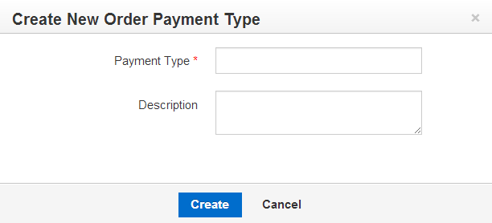

After fill all data and press Create button, new Order Payment Type will be added to system.

#### Delivery Options Management

From menu bar users click “Option config”. Then click “Delivery Option”. List of delivery options will appears as the follow picture

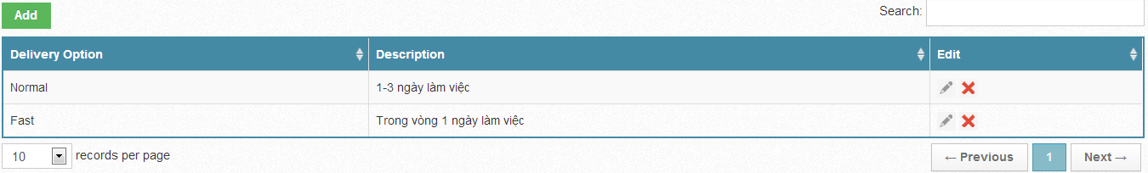

From this page, users can Edit, set location or remove Delivery Options.

Press to edit, to remove Delivery Option.

Add new Delivery Option by click  button. Adding Delivery Option pop up will appear as the followed picture:



After fill all data and press Create button, new Delivery Option will be added to system.

#### City Province Management

From menu bar users click “Option config”. Then click “City Province”. List of City Province will appears as the follow picture

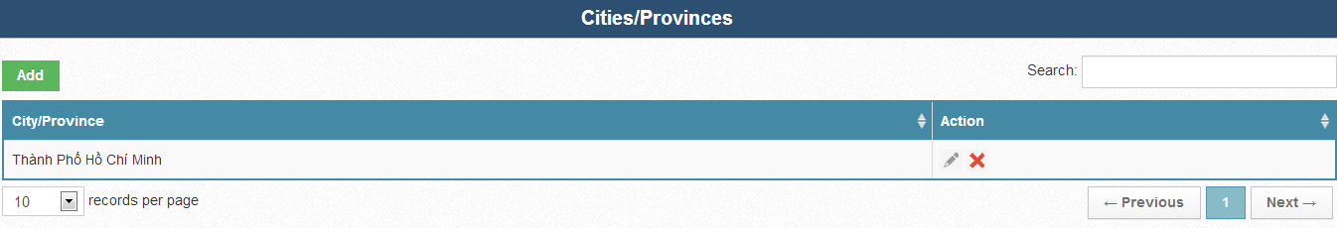

From this page, users can Edit, set location or remove city/province..

Press for edit , for remove City Province.

Add new City Province by click  button. Adding City Province pop up will appear as the followed picture:

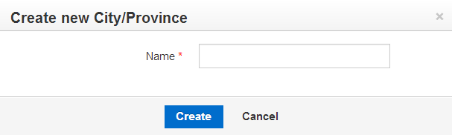

After fill all data and press Create button, new City Province will be added to system.

#### Districts Management

From menu bar users click “Option config”. Then click “Districts”. List of Districts will appears as the follow picture

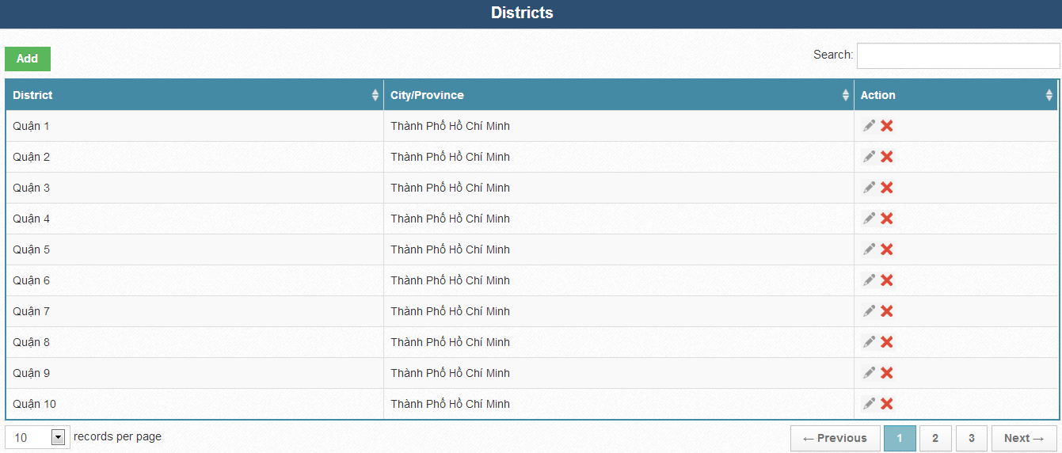

From this page, users can Edit, set location or remove Districts.

Press for edit , for remove Districts.

Add new Districts by click  button. Adding Districts pop up will appear as the followed picture:

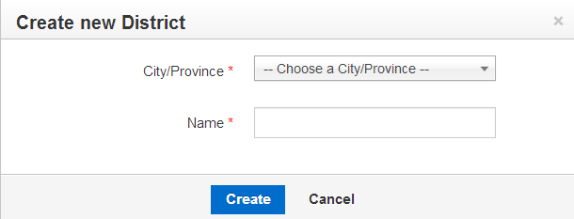

After fill all data and press Create button, new Districts will be added to system.

#### Wards management

From menu bar users click “Option config”. Then click “Wards”. List of Wards will appears as the follow picture

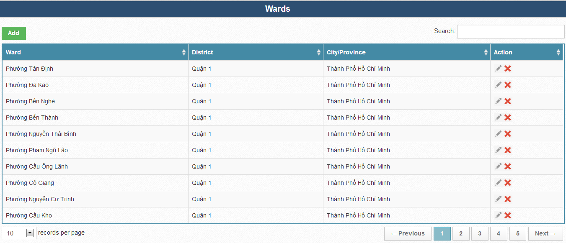

From this page, users can Edit, set location or remove Wards.

Press for edit , for remove Wards.

Add new Wards by click  button. Adding Wards pop up will appear as the followed picture:

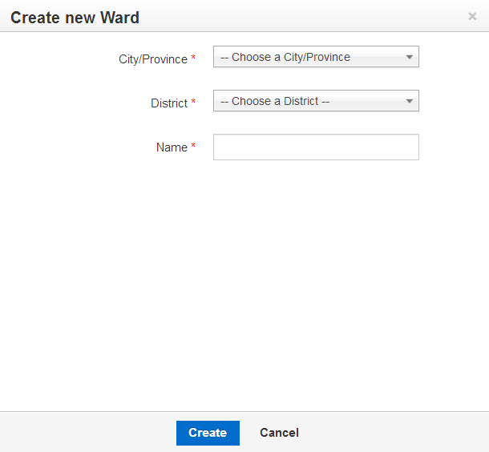

After fill all data and press Create button, new Wards will be added to system.